

AUDIO

WIRELESS PRO AUDIO

WiSpeak
Ref.
Name
Nettó lista ár Bruttó lista Nettó lista ár Bruttó lista ár
EUR ár EUR HUF HUF

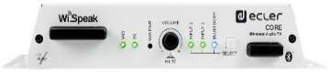  CCORE CORE WiSpeak CORE is the transmitter device that communicates with all the receiver devices to create a 495,80 €  WiSpeak wireless network, and takes the role of the Master Unit.  Its main functions are to pair and send audio contents to all the receivers. Includes 3 audio inputs (Euroblock, RCA, Bluetooth), remote port for a WPa-VOL panel and a MUTE port for external dry contact triggering. Managed by WiSpeak grip app.  Dimensions 225x120x40mm / 8.9”x4.7”x1.6”. Weight 0.8kg / 1.76 lb. | 629,67 € | 200 800 Ft | 255 016 Ft

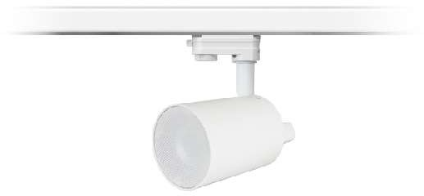  CTUBE3WH TUBE WiSpeak TUBE is a self-powered 3" lamp style loudspeaker with wireless audio reception and control 403,46 €  capabilities under the control of the Master unit, featuring an AUX output (Euroblock) and a installation system which is compatible with ceiling light rails. Dimensions (without accessories) Ø 96mm x 110mm /Ø 3,8" x 4,3" . Weight 0,8 kg / 1.76lb. White colour.  Delivered by units. Price per unit. | 512,39 € | 163 400 Ft | 207 518 Ft

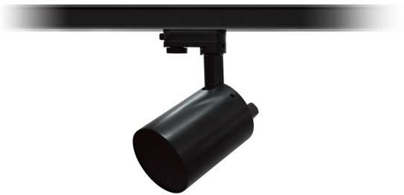  CTUBE3BK TUBE WiSpeak TUBE is a self-powered 3" lamp style loudspeaker with wireless audio reception and control 403,46 €  capabilities under the control of the Master unit, featuring an AUX output (Euroblock) and a installation system which is compatible with ceiling light rails. Dimensions (without accessories) Ø 96mm x 110mm /Ø 3,8" x 4,3" . Weight 0,8 kg / 1.76lb. Black colour. Delivered by units. Price per unit. | 512,39 € | 163 400 Ft | 207 518 Ft

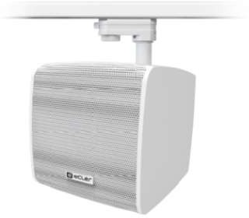  CCUBE5WH CUBE WiSpeak CUBE is a self-powered 5" loudspeaker cabinet with wireless audio reception and control 507,65 €  capabilities under the control of the Master unit, featuring an AUX output (Euroblock) and a installation system which is compatible with ceiling light rails. Alternatively, wall mount or desktop installation is as well possible by means of the included accessories. Dimensions (without accessories) 173x180x185 mm / 6,81" x 7,08" x 7,28". Weight 2,4kg / 5.29lb. White colour. Delivered by units. Price per unit. | 644,72 € | 205 600 Ft | 261 112 Ft

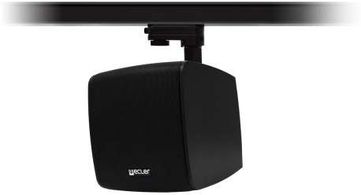  CCUBE5BK CUBE WiSpeak CUBE is a self-powered 5" loudspeaker cabinet with wireless audio reception and control 507,65 €  capabilities under the control of the Master unit, featuring an AUX output (Euroblock) and a installation system which is compatible with ceiling light rails. Alternatively, wall mount or desktop installation is as well possible by means of the included accessories. Dimensions (without accessories) 173x180x185 mm / 6,81" x 7,08" x 7,28". Weight 2,4kg / 5.29lb. Black colour. Delivered by units. Price per unit. | 644,72 € | 205 600 Ft | 261 112 Ft

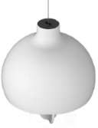  CGLOBE5PDWH GLOBE WiSpeak GLOBE is a self-powered 2-way full range sphere loudspeaker cabinet with wireless audio 480,74 €  reception and control capabilities under the control of a WiSpeak CORE Master unit, featuring a pendant installation system. Includes a 5" woofer and a 1" silk dome tweeter. Dimensions (without accessories) Ø287mm x 331mm(H) / Ø11.3 in. x 13 in. (H). Weight 2.2 Kg / 4.85 lbs. White colour. Delivered by units. Price per unit. | 610,54 € | 194 700 Ft | 247 269 Ft

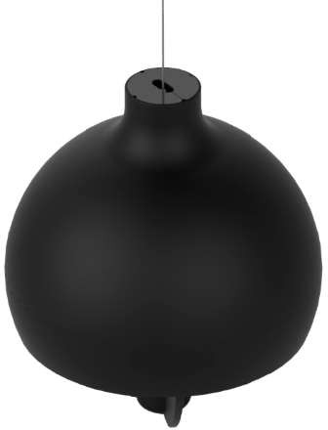  CGLOBE5PDBK GLOBE WiSpeak GLOBE is a self-powered 2-way full range sphere loudspeaker cabinet with wireless audio 480,74 €  reception and control capabilities under the control of a WiSpeak CORE Master unit, featuring a pendant installation system. Includes a 5" woofer and a 1" silk dome tweeter. Dimensions (without accessories) Ø287mm x 331mm(H) / Ø11.3 in. x 13 in. (H). Weight 2.2 Kg / 4.85 lbs. Black colour.  Delivered by units. Price per unit. | 610,54 € | 194 700 Ft | 247 269 Ft

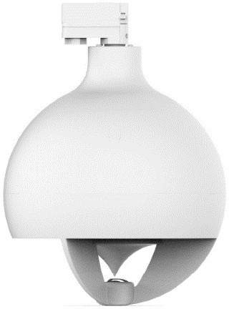  CGLOBE5RMWH GLOBE WiSpeak GLOBE is a self-powered 2-way full range sphere loudspeaker cabinet with wireless audio 480,74 €  reception and control capabilities under the control of a WiSpeak CORE Master unit, featuring an installation system which is compatible with ceiling light rails. Includes a 5" woofer and a 1" silk dome tweeter. Dimensions (without accessories) Ø287mm x 331mm(H) / Ø11.3 in. x 13 in. (H). Weight 2.2 Kg  / 4.85 lbs. White colour. Delivered by units. Price per unit. | 610,54 € | 194 700 Ft | 247 269 Ft

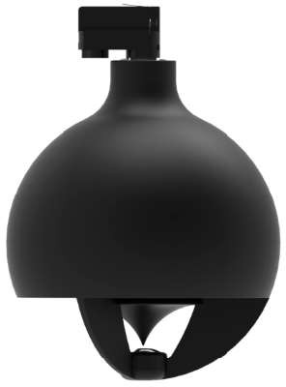  CGLOBE5RMBK GLOBE WiSpeak GLOBE is a self-powered 2-way full range sphere loudspeaker cabinet with wireless audio 480,74 €  reception and control capabilities under the control of a WiSpeak CORE Master unit, featuring an installation system which is compatible with ceiling light rails. Includes a 5" woofer and a 1" silk dome tweeter. Dimensions (without accessories) Ø287mm x 331mm(H) / Ø11.3 in. x 13 in. (H). Weight 2.2 Kg  / 4.85 lbs. Black colour. Delivered by units. Price per unit. | 610,54 € | 194 700 Ft | 247 269 Ft

WiLD

Ref.
Name
Nettó lista ár Bruttó lista Nettó lista ár Bruttó lista ár
EUR ár EUR HUF HUF

NEW! | CWILDTX  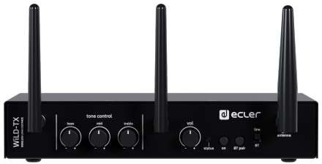 | WiLD-TX | WiLD-TX is the transmitter device that communicates with all the receiver devices to create a WiLD wireless network.2 audio inputs available: Analogue stereo, unbalanced. 2 x RCA connectors and Bluetooth®, class 1 (up to 25 meters range, maximum). Mute port and remote port (WPaVOL or compatible panel). Dimensions TBC. Weight TBC. Black colour. Delivered by units. Price per unit. | 330,12 € | 419,26 € | 133 700 Ft | 169 799 Ft

  NEW! | CWILD14WH  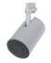 | WiLD-14 | WiLD-14 is a self-powered 4" lamp style loudspeaker with wireless audio reception under the control of the transmitter, featuring an installation system which is compatible with ceiling light rails. 4" woofer  + 0,75" tweeter, 40W amplifier power output. Dimensions TBC. Weight TBC. White colour. Delivered by units. Price per unit. | 400,49 € | 508,63 € | 162 200 Ft | 205 994 Ft

NEW! | CWILD14BK  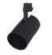 | WiLD-14 | WiLD-14 is a self-powered 4" lamp style loudspeaker with wireless audio reception under the control of the transmitter, featuring an installation system which is compatible with ceiling light rails. 4" woofer  + 0,75" tweeter, 40W amplifier power output. Dimensions TBC. Weight TBC. Black colour. Delivered by units. Price per unit. | 400,49 € | 508,63 € | 162 200 Ft | 205 994 Ft

NEW! | CWILDSB18BK  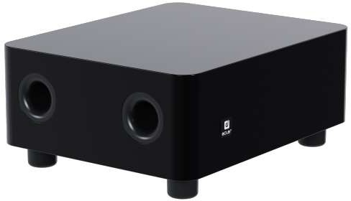 | WiLD-SB18 | WiLD-SB18 is a compact self-powered 8" subwoofer with wireless audio reception under the control of the transmitter. 8" woofer. 100W Amplifier power output. Dimensions TBC. Weight TBC. Black colour. Delivered by units. Price per unit. | 801,73 € | 1 018,20 € | 324 700 Ft | 412 369 Ft
ACCESSORIES
Ref.
Name
Nettó lista ár Bruttó lista Nettó lista ár Bruttó lista ár
EUR ár EUR HUF HUF

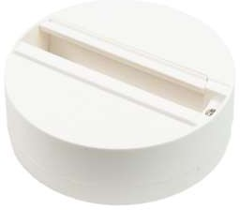  CTUBESMAWH TUBE SMA TUBESMA is a surface mount adapter to allow installing a TUBE or WiLD-14 unit in locations where 39,26 €  there is no available lighting rail. | 49,86 € | 15 900 Ft | 20 193 Ft

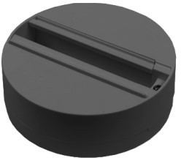  CTUBESMABK TUBE SMA TUBESMA is a surface mount adapter to allow installing a TUBE or WiLD-14 unit in locations where 39,26 €  there is no available lighting rail. | 49,86 € | 15 900 Ft | 20 193 Ft

SOUND SOURCES
MICROPHONES
Ref. Name | Nettó lista ár EUR | Bruttó lista ár EUR | Nettó lista ár HUF | Bruttó lista ár HUF

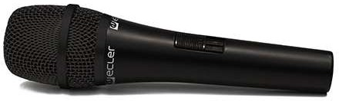  CEMHH1 eMHH1 Affordable handheld cardioid dynamic microphone, with a robust design that makes it ideal for voice 68,40 €  applications. It comes with a microphone stand adapter, 6 metres XLR-XLR cable and transport bag. Dimensions 185 x 50 x 50 mm. Weight 246 g. | 86,86 € | 27 700 Ft | 35 179 Ft

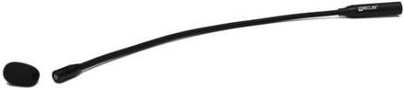  CEMCN2 eMCN2 Condenser gooseneck cardioid microphone, with a perfect profile for message, speech and 115,56 €  conferencing applications. Total length 55 cm. It includes anti-pop wind-screen cover. | 146,76 € | 46 800 Ft | 59 436 Ft

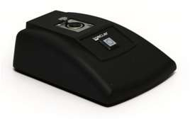  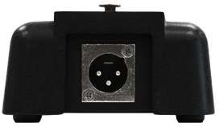  CEMBASE eMBASE Desktop connection base for the eMCN2 microphone, as well as for other microphones with standard 87,41 €  XLR connector. It includes ON / OFF switch that enables / disables the microphone signal. Dimensions 45 x 140 x 110 mm. Weight: 860g. | 111,01 € | 35 400 Ft | 44 958 Ft
AUDIO PLAYERS
Ref.
Name
Nettó lista ár Bruttó lista Nettó lista ár Bruttó lista ár
EUR ár EUR HUF HUF

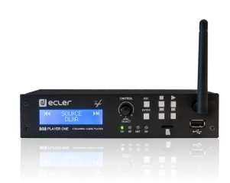  CPLAYERONE PLAYER ONE Compact audio player with a stereo output that can play music contents from local storage media 505,68 €  (USB/MicroSD card), Internet streams or digital sharing streams (DLNA and Airplay compatible). It includes Ethernet port, WiFi connection, USB and Micro-SD reader slots, front panel LCD display and local controls .Remote management by Ecler GALLERY, remote control by RePLAYER mobile app.  Dimensions 241 x 44 x 152mm (install 2 PLAYER ONE in 1RU with 1UHRMKIT accessory). Weight 680 g. | 642,21 € | 204 800 Ft | 260 096 Ft

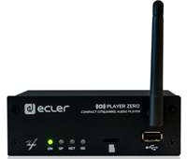  CPLAYERZERO PLAYER ZERO Compact audio player with a stereo output that can play music contents from local storage media 405,43 €  (USB/MicroSD card), Internet streams or digital sharing streams (DLNA and Airplay compatible). It includes Ethernet port, WiFi connection, USB and Micro-SD reader slots .Remote management by Ecler GALLERY, remote control by RePLAYER mobile app. Dimensions 126.5 x 44 x 132 mm / 4.98” x 1.73” x  5.19“. Weight 0.6 Kg / 1.32 lb | 514,90 € | 164 200 Ft | 208 534 Ft

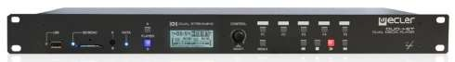  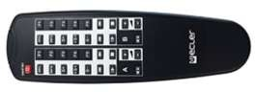  CDUONTPLAYER DUONET PLAYER Double audio sound source that features full EclerNet compatibility (UCP control system, 1 085,68 €  WPNETTOUCH remote management, TP-NET protocol, etc.). It includes 2 independent stereo media players, each one being able to play Internet audio streams and local (USB/SD) or networked audio media. The device have 2 Euroblock line level balanced outputs, remote control, priority (messages, warnings) and 4 GPI ports to trigger events. Dimensions 482 x 44(1RU) x 250mm. Weight 4,2 kg | 1 378,81 € | 439 700 Ft | 558 419 Ft

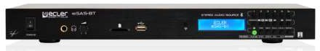  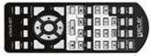  CESASBT eSAS-BT Stereo audio source including FM tuner, USB slot, SD slot and Bluetooth connection. It performs 278,02 €  unbalanced and balanced stereo audio outputs and headphones output (jack) with volume control in frontal panel. IR remote control, FM antenna, 2x RCA cables and rack-mount bracket included.  Dimensions 482 x 44(1RU) x 132mm. Weight 1,4 kg | 353,09 € | 112 600 Ft | 143 002 Ft

INSTALLATION MIXERS
INSTALLATION MIXERS
Ref. Name SAM SERIES | Nettó lista ár EUR | Bruttó lista ár EUR | Nettó lista ár HUF | Bruttó lista ár HUF

EOL | 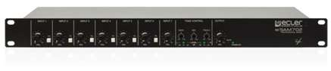  CESAM702C | eSAM702 | Installation audio mixer in standard rack format, featuring 6 MIC/LINE ST inputs, 1 LINE ST input, 1 main mix balanced output and one AUX/REC additional output. It includes a 3 band tone control section, Talkover (priority) function assignable to each MIC/LINE input over the mix bus, 18V phantom available for all mic inputs, ST/MONO mix switch and MUTE port for external dry contact triggering. Dimensions 482.6 x 44(1RU) x 120 mm. Weight 1,8 kg | 514,81 € | 653,81 € | 208 500 Ft | 264 795 Ft

EOL | 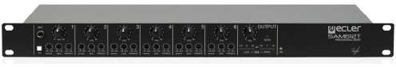  CSAM612T | SAM612T | Installation audio mixer in standard rack format, featuring 6 MIC/LINE ST inputs + 1 ST MIX input and 1 stereo balanced output. Each input has a dedicated 3-band tone control and 18V phantom power for MIC inputs. Input 1 includes talkover (priority) function over the mix bus and additional front panel jack connector. Main output ST/MONO mode switch and MUTE port for external dry contact triggering.  Dimensions 482.6x44(1RU)x120 mm. Weight 2,0 kg | 594,07 € | 754,47 € | 240 600 Ft | 305 562 Ft
Ref.
Name
COMPACT SERIES
Nettó lista ár Bruttó lista Nettó lista ár Bruttó lista ár
EUR ár EUR HUF HUF

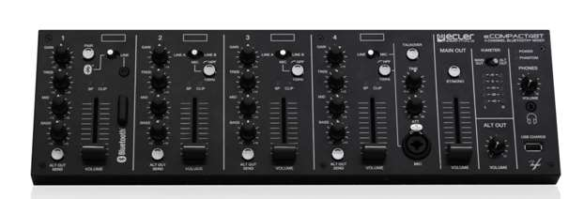  CECOMPACT4BT eCOMPACT4BT Desktop/19" rack installation mixer. INS: 4 mic with switchable HP-filter and Phantom power 48V; 6 897,04 €  line ST; Bluetooth® connex; aux (mini-jack). OUTS: main balanced (XLR) with ST/mono switch; SUB OUT mono (XLR) with switchable LP-filter; alternative ALT (RCA); headphones (mini-Jack). 3 Band tone Ctrl and ALT OUT (alternative output) send per channel on all channels; Talkover (CH4) with mic input (combo) and USB charging port. It includes power supply and rack-mount kit. | 1 139,24 € | 363 300 Ft | 461 391 Ft
Ref.
Name
SAMI SERIES
Nettó lista ár Bruttó lista Nettó lista ár Bruttó lista ár
EUR ár EUR HUF HUF

NEW! | 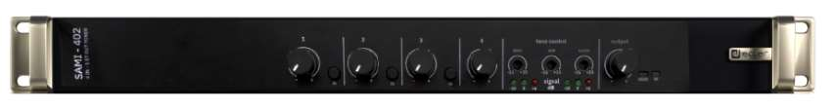  CSAMI402 | SAMI-402 | Installation audio mixer in standard rack format, featuring 3 MIC/LINE ST inputs, 1 LINE ST input, 1 main mix balanced output and one AUX/REC additional output. It includes a 3 band tone control section, Talkover (priority) function assignable to each MIC/LINE input over the mix bus, 18V phantom power for all mic inputs, ST/MONO mix switch and MUTE port for external dry contact triggering.  Dimensions 482.6 x 44(1RU) x 120 mm. Weight 1,7 kg | 389,38 € | 494,52 € | 157 700 Ft | 200 279 Ft

NEW! | 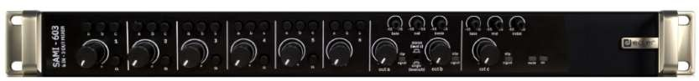  CSAMI603 | SAMI-603 | 6 inputs and 3 outputs installation audio mixer. Inputs: 1x MIC, 4x MIC/LINE ST, 1x LINE ST. Outputs: 1x ST (A/B) and 1x MONO (C). A/B output can operates in ST/MONO mode. Each input can be routed to output A, B and/or C. It includes a 3 band tone control section, talkover (priority) function assignable to each input over the mix bus, ST/MONO mix switch for A/B output and MUTE port for external dry contact triggering. Dimensions 482.6x44(1RU)x120 mm. Weight 2,1 kg | 535,80 € | 680,47 € | 217 000 Ft | 275 590 Ft

NEW! | 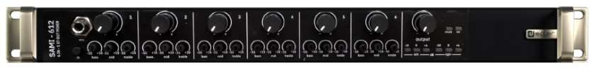  CSAMI612 | SAMI-612 | Installation audio mixer in standard rack format, featuring 6 MIC/LINE ST inputs + 1 ST MIX input and 1 stereo balanced output. Each input has a dedicated 3-band tone control and 18V phantom power for MIC inputs. Input 1 includes talkover (priority) function over the mix bus and additional front panel jack connector. Main output ST/MONO mode switch and MUTE port for external dry contact triggering. Dimensions 482.6x44(1RU)x120 mm. Weight 2,0 kg | 550,86 € | 699,60 € | 223 100 Ft | 283 337 Ft

NEW! | 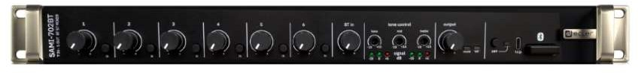  CSAMI702BT | SAMI-702BT | Installation audio mixer in standard rack format, featuring 6 MIC/LINE ST inputs, 1 BT input, 1 main mix balanced output and one AUX/REC additional output. It includes a 3 band tone control section, Talkover (priority) function assignable to each MIC/LINE input over the mix bus, 18V phantom available for all mic inputs, ST/MONO mix switch and MUTE port for external dry contact triggering. Dimensions  482.6 x 44(1RU) x 120 mm. Weight 1,8 kg | 600,99 € | 763,25 € | 243 400 Ft | 309 118 Ft

DIGITAL MATRIXES & PROCESSORS

DIGITAL MATRIXES
Ref.
Name
Nettó lista ár Bruttó lista Nettó lista ár Bruttó lista ár
EUR ár EUR HUF HUF

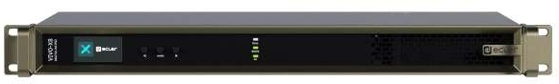  NEW! |   CVIVOX8 | VIVO-X8 | VIVO-X8 is an EclerPLEX Host with 8 analogue and 8 Dante™/AES67 audio input ports, 8 analogue and 8 Dante/AES67 audio output ports, scalable thanks to two X-link ports. A BIO-X8 expansion unit can be connected to each X-link port. VIVO-X8 as a Host in an EclerPLEX project, can contain multiple projects running simultaneously and serve user panels. | 2 607,65 € | 3 311,72 € | 1 056 100 Ft | 1 341 247 Ft

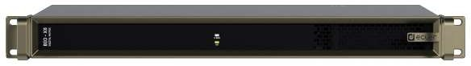  NEW! | CBIOX8 | BIO-X8 | BIO-X8 is an affordable expansion interface that can easily scale up an VIVO-X8 digital matrix, adding to its default size, 8 input and 8 output analogue audio ports, 8 GPI ports and 8 GPO ports. A maximum of 2 BIO-X8 units can be linked to the same VIVO-X8, reaching a maximum total of 24 analogue audio input ports, 24 analogue audio output ports, 24 GPIs and 24 GPOs control ports. | 1 303,46 € | 1 655,39 € | 527 900 Ft | 670 433 Ft
Ref.
Name
MIMO Series
Nettó lista ár Bruttó lista Nettó lista ár Bruttó lista ár
EUR ár EUR HUF HUF

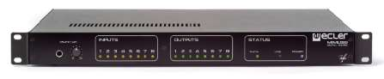  CMIMO88 MIMO88 8 balanced MIC/LINE inputs / 8 balanced outputs + 2 monitor outputs digital audio matrix, fully 2 784,20 €  programmable through EclerNet Manager and linkable to a second unit to become a 16x16 matrix. Includes 8 GPI and 8 GPO ports. DSP processing: Parametric EQ & filters for each channel, delays, compressor/limiter, paging, priority, automatic mix (MIMO Firmware) and remote control via UCP or WPNETTOUCH.Dimensions 482.6 x 44 x 266.5 mm. Weight 3.5 kg | 3 535,93 € | 1 127 600 Ft | 1 432 052 Ft

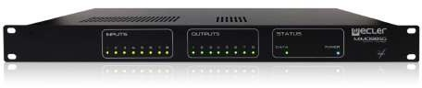  CMIMO88SG MIMO88SG 8 balanced MIC/LINE inputs / 8 balanced outputs digital audio matrix, fully programmable through 1 804,94 €  EclerNet Manager. Includes 8 GPI ports. DSP processing: Parametric EQ & filters for each channel, delays, compressor/limiter, paging, priority, automatic mix (MIMO Firmware) and remote control via UCP or WPNETTOUCH. Dimensions 482.6 x 44 x 266.5 mm. Weight 3.5 kg | 2 292,27 € | 731 000 Ft | 928 370 Ft

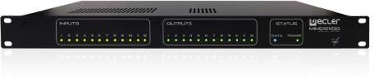  CMIMO1212SG MIMO1212SG 12 balanced MIC/LINE inputs / 12 balanced outputs digital audio matrix, fully programmable through 2 077,78 €  EclerNet Manager. Includes 12 GPI ports. DSP processing: Parametric EQ & filters for each channel, delays, compressor/limiter, paging, priority, automatic mix (MIMO Firmware) and remote control via UCP or WPNETTOUCH. Dimensions 1RU x 266,5mm depth. Weight 3,5 kg | 2 638,78 € | 841 500 Ft | 1 068 705 Ft

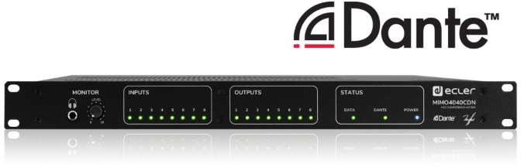  CMIMO4040CDN MIMO4040CDN Digital matrix with native processing of 40 inputs and 40 outputs (8 analogue inputs, 8 analogue 4 145,43 €  outputs, 32 Dante™ inputs and 32 Dante™ outputs). MIMO4040CDN comes with a CONFERENCE tailored firmware, including Automixer, Feedback Killer and Acoustic Echo Cancelling functions. It features accessories from WPNET Series connected by Ethernet. MIMO4040CDN is also capable of executing EclerNet projects thanks to its processor acting as a UCP server. Dimensions 482,6x44x266,5mm. Weight 3.25 kg | 5 264,70 € | 1 678 900 Ft | 2 132 203 Ft

CM40AEC2EXP M40AEC2EXP Expansion license +2 AEC processing channels for MIMO4040CDN 112,59 €  *up to 8 AEC channels max. available in MIMO4040CDN | 142,99 € | 45 600 Ft | 57 912 Ft

CM40AEC4EXP M40AEC4EXP Expansion license +4 AEC processing channels for MIMO4040CDN 225,93 €  *up to 8 AEC channels max. available in MIMO4040CDN | 286,93 € | 91 500 Ft | 116 205 Ft

CM40AEC6EXP M40AEC6EXP Expansion license +6 AEC processing channels for MIMO4040CDN 339,26 €  *up to 8 AEC channels max. available in MIMO4040CDN | 430,86 € | 137 400 Ft | 174 498 Ft

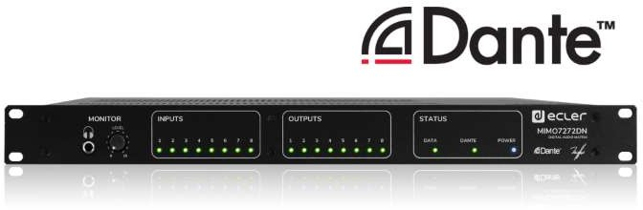  CMIMO7272DN MIMO7272DN 64x64 native processing digital matrix with 72 inputs and 72 outputs (8 analogue inputs, 8 analogue 4 145,43 €  outputs, 64 Dante™ inputs and 64 Dante™ outputs). Incorporating audio over IP technology, MIMO7272DN allows signal transmission using a Local Ethernet network. It features accessories from WPNET Series connected by Ethernet. MIMO7272DN is also capable of executing EclerNet projects thanks to its processor acting as a UCP server. Dimensions 482,6x44x266,5mm. Weight 3.25 kg | 5 264,70 € | 1 678 900 Ft | 2 132 203 Ft
Ref.
Name
Nettó lista ár Bruttó lista Nettó lista ár Bruttó lista ár
EUR ár EUR HUF HUF

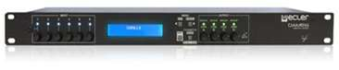  CDAM614C DAM614 Fully programmable audio digital mixer. It includes 6 audio inputs (2x LINE ST + 4x LINE/MIC being 949,14 €  possible to use them independently (mono) or as stereo-coupled inputs) and 4 audio outputs (can be used as mono or stereo zones). Phantom power, front panel inputs and outputs level controls, DSP processing, RS-232 connectivity (compatible with EclerCOMM/CA-NET) and 4 REMOTE control ports (0- 10VDC). Dimensions 482.6 x 44(1RU) x 120 mm. Weight 2.00 kg | 1 205,40 € | 384 400 Ft | 488 188 Ft
DIGITAL ZONERS
Ref.
Name
HUB Series
Nettó lista ár Bruttó lista Nettó lista ár Bruttó lista ár
EUR ár EUR HUF HUF

  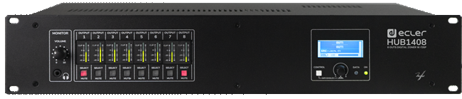  CHUB1408 HUB1408 HUB1408 is a digital audio zoner with a global size of 14 input and 8 output analogue channels. 1 226,17 €  Available inputs are 4 MIC/LINE and 2 ST LINE local inputs, and 8 REMOTE LINE inputs. Available DSP: frequency shifter, link stereo, delay, crossover filters, graphic EQ, compressor/limiter and much more. Ecler pilot application, compatible with Android and iOS: control graphic panels set to user requirements. HxWxD: 88 (2RU) x 482,6 x 200mm. Weight 3,7 kg | 1 557,24 € | 496 600 Ft | 630 682 Ft

  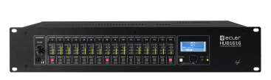  CHUB1616 HUB1616 HUB1616 is a digital audio zoner with a global size of 16 input and 16 output analogue channels. The 1 651,36 €  input channels are: 4 channels for MIC/MONO LINE, 4 channels for ST LINE and 8 channels for MONO LINE received on the unit’s REMOTE ports, from wall panels eMCONTROL1. Available DSP: frequency shifter, link stereo, delay, crossover filters, graphic EQ, compressor/limiter and much more. Ecler pilot application, compatible with Android and iOS: control graphic panels set to user requirements. HxWxD: 88 (2RU) x 482,6 x 200mm. Weight 3,7 kg | 2 097,22 € | 668 800 Ft | 849 376 Ft

DANTE INTERFACES
Ref.
Name
Nettó lista ár Bruttó lista Nettó lista ár Bruttó lista ár
EUR ár EUR HUF HUF

NEW! | 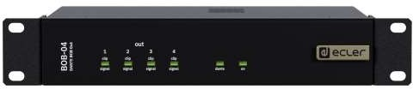  CBOB04 | BOB-04 | 4 LINE outputs Dante™ Break Out Box. It allows taking up to 4 Dante™ channels from the Ethernet network and converting them to 4 analogue audio LINE level signals. PoE (Power over Ethernet) DC supply directly from PoE ready Ethernet switches (external AC power supply available as an optional accessory). | 500,74 € | 635,94 € | 202 800 Ft | 257 556 Ft

NEW! | 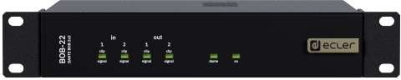  CBOB22 | BOB-22 | 2x MIC/LINE inputs and 2 LINE outputs Dante Break Out Box. It allows taking up to 2 Dante™ channels from the Ethernet network and converting them to 2 analogue audio  LINE level signals. It also allows taking up to 2 MIC/LINE analogue audio signals, convert them to 2 Dante™ channels and sent them to the Ethernet network. PoE (Power over Ethernet) DC supply directly from PoE ready Ethernet switches (external AC power supply available as an optional accessory). | 600,99 € | 763,25 € | 243 400 Ft | 309 118 Ft

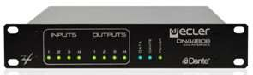  CDN44BOBC DN44BOB 4 inputs/4 outputs DANTE (Audio Over IP) Break Out Box. It allows to convert 4 analogue audio signals 1 228,15 €  into 4 DANTE channels and send them into an Ethernet LAN, as well as to take 4 DANTE channels from the Ethernet network and convert them to analogue audio signals. It includes 4 GPI (0-10VDC) and 4 GPO control ports (NO/NC relays). Can be used together with EclerNet DANTE ready products or as a stand-alone DANTE interface. PUM3 included: rack-mount accessory to mount 2 halfwidth RU devices in 1 standard width RU space.  Dimensions 241 x 44(1RU) x 152 mm. Weight 1.1 kg | 1 559,75 € | 497 400 Ft | 631 698 Ft
LOUDSPEAKERS PROCESSORS
Ref.
Name
ALMA SERIES
Nettó lista ár Bruttó lista Nettó lista ár Bruttó lista ár
EUR ár EUR HUF HUF

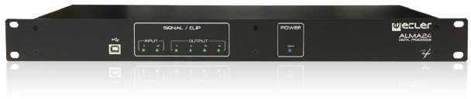  CALMA24 ALMA24 Digital loudspeaker manager including 2 audio inputs and 4 audio outputs (all balanced), USB interface 646,17 €  and 2 volume remote control ports (0-10VDC). Includes DSP processor 24bits/48kHz, parametric EQ, 3 crossover types, 20 user presets and password protection.  ALMA24 is a 1RU stand-alone processor and EclerCOMM Manager compatibility. Dimensions 482.6 x 44 x 120 mm. Weight 1.75 kg | 820,64 € | 261 700 Ft | 332 359 Ft

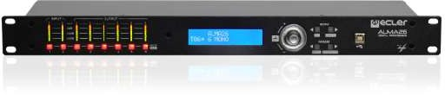  CALMA26 ALMA26 Digital loudspeaker manager including 2 audio inputs and 6 audio outputs (all balanced), USB interface 881,98 €  and 2 volume remote control ports (0-10VDC). Includes DSP processor 24bits/48kHz, parametric EQ, 3 crossover types, 20 user presets and password protection.  ALMA24 is a 1RU stand-alone processor and EclerCOMM Manager compatibility. Dimensions 482.6 x 44 x 120 mm. Peso 1.75 kg | 1 120,11 € | 357 200 Ft | 453 644 Ft

AMPLIFIERS
NETWORKABLE AMPLIFIERS
Ref. Name VIDA SERIES | Nettó lista ár EUR | Bruttó lista ár EUR | Nettó lista ár HUF | Bruttó lista ár HUF

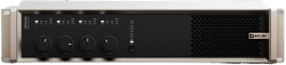  CVIDA16Q VIDA-16Q 1600W digital amplifier, with 4 amplified outputs that can be independently configured in high 2 720,00 €  (100/70V) or low (8/4/2ohm) impedance. The VersaPower technology, developed by Ecler, allows an asymmetrical power distribution. Max output power @ 2Ω/4Ω/8Ω or @70/100V - Single channel is 1600W. Audio player - with microSD slot for local audio files – as well as signal generator, plus 2 auxiliary line outputs and 4 Dante digital outputs. Internal matrix and signal processing. Remote control user application for iOS/Android/Web. Control and scheduled events for automation. Ultra low power consumption mode. Dimensions 482,6x88(2RU)x410 mm / 19"x3.46"x16.14". Weight 9,3 kg. /  20.5 lb. | 3 454,40 € | 1 101 600 Ft | 1 399 032 Ft

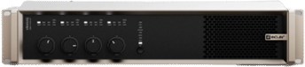  CVIDA24Q VIDA-24Q 2400W digital amplifier, with 4 amplified outputs that can be independently configured in high 3 081,98 €  (100/70V) or low (8/4/2ohm) impedance. Max output power @ 2Ω/4Ω/8Ω or @70/100V – 4x600W /4 Ω symetrical power distribution. The VersaPower technology, developed by Ecler, allows an asymmetrical power distribution with a max output power @ 4Ω or 100V – into one single channel 2400W. Audio player - with microSD slot for local audio files – as well as signal generator, plus 2 auxiliary line outputs and 4 Dante digital outputs. Internal matrix and signal processing. Remote control user application for iOS/Android/Web. Control and scheduled events for automation. Ultra low power consumption mode. Dimensions 482,6x88(2RU)x410 mm / 19"x3.46"x16.14". Weight 9,3 kg. /  20.5 lb. | 3 914,11 € | 1 248 200 Ft | 1 585 214 Ft

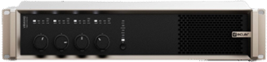  CVIDA48Q VIDA-48Q 4800W digital amplifier, with 4 amplified outputs that can be independently configured in high 3 697,04 €  (100/70V) or low (8/4/2ohm) impedance. The VersaPower technology, developed by Ecler, allows an asymmetrical power distribution. Max output power @ 2Ω/4Ω/8Ω or @70/100V - Single channel is 2600W. Audio player - with microSD slot for local audio files – as well as signal generator, plus 2 auxiliary line outputs and 4 Dante digital outputs. Internal matrix and signal processing. Remote control user application for iOS/Android/Web. Control and scheduled events for automation. Ultra low power consumption mode. Dimensions 482,6x88(2RU)x410 mm / 19"x3.46"x16.14". Weight 9,3 kg. /  20.5 lb. | 4 695,24 € | 1 497 300 Ft | 1 901 571 Ft
Ref.
Name
HALO SERIES
Nettó lista ár Bruttó lista Nettó lista ár Bruttó lista ár
EUR ár EUR HUF HUF

NEW! | 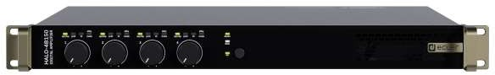  CHALO2B300 | HALO-2B300 | 2x300W amplifier, with 2 powered outputs usable as Low and High Impedance. Bridge between outputs should be used in High impedance or to double the power in Low Impedance. The built-in web interface (similar to VIDA Series) allows easy programming and control of basic or advanced functions, thanks to different access levels. All models include a single Ethernet interface for setup, control and Dante™/AES67 protocol. Flexible end user control through customizable user panels, accessible via web GUI or mobile application. | TBC | TBC | TBC | TBC

NEW! | CHALO4B150 | HALO-4B150 | 4x150W amplifier, with 2 powered outputs usable as Low and High Impedance. Bridge between outputs should be used in High impedance or to double the power in Low Impedance. The built-in web interface (similar to VIDA Series) allows easy programming and control of basic or advanced functions, thanks to different access levels. All models include a single Ethernet interface for setup, control and Dante™/AES67 protocol. Flexible end user control through customizable user panels, accessible via web GUI or mobile application. | TBC | TBC | TBC | TBC

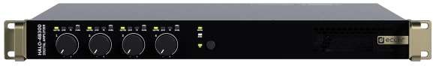  NEW! | CHALO4B300 | HALO-4B300 | 4x300W amplifier, with 2 powered outputs usable as Low and High Impedance. Bridge between outputs should be used in High impedance or to double the power in Low Impedance. The built-in web interface (similar to VIDA Series) allows easy programming and control of basic or advanced functions, thanks to different access levels. All models include a single Ethernet interface for setup, control and Dante™/AES67 protocol. Flexible end user control through customizable user panels, accessible via web GUI or mobile application. | TBC | TBC | TBC | TBC
Ref.
Name
HADA SERIES
Nettó lista ár Bruttó lista Nettó lista ár Bruttó lista ár
EUR ár EUR HUF HUF

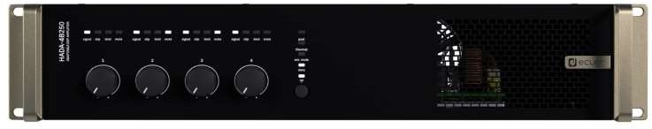  CHADA4B150 HADA-4B150 HADA-4B150 is a 4x125W digital amplifier that supports low and high impedance loads. The internal 1 264,20 €  DSP, through the HADA DSP Manager software, allows tailoring the input and output signal through parametric EQs, multi-band compressors, limiters, and delays and each configuration can be saved as a preset.. Dimensions 482.6 x 88 x 281,5 mm / 19 x 3.46 x 11.08 in. Weight 4.7 Kg / 10.36 lbs | 1 605,53 € | 512 000 Ft | 650 240 Ft

CHADA4B250 HADA-4B250 HADA-4B250 is a 4x250W digital amplifier that supports low and high impedance loads. The internal 1 366,67 €  DSP, through the HADA DSP Manager software, allows tailoring the input and output signal through parametric EQs, multi-band compressors, limiters, and delays and each configuration can be saved as a preset.. Dimensions 482.6 x 88 x 281,5 mm / 19 x 3.46 x 11.08 in. Weight 5.0 Kg / 11.02 lb | 1 735,67 € | 553 500 Ft | 702 945 Ft

CHADA4B400 HADA-4B400 HADA-4B400 is a 4x400W digital amplifier that supports low and high impedance loads. The internal 1 489,88 €  DSP, through the HADA DSP Manager software, allows tailoring the input and output signal through parametric EQs, multi-band compressors, limiters, and delays and each configuration can be saved as a preset.. Dimensions 482.6 x 88 x 281,5 mm / 19 x 3.46 x 11.08 in. Weight 5.4 Kg / 11.91 lb | 1 892,14 € | 603 400 Ft | 766 318 Ft

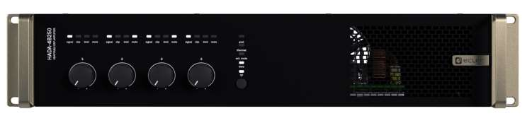  CHADA4B500 HADA-4B500 HADA-4B500 is a 4x500W digital amplifier that supports low and high impedance loads. The internal 1 593,33 €  DSP, through the HADA DSP Manager software, allows tailoring the input and output signal through parametric EQs, multi-band compressors, limiters, and delays and each configuration can be saved as a preset.. Dimensions 482.6 x 88 x 281,5 mm / 19 x 3.46 x 11.08 in. 5.6 Kg / 12.35 lb | 2 023,53 € | 645 300 Ft | 819 531 Ft

CHADA4B750 HADA-4B750 HADA-4B750 is a 4x750W digital amplifier that supports low and high impedance loads. The internal 1 952,35 €  DSP, through the HADA DSP Manager software, allows tailoring the input and output signal through parametric EQs, multi-band compressors, limiters, and delays and each configuration can be saved as a preset.. Dimensions 482.6 x 88 x 281,5 mm / 19 x 3.46 x 11.08 in. Weight 6.0 Kg / 13.22 lb | 2 479,48 € | 790 700 Ft | 1 004 189 Ft
Ref.
Name
NXA SERIES
Nettó lista ár Bruttó lista Nettó lista ár Bruttó lista ár
EUR ár EUR HUF HUF

EOL | 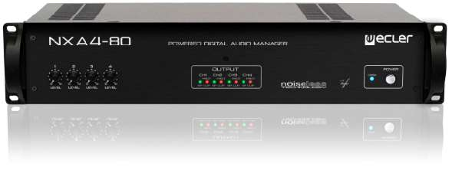  CNXA480 | NXA 4-80 | 4 in/4 out self-powered digital manager that stays halfway between a digital matrix and a class D multichannel amplifier (4 x 85W @ 4Ω RMS). Includes a powerful DSP processor, auto stand-by function, convection cooling, health self-test mode function and 4 GPI ports. Compatible with EclerNet Manager platform and UCP remote control system. Dimensions 482.6 x 88 x 373 mm. Weight 9.2 kg | 1 597,28 € | 2 028,55 € | 646 900 Ft | 821 563 Ft

EOL | 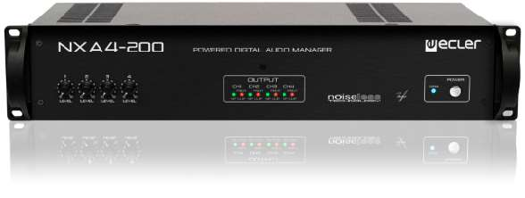  CNXA4200 | NXA 4-200 | 4 in /4 out self-powered digital manager that stays halfway between a digital matrix and a class D multichannel amplifier (4 x 202W @ 4Ω RMS). Includes a powerful DSP processor, auto stand-by function, convection cooling, health self-test mode function and 4 GPI ports. Compatible with EclerNet Manager platform and UCP remote control system. Dimensions 482.6 x 88(2RU) x 373 mm. Weight  12.6 kg | 2 224,44 € | 2 825,04 € | 900 900 Ft | 1 144 143 Ft

EOL | 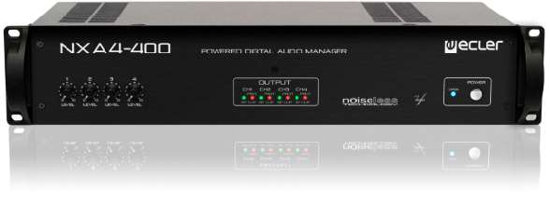  CNXA4400 | NXA 4-400 | 4 in /4 out self-powered digital manager that stays halfway between a digital matrix and a class D multichannel amplifier (4 x 416W @ 4Ω RMS). Includes a powerful DSP processor, auto stand-by function, convection cooling, health self-test mode function and 4 GPI ports. Compatible with EclerNet Manager platform and UCP remote control system. Dimensions 482. 6x 88(2RU) x 373 mm. Weight  16.0 kg | 3 086,17 € | 3 919,44 € | 1 249 900 Ft | 1 587 373 Ft

COMMERCIAL AMPLIFIERS
Ref.
Name
AURA SERIES
Nettó lista ár Bruttó lista Nettó lista ár Bruttó lista ár
EUR ár EUR HUF HUF

CAURA2H150 AURA-2H150 Stereo amplifier with 2 x 150 WRMS @ 70/100V (high impedance) powered outputs. Iincludes the 770,62 €  option to link channels to the first input via a rear panel selector, as well as auto stand-by, overload and thermal protection, PFC, and an anti-clipping system. The front panel volume knobs can be locked using rear panel switches. Dimensions 440 x 44(1RU) x 221mm. Weight 6.05 kg | 978,68 € | 312 100 Ft | 396 367 Ft

CAURA4H150 AURA-4H150 Multichannel amplifier with 4 x 150 WRMS @ 70/100V (high impedance) powered outputs. Includes 1 129,88 €  the option to link channels to the first input via a rear panel selector, as well as auto stand-by, overload and thermal protection, PFC, and an anti-clipping system. The front panel volume knobs can be locked using rear panel switches. Dimensions 440 x 44(1RU) x 341mm. Weight 10.5 kg | 1 434,94 € | 457 600 Ft | 581 152 Ft

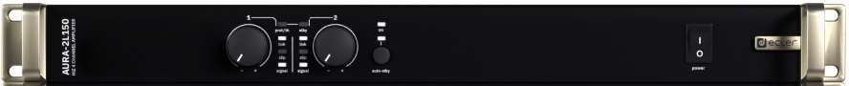  CAURA2L150 AURA-2L150 Stereo 2x150 WRMS @ 4 Ω, high efficiency amplifier. Includes the option to link channels to the first 564,94 €  input via a rear panel selector, as well as auto stand-by, overload and thermal protection, PFC, and an anti-clipping system. The front panel volume knobs can be locked using rear panel switches.  Dimensions 440 x 44(1RU) x 161 mm. Weight 2.60 kg | 717,47 € | 228 800 Ft | 290 576 Ft

CAURA4L150 AURA-4L150 4x150 WRMS @ 4 Ω, high efficiency multichannel amplifier. Includes the option to link channels to the 821,73 €  first input via a rear panel selector, as well as auto stand-by, overload and thermal protection, PFC, and an anti-clipping system. The front panel volume knobs can be locked using rear panel switches.  Dimensions 482.6 x 44(1RU) x 221 mm. Weight 3.60 kg | 1 043,60 € | 332 800 Ft | 422 656 Ft

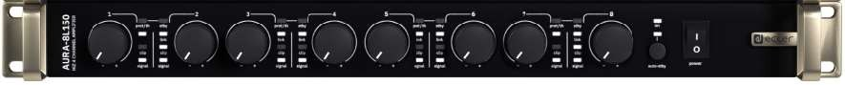  CAURA8L150 AURA-8L150 8x150 WRMS @ 4 Ω, high efficiency multichannel amplifier. Includes the option to link channels to the 1 540,99 €  first input via a rear panel selector, as well as auto stand-by, overload and thermal protection, PFC, and an anti-clipping system. The front panel volume knobs can be locked using rear panel switches.  Dimensions 482.6 x 44(1RU) x 341 mm. Weight 6 kg | 1 957,05 € | 624 100 Ft | 792 607 Ft

NEW! | 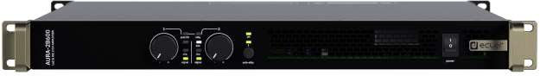  CAURA2B600 | AURA-2B600 | 2x600WRMS @ 4Ω offering compatibility with both LoZ (2/4/8Ω) and HiZ (70/100V) configurations and supporting dual or bridge mode (@4/8Ω). AURA Series also includes the option to link channels to the first input via a rear panel selector, as well as auto stand-by, overload and thermal protection, PFC, and an anti-clipping system. The front panel volume knobs can be locked using rear panel switches. | 801,73 € | 1 018,20 € | 324 700 Ft | 412 369 Ft

NEW! | 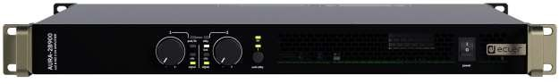  CAURA2B900 | AURA-2B900 | 2x900WRMS @ 4Ω offering compatibility with both LoZ (2/4/8Ω) and HiZ (70/100V) configurations and supporting dual or bridge mode (@4/8Ω). AURA Series also includes the option to link channels to the first input via a rear panel selector, as well as auto stand-by, overload and thermal protection, PFC, and an anti-clipping system. The front panel volume knobs can be locked using rear panel switches. | 1 002,47 € | 1 273,14 € | 406 000 Ft | 515 620 Ft

NEW! | CAURA4B600 | AURA-4B600 | 4x600WRMS @ 4Ω offering compatibility with both LoZ (2/4/8Ω) and HiZ (70/100V) configurations and supporting dual or bridge mode (@4/8Ω). AURA Series also includes the option to link channels to the first input via a rear panel selector, as well as auto stand-by, overload and thermal protection, PFC, and an anti-clipping system. The front panel volume knobs can be locked using rear panel switches. | 1 303,46 € | 1 655,39 € | 527 900 Ft | 670 433 Ft

NEW! | CAURA4B900 | AURA-4B900 | 4x900WRMS @ 4Ω offering compatibility with both LoZ (2/4/8Ω) and HiZ (70/100V) configurations and supporting dual or bridge mode (@4/8Ω). AURA Series also includes the option to link channels to the first input via a rear panel selector, as well as auto stand-by, overload and thermal protection, PFC, and an anti-clipping system. The front panel volume knobs can be locked using rear panel switches. | 1 554,07 € | 1 973,67 € | 629 400 Ft | 799 338 Ft
Ref.
Name
eLPA SERIES
Nettó lista ár Bruttó lista Nettó lista ár Bruttó lista ár
EUR ár EUR HUF HUF

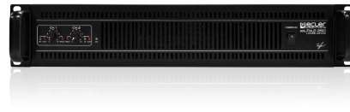  CELPA2350 eLPA2-350 Stereo amplifier delivering 2 x 345 WRMS @ 4Ω. Have 2 XLR balanced inputs, 2 Speakon® and terminal 662,22 €  type connection outputs. Ultra light and versatile format. Built in crossover (150Hz), permanently activated anti-clip circuit and efficient progressive ventilation system.2 Bridged Channels @ 8 Ω 560 WRMS. Dimensions 482.6 x 88(2RU) x 266 mm. Weight 5.50 kg | 841,02 € | 268 200 Ft | 340 614 Ft

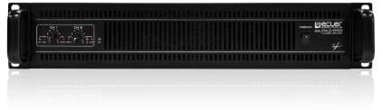  CELPA2650 eLPA2-650 Stereo amplifier delivering 2 x 630 WRMS @ 4Ω. Have 2 XLR balanced inputs, 2 Speakon® and terminal 849,88 €  type connection outputs. Ultra light and versatile format. Permanently activated anti-clip circuit and efficient progressive ventilation system. 2 Bridged Channels @ 8 Ω 1220 WRMS. Dimensions 482.6 x 88(2RU) x 266 mm / 6.00kg | 1 079,34 € | 344 200 Ft | 437 134 Ft

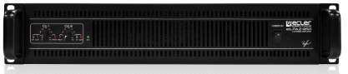  CELPA2950 eLPA2-950 Stereo amplifier delivering 2 x 950 WRMS @ 4Ω. Have 2 XLR balanced inputs, 2 Speakon® and terminal 999,26 €  type connection outputs. Ultra light and versatile format. Permanently activated anti-clip circuit and efficient progressive ventilation system. 2 Bridged Channels @ 8 Ω 1840 WRMS. Dimensions 482,6 x 88(2RU)x 266 mm. Weight 6,15 kg | 1 269,06 € | 404 700 Ft | 513 969 Ft

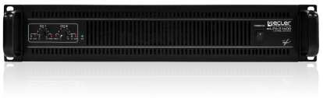  CELPA21400 eLPA2-1400 Stereo amplifier delivering 2 x 1400 WRMS @ 4Ω. Have 2 XLR balanced inputs, 2 Speakon® and 1 129,88 €  terminal type connection outputs. Ultra light and versatile format. Permanently activated anti-clip circuit and efficient progressive ventilation system. 2 Bridged Channels @ 8 Ω 2600 WRMS. Dimensions 482,6 x 88(2RU) x 304 mm. Weight 6,35 kg | 1 434,94 € | 457 600 Ft | 581 152 Ft
Ref.
Name
eGPA SERIES
Nettó lista ár Bruttó lista Nettó lista ár Bruttó lista ár
EUR ár EUR HUF HUF

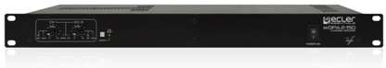  CEGPA2300 eGPA2-300 Stereo, 2x310 WRMS @ 4 Ω, high efficiency stereo amplifier (class D). Auto stand-by function, fanless 718,52 €  design 100% silent. 2 Bridged Channels @ 8Ω 600 WRMS. Dimensions 440 x 44(1RU) x 221 mm. Weight  3.40 kg | 912,52 € | 291 000 Ft | 369 570 Ft

Ref.
Name
GPA SERIES
Nettó lista ár Bruttó lista Nettó lista ár Bruttó lista ár
EUR ár EUR HUF HUF

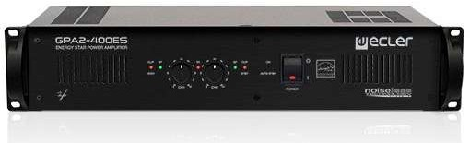  CGPA2400ES GPA2-400ES Stereo amplifier delivering 2 x 350 WRMS @ 4 Ω. True green profile: high efficiency, auto stand-by 976,30 €  function, 100% silent fanless design, Energy Star certified. 2 remote volume control ports and bridge mode 2 channels @ 8Ω 700 WRMS. Dimensions 482.6 x 88(2RU) x 373 mm. Weight 10.8 kg | 1 239,90 € | 395 400 Ft | 502 158 Ft

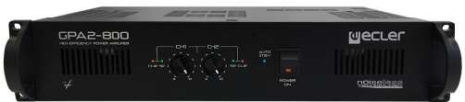  CGPA2800 GPA2-800 Stereo amplifier delivering 2 x 720 WRMS @ 4 Ω, and ready to drive 1000 WRMS @ 2Ω loudspeaker 1 335,56 €  loads (4 x 8 Ω loudspeakers in parallel, per channel). True green profile: high efficiency, auto stand-by function, 100% silent fanless design. 2 remote volume control ports and bridge mode 2 Channels @ 8Ω 1150 WRMS. Dimensions 482.6 x 88(2RU) x 373 mm. Weight 10.8 kg | 1 696,16 € | 540 900 Ft | 686 943 Ft
Ref.
Name
eHSA SERIES
Nettó lista ár Bruttó lista Nettó lista ár Bruttó lista ár
EUR ár EUR HUF HUF

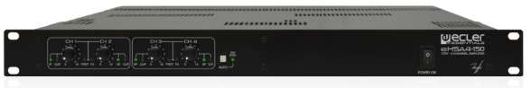  CEHSA460 eHSA4-60 Multichannel amplifier Class D with 4x60 WRMS @ 70/100V (high impedance) powered outputs, and 770,62 €  low impedance output. Its noiseless convection cooling, and its auto stand-by function provide this amplifier with a true green profile. Include link channel buttons, that allows to replicate the input channel signal in the adjacent one. Dimensions 482,6 x 44(1RU) x 280mm. Weight 7,8 kg | 978,68 € | 312 100 Ft | 396 367 Ft

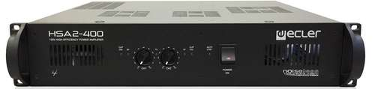  CHSA2400ES HSA2-400ES Stereo amplifier with low and high impedance powered outputs (2x400 WRMS). Includes 2 balanced 1 243,21 €  inputs (XLR and Euroblock), 2 remote volume ports and Euroblock outputs. True green profile( Energy Star® Certification): auto stand-by function and noiseless convection cooling. Dimensions 482.6 x 88(2RU) x 373 mm. Weight 16.4 kg | 1 578,88 € | 503 500 Ft | 639 445 Ft
MIXING AMPLIFIERS
Ref.
Name
eHMA SERIES
Nettó lista ár Bruttó lista Nettó lista ár Bruttó lista ár
EUR ár EUR HUF HUF

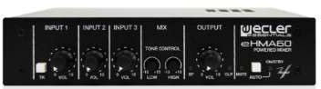  CEHMA60C eHMA60 Self-powered audio mixer including 1 MIC input and two MIC/LINE ST inputs. It features a 60W 369,38 €  powered output that supports both low (4 Ω) and high impedance (70/100V) loudspeaker lines. It also includes an audio priority system, phantom power, 2 band tone control, auto stand-by mode, MUTE port and universal power supply unit (24 VDC IN).Dimensions 200x44x150 mm. Weight 1.9kg.  1UHRMKIT Rack Mount Kit included. | 469,12 € | 149 600 Ft | 189 992 Ft

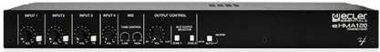  CEHMA120C eHMA120 Stereo, Self-powered audio mixer including 3x MIC/LINE ST and 1x LINE ST input. It features a 95W 545,93 €  powered mono output that supports both low (4Ω) and high impedance (70/100V) loudspeaker lines, with 2-ZONE ON/OFF switches. Includes audio priority system, pager (1 zone), phantom, 2 band tone control, auto stand-by, MUTE port and universal power supply unit (compatible with 24 VDC IN).  Dimensions 435x44x120 mm. Weight 2.9kg 1UHRMKIT Rack Mount Kit included | 693,33 € | 221 100 Ft | 280 797 Ft

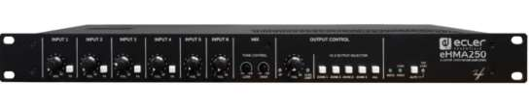  CEHMA250 eHMA250 Self-powered audio mixer including 2 MIC, 2 MIC/LINE ST and 2 LINE ST inputs. It features a 250W 856,79 €  powered mono output that supports both low (4 and 8Ω) and high impedance (50/70/100V) loudspeaker lines, with 4-ZONE ON/OFF switches. Includes an audio priority system, Pager (1 zone), phantom power, remote control port (WPm), AUX/REC output, 2 band tone control, auto stand-by mode and MUTE port. Dimensions 435x220x44mm / 17,1”x8,7”x1,7”mm. Weight 3kg / 6.6lb. | 1 088,12 € | 347 000 Ft | 440 690 Ft
Ref. Name HMA SERIES RRP € RRP € RRP € RRP €

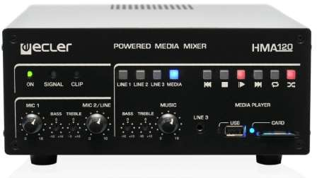  CHMA120 HMA120 Self-powered mixer including an integrated media player (USB,SD) and 5 external audio inputs: 3 x LINE 646,17 €  ST, 1 MIC/LINE and 1 MIC. It features a 120W powered output that supports both low (4Ω) and high impedance (70/100V) loudspeaker lines. It also includes a 2 level priority system, auto stand-by mode, 2 band control tone, AUX OUT and a remote control port WPm series compatible. Dimensions 210 x 88 x 230 mm. Weight 5.95 kg Compatible with the 2UHRMKIT Rack Mount Kit. | 820,64 € | 261 700 Ft | 332 359 Ft
ULTRA COMPACT AMPLIFIERS
Ref.
Name
CA SERIES
Nettó lista ár Bruttó lista Nettó lista ár Bruttó lista ár
EUR ár EUR HUF HUF

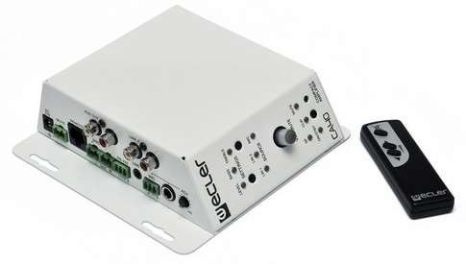  CCA40 CA40 2 x 20 WRMS @ 4Ω stereo compact amplifier with a balanced MIC input (includes phantom power, 352,35 €  Talkover and noise gate) and 2 LINE inputs. 3 output modes (STEREO, PARALLEL and BRIDGE) and AUX output. 2 band control tone, IR remote control included, serial RS-232 port (EclerCOMM and CA-NET compatible) and 0-10 VDC remote port for WPm wall panel series (volume and source selection). Auto- standby function and MUTE port. Dimensions 155 x 155 x 45 mm. Weight 0.65 kg | 447,48 € | 142 700 Ft | 181 229 Ft

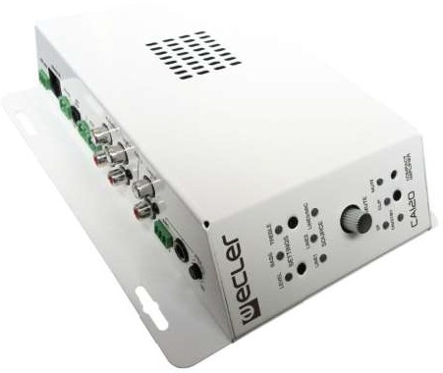  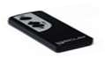  CCA120C CA120 2 x 60 WRMS @ 4Ω stereo compact amplifier with a MIC/LINE input (includes phantom power, 516,79 €  Talkover and noise gate) and 2 LINE inputs. AUX output. Control features: 2 band control tone, IR remote control included, serial RS-232 port (EclerCOMM and CA-NET compatible) and 0-10 VDC remote port for WPm wall panel series (volume and source selection). Auto-standby function and MUTE port. Dimensions 160 x 210 x 48 mm. Weight 0.95 kg | 656,32 € | 209 300 Ft | 265 811 Ft

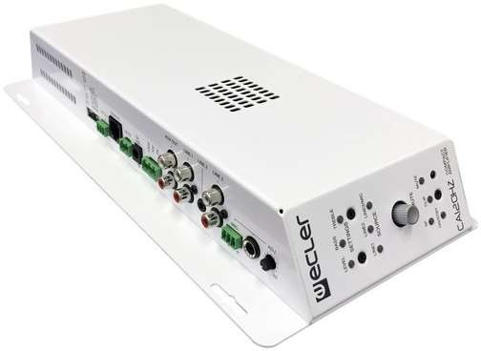  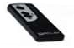  CCA120HZC CA120HZ High impedance version of the CA120, delivering 120W @ 70/100V line level, with a MIC/LINE input 557,04 €  (includes phantom power, Talkover and noise gate) and 2 LINE inputs. AUX output. Control features: 2 band control tone, IR remote control included, serial RS-232 port (EclerCOMM and CA-NET compatible) and 0-10 VDC remote port for WPm wall panel series (volume and source selection). Auto-standby function and MUTE port. Dimensions 160 x 325 x 48 mm. Weight 2.92 kg | 707,44 € | 225 600 Ft | 286 512 Ft

Ref.
Name
eCA SERIES
Nettó lista ár Bruttó lista Nettó lista ár Bruttó lista ár
EUR ár EUR HUF HUF
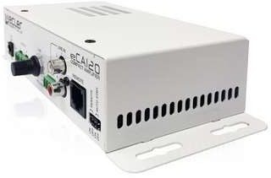  CECA120C eCA120 2 x 60 WRMS @ 4 Ω stereo micro-amplifier, in a very compact format and a light and silent (fanless) 418,52 €  design. It features 1 LINE ST input (RCA/Euroblock), AUTO STANDBY function and volume remote control, compatible with Ecler WPmVOL and WPmVOL-SR wall panels (0-10 VDC). Auto-standby function. External, universal and CE/UL/CCC certified power supply. Dimensions: 190 x 48 x 90mm. Weight 600 g. | 531,52 € | 169 500 Ft | 215 265 Ft

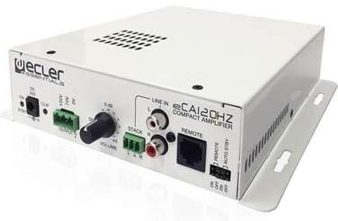  CECA120HZC eCA120HZ Mono micro-amplifier delivering 1 x 120 WRMS @ 70V / 100 V line level (high impedance), built in a 473,58 €  very compact format and a light and silent (fanless) design. It features 1 LINE ST input (RCA/Euroblock), AUTO STANDBY function and volume remote control, compatible with WPmVOL and WPmVOL-SR wall panels (0-10 VDC). Auto-standby function.  External, universal and CE/UL/CCC certified power supply. Dimensions: 190 x 48 x 190mm. Weight 2.3 kg | 601,45 € | 191 800 Ft | 243 586 Ft

LOUDSPEAKERS
IN-CEILING LOUDSPEAKERS
Ref. Name | Nettó lista ár EUR | Bruttó lista ár EUR | Nettó lista ár HUF | Bruttó lista ár HUF

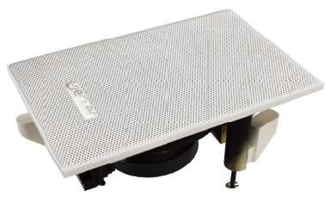  CIW103 IW103 3" in-ceiling / in-wall installation loudspeaker featuring a rectangular and discreet design, and including 81,48 €  a high impedance transformer unit with 15 and 30 W power selections @ 100V line level. Dimensions 110 x 165 x 80 mm. Weight 900g. Delivered by master carton of 8 units. Price per unit. | 103,48 € | 33 000 Ft | 41 910 Ft
Ref.
Name
eIC SERIES
Nettó lista ár Bruttó lista Nettó lista ár Bruttó lista ár
EUR ár EUR HUF HUF

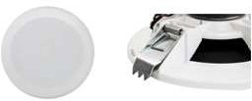  CEIC51FM eIC51FM Fast installation in-ceiling loudspeaker. It features a 4,5" woofer, 6 WRMS @ 8 Ω nominal power and 23,21 €  70/100V line transformer with 3 and 6 W power selections. Internal diameter 150 mm. External diameter 160mm. Required depth 54mm. Weight 500g. Price per unit. | 29,48 € | 9 400 Ft | 11 938 Ft

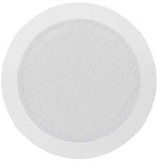  CEIC52 eIC52 2-way cost-effective in-ceiling loudspeaker with a great sound performance. It features a 5,25" woofer 43,21 €  and a 0,75" tweeter, 20 WRMS @ 8 Ω nominal power and 100V line transformer with 3 and 6 W power selections. Internal diameter 164mm. External diameter 202mm. Required depth: 65mm. Weight 1.0 kg Delivered by master carton of 8 units. Price per unit. | 54,88 € | 17 500 Ft | 22 225 Ft

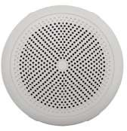  CEIC52MS eIC52MS 2-way in-ceiling loudspeaker suitable for installations exposed to extreme humidity and/or 64,44 €  temperature. It features 1x5" woofer and 1x1" tweeter with a global power admission of 20 WRMS @ 8Ω. Internal diameter 120mm. External diameter 165mm. Required depth 79mm. Weight 700g.  Delivered by units. Price per unit. | 81,84 € | 26 100 Ft | 33 147 Ft
Ref.
Name
IC SERIES
Nettó lista ár Bruttó lista Nettó lista ár Bruttó lista ár
EUR ár EUR HUF HUF

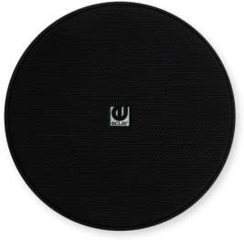  CIC3BK IC3 1-way loudspeaker is the perfect option for 70/100 V (0.75/1.5/3/6 W) and low impedance sound 50,37 €  solutions. It mounts a 3” woofer in a discreet design. Cutout size 90mm. Internal diameter 88mm. External diameter 105mm. Required depth 90mm. Weight 500g. Black colour. Delivered by master carton of 2 units. Price per unit. | 63,97 € | 20 400 Ft | 25 908 Ft

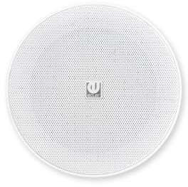  CIC3WH IC3 1-way loudspeaker is the perfect option for 70/100 V (0.75/1.5/3/6 W) and low impedance sound 50,37 €  solutions. It mounts a 3” woofer in a discreet design. Cutout size 90mm. Internal diameter 88mm. External diameter 105mm. Required depth 90mm. White colour. Weight 500g. Delivered by master carton of 2 units. Price per unit. | 63,97 € | 20 400 Ft | 25 908 Ft

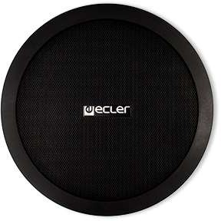  CIC6BK IC6BK 2-way loudspeaker is the perfect option for 70/100 V (2.5/5/7.5/15 W) and low impedance sound 69,38 €  solutions (40 WRMS @8Ω). It mounts a 6” woofer and a 1" tweeter in a discreet design. Cutout size 180mm. Internal diameter 178mm. External diameter 204mm. Required depth 73mm. Weight 1,52kg Delivered by master carton of 2 units. Price per unit. Black colour. | 88,12 € | 28 100 Ft | 35 687 Ft

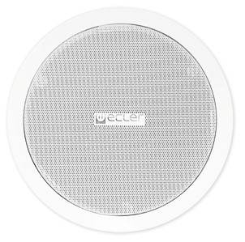  CIC6 IC6 2-way loudspeaker is the perfect option for 70/100 V (2.5/5/7.5/15 W) and low impedance sound 69,38 €  solutions (40 WRMS @8Ω). It mounts a 6” woofer and a 1" tweeter in a discreet design. Cutout size 180mm. Internal diameter 178mm. External diameter 204mm. Required depth 73mm. Weight 1,52kg Delivered by master carton of 2 units. Price per unit. White colour. | 88,12 € | 28 100 Ft | 35 687 Ft

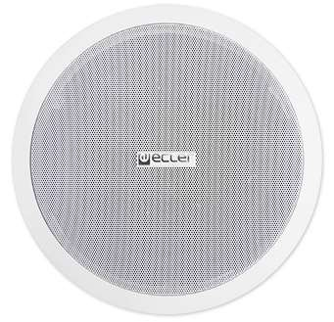  CIC8 IC8 2-way loudspeaker is the perfect option for 70/100 V (5/7.5/15/30 W) and low impedance sound 97,53 €  solutions (60 WRMS @8Ω). It mounts an 8” woofer and a 1" tweeter in a discreet design. Cutout size 222mm. Internal diameter 220mm. External diameter 245mm. Required depth 91mm. Weight 2,3kg Delivered by master carton of 2 units. Price per unit. White colour. | 123,86 € | 39 500 Ft | 50 165 Ft

NEW! | CIC6IBK  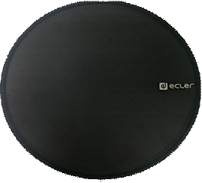 | IC6i | 2-way loudspeaker is the perfect option for 70/100 V (2.5/5/7.5/15 W) and low impedance sound solutions (40 WRMS @8Ω). It mounts a 6” woofer and a 1" tweeter in a discreet design. Cutout size 180mm. Internal diameter 178mm. External diameter 204mm. Required depth 73mm. Magnetic Grille. Weight 1,52kg Delivered by master carton of 2 units. Price per unit. Black colour. | 69,38 € | 88,12 € | 28 100 Ft | 35 687 Ft

NEW! | CIC6IWH  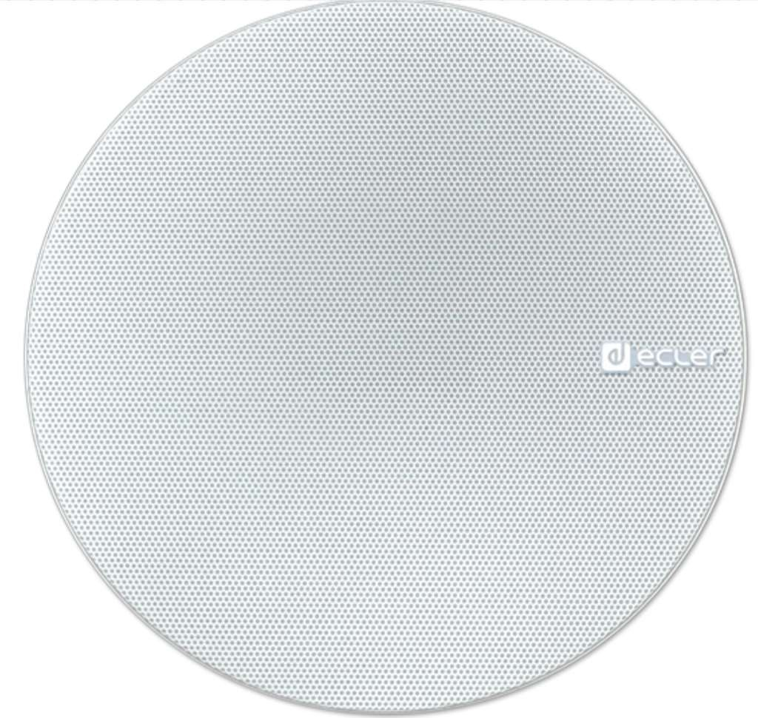 | IC6i | 2-way loudspeaker is the perfect option for 70/100 V (2.5/5/7.5/15 W) and low impedance sound solutions (40 WRMS @8Ω). It mounts a 6” woofer and a 1" tweeter in a discreet design. Cutout size 180mm. Internal diameter 178mm. External diameter 204mm. Required depth 73mm. Magnetic Grille. Weight 1,52kg Delivered by master carton of 2 units. Price per unit. White colour. | 69,38 € | 88,12 € | 28 100 Ft | 35 687 Ft

NEW! | CIC8IWH | IC8i | 2-way loudspeaker is the perfect option for 70/100 V (5/7.5/15/30 W) and low impedance sound solutions (60 WRMS @8Ω). It mounts an 8” woofer and a 1" tweeter in a discreet design. Cutout size 222mm. Internal diameter 220mm. External diameter 245mm. Required depth 91mm. Magnetic Grille. Weight 2,3kg. Delivered by master carton of 2 units. Price per unit. White colour. | 97,53 € | 123,86 € | 39 500 Ft | 50 165 Ft
Ref.
Name
VIC SERIES
Nettó lista ár Bruttó lista Nettó lista ár Bruttó lista ár
EUR ár EUR HUF HUF

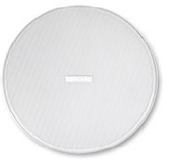  CVIC6 VIC6 2-way loudspeaker is the perfect option for 70/100 V (2,5/5/10/20/40 W) and low impedance sound 110,37 €  solutions (40 WRMS @8Ω). It mounts a 6,5” woofer and a 0,5" steerable tweeter in a discreet design. Dimensions (ØxD): 232x105mm. Weight 1,8kg.  Delivered by master carton of 2 units. Price per unit. | 140,17 € | 44 700 Ft | 56 769 Ft

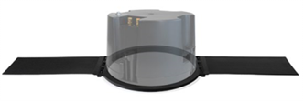  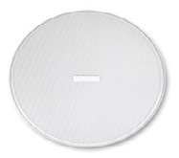  CVIC6X VIC6X 2-way loudspeaker is the perfect option for 70/100 V (2,5/5/10/20/40 W) and low impedance sound 175,80 €  solutions (40 WRMS @8Ω). It mounts a 6,5” woofer and a 0,5" steerable tweeter in a discreet design. With plastic back can and tile bridge.  Dimensions (ØxD): 232x170mm. Weight 1,8kg. Delivered by master carton of 2 units. Price per unit. | 223,27 € | 71 200 Ft | 90 424 Ft

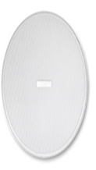  CVIC8 VIC8 2-way loudspeaker is the perfect option for 70/100 V (3,75/7,5/15/30/60 W) and low impedance sound 140,49 €  solutions (60 WRMS @8Ω). It mounts an 8” woofer and a 0,5" steerable tweeter in a discreet design. Dimensions (ØxD): 282x115mm. Weight 2,3kg.  Delivered by master carton of 2 units. Price per unit. | 178,43 € | 56 900 Ft | 72 263 Ft

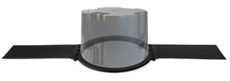  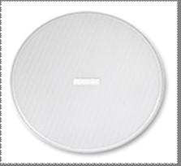  CVIC8X VIC8X 2-way loudspeaker is the perfect option for 70/100 V (3,75/7,5/15/30/60 W) and low impedance sound 249,88 €  solutions (60 WRMS @8Ω). It mounts an 8” woofer and a 0,5" steerable tweeter in a discreet design. With plastic back can and tile bridge.  Dimensions (ØxD): 282x200mm. Weight 3,1kg. Delivered by master carton of 2 units. Price per unit. | 317,34 € | 101 200 Ft | 128 524 Ft

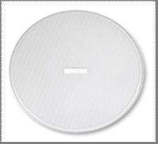  CVICSB81 VICSB8 Sub-woofer reinforcement loudspeaker is the perfect option for 70/100 V (3,75/7,5/15/30/60 W) and 237 €  low impedance sound solutions. It mounts an 8” providing 80 WRMS power in a discreet design.Dimensions (ØxD): 282x135mm. Weight 3,1kg.  Delivered by units. Price per unit. | 237 € | 101 200 Ft | 128 524 Ft

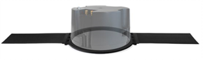  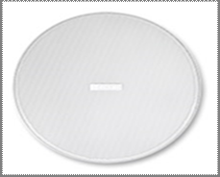  CVICSB8X VICSB8X Sub-woofer reinforcement loudspeaker is the perfect option for 70/100 V (3,75/7,5/15/30/60 W) and 360,25 €  low impedance sound solutions. It mounts an 8” providing 80 WRMS power in a discreet design. With plastic back can and tile bridge.  Dimensions (ØxD): 282x200mm. Weight 3,9kg. Delivered by master carton of 2 units. Price per unit. | 457,51 € | 145 900 Ft | 185 293 Ft

HIGH PERFORMANCE LOUDSPEAKERS
Ref.
Name
MIA SERIES
Nettó lista ár Bruttó lista Nettó lista ár Bruttó lista ár
EUR ár EUR HUF HUF

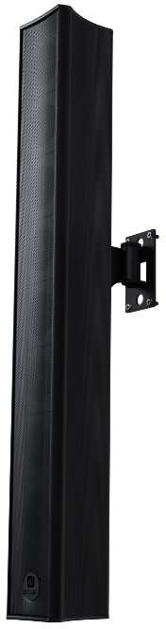  CMIA81BK MIA-81 MIA-81 is a an elegant, unique a compact design column loudspeaker, built in a single aluminium piece 580,99 €  to avoid vibrations and mechanical stress. MIA-81 includes 8x1.5” drivers delivering 40WRMS and the possibility of working in 16 Ω or 64 Ω. IP44 rated. Includes FLATY bracket made out of stainless-steel that permits adjusting the height at any point of the length of the column. Black colour. Dimensions 58 x 448 x 67 mm / 2.28 x 17.64 x 2.64 in. (WxHxD). Weight 1.2 kg / 1.64 lb. Delivered by units. Price per unit. | 737,85 € | 235 300 Ft | 298 831 Ft

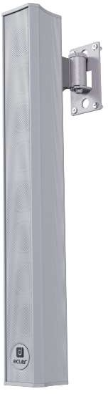  CMIA81WH MIA-81 MIA-81 is a an elegant, unique a compact design column loudspeaker, built in a single aluminium piece 580,99 €  to avoid vibrations and mechanical stress. MIA-81 includes 8x1.5” drivers delivering 40WRMS and the possibility of working in 16 Ω or 64 Ω. IP44 rated. Includes FLATY bracket made out of stainless-steel that permits adjusting the height at any point of the length of the column. White colour. Dimensions 58 x 448 x 67 mm / 2.28 x 17.64 x 2.64 in. (WxHxD). Weight 1.2 kg / 1.64 lb. Delivered by units. Price per unit. | 737,85 € | 235 300 Ft | 298 831 Ft

CMIA82BK MIA-82 MIA-82 is a an elegant, unique a compact design column loudspeaker, built in a single aluminium piece 767,65 €  to avoid vibrations and mechanical stress. MIA-82 includes 8x2.5” drivers delivering 150WRMS and the possibility of working in 16 Ω or 64 Ω. IP44 rated. Includes the versatile smart pan and tilt bracket HANDY made out of stainless-steel that permits adjusting the height at any point of the length of the column. Black colour. Dimensions 83 x 648 x 87 mm / 3.27 x 25.51 x 3.43 in. (WxHxD). Weight 2.65 kg /  5.84 lb. Delivered by units. Price per unit. | 974,92 € | 310 900 Ft | 394 843 Ft

CMIA82WH MIA-82 MIA-82 is a an elegant, unique a compact design column loudspeaker, built in a single aluminium piece 767,65 €  to avoid vibrations and mechanical stress. MIA-82 includes 8x2.5” drivers delivering 150WRMS and the possibility of working in 16 Ω or 64 Ω. IP44 rated. Includes the versatile smart pan and tilt bracket HANDY made out of stainless-steel that permits adjusting the height at any point of the length of the column. White colour. Dimensions 83 x 648 x 87 mm / 3.27 x 25.51 x 3.43 in. (WxHxD). Weight 2.65 kg  / 5.84 lb. Delivered by units. Price per unit. | 974,92 € | 310 900 Ft | 394 843 Ft
Ref.
Name
NIMBO SERIES
Nettó lista ár Bruttó lista Nettó lista ár Bruttó lista ár
EUR ár EUR HUF HUF

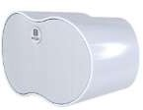  CNIMBO14WH NIMBO-14 2-way passive loudspeaker for surface mounting (1x 4" woofers and 1" tweeter). 40 WRMS @ 8 ohm. 353,33 €  Suitable for outdoor applications, with a wide dispersion pattern and IP-44 rating. White color. Dimensions 250 x 148.7x 150 mm / 9.84 x 5.85 x 5.91 in. Weight 1.7 kg / 3.75 lb. Delivered by units. Price per unit. | 448,73 € | 143 100 Ft | 181 737 Ft

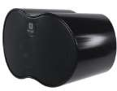  CNIMBO14BK NIMBO-14 2-way passive loudspeaker for surface mounting (1x 4" woofers and 1" tweeter). 40 WRMS @ 8 ohm. 353,33 €  Suitable for outdoor applications, with a wide dispersion pattern and IP-44 rating. Black color. Dimensions 250 x 148.7x 150 mm / 9.84 x 5.85 x 5.91 in. Weight 1.7 kg / 3.75 lb. Delivered by units. Price per unit. | 448,73 € | 143 100 Ft | 181 737 Ft

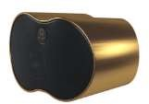  CNIMBO14GD NIMBO-14 2-way passive loudspeaker for surface mounting (1x 4" woofers and 1" tweeter). 40 WRMS @ 8 ohm. 353,33 €  Suitable for outdoor applications, with a wide dispersion pattern and IP-44 rating. Gold color. Dimensions 250 x 148.7x 150 mm / 9.84 x 5.85 x 5.91 in. Weight 1.7 kg / 3.75 lb. Delivered by units. Price per unit. | 448,73 € | 143 100 Ft | 181 737 Ft

NEW! | CNIMBO14TN  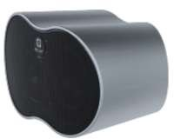 | NIMBO-14 | 2-way passive loudspeaker for surface mounting (1x 4" woofers and 1" tweeter). 40 WRMS @ 8 ohm. Suitable for outdoor applications, with a wide dispersion pattern and IP-44 rating. Titanium color.  Dimensions 250 x 148.7x 150 mm / 9.84 x 5.85 x 5.91 in. Weight 1.7 kg / 3.75 lb. Delivered by units. Price per unit. | 353,33 € | 448,73 € | 143 100 Ft | 181 737 Ft

  CNIMBO14CR NIMBO-14 NIMBO-14 cabinet RAL customization (black grill and bracket). MOQ: 8 units. Delivery time: 45 days. 405,43 €  Dimensions 250 x 148.7x 150 mm / 9.84 x 5.85 x 5.91 in. Weight 1.7 kg / 3.75 lb. Delivered by units. Price per unit. | 514,90 € | 164 200 Ft | 208 534 Ft

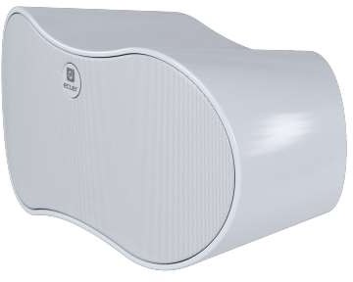  CNIMBO24WH NIMBO-24 2-way passive loudspeaker for surface mounting (2x 4" woofers and 1" tweeter). Capable of working at 516,79 €  both 4 Ωand 16Ωin low impedance, featuring the front switch locatedbehind the logo. 80 WRMS. Suitable for outdoor applications, with a wide dispersion pattern and IP-44 rating. White color. Dimensions 370 x 180 x 180 mm. / 14.56"x7.08"x7.08". Weight 3 kg. / 6,61 lb. Delivered by units. Price per unit. | 656,32 € | 209 300 Ft | 265 811 Ft

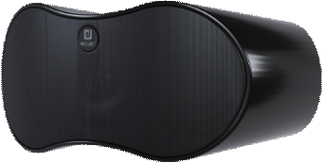  CNIMBO24BK NIMBO-24 2-way passive loudspeaker for surface mounting (2x 4" woofers and 1" tweeter). Capable of working at 516,79 €  both 4 Ωand 16Ωin low impedance, featuring the front switch locatedbehind the logo. 80 WRMS. Suitable for outdoor applications, with a wide dispersion pattern and IP-44 rating. Black color.  Dimensions 370 x 180 x 180 mm. / 14.56"x7.08"x7.08". Weight 3 kg. / 6,61 lb..Delivered by units. Price per unit. | 656,32 € | 209 300 Ft | 265 811 Ft

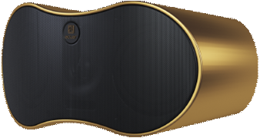  CNIMBO24GD NIMBO-24 2-way passive loudspeaker for surface mounting (2x 4" woofers and 1" tweeter). Capable of working at 516,79 €  both 4 Ωand 16Ωin low impedance, featuring the front switch locatedbehind the logo. 80 WRMS. Suitable for outdoor applications, with a wide dispersion pattern and IP-44 rating. Gold color.  Dimensions 370 x 180 x 180 mm. / 14.56"x7.08"x7.08". Weight 3 kg. / 6,61 lb. Delivered by units. Price per unit. | 656,32 € | 209 300 Ft | 265 811 Ft

NEW! | 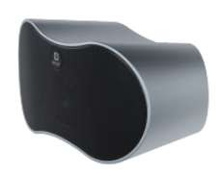  CNIMBO24TN | NIMBO-24 | 2-way passive loudspeaker for surface mounting (2x 4" woofers and 1" tweeter). Capable of working at both 4 Ωand 16Ωin low impedance, featuring the front switch locatedbehind the logo. 80 WRMS. Suitable for outdoor applications, with a wide dispersion pattern and IP-44 rating. Titanium color.  Dimensions 370 x 180 x 180 mm. / 14.56"x7.08"x7.08". Weight 3 kg. / 6,61 lb. Delivered by units. Price per unit. | 516,79 € | 656,32 € | 209 300 Ft | 265 811 Ft

CNIMBO24CR NIMBO-24 NIMBO-24 cabinet RAL customization (black grill and bracket). MOQ: 8 units. Delivery time: 45 days. 594,07 €  Dimensions 370 x 180 x 180 mm. / 14.56"x7.08"x7.08". Weight 3 kg. / 6,61 lb. Delivered by units. Price per unit. | 754,47 € | 240 600 Ft | 305 562 Ft

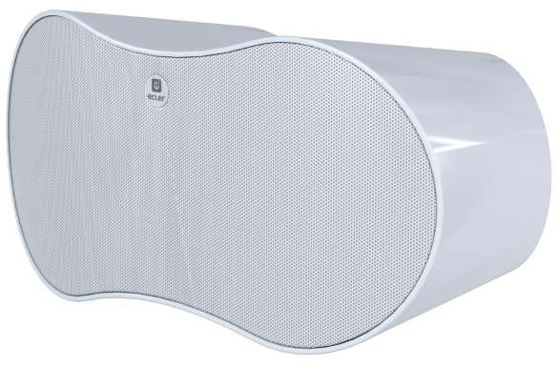  CNIMBO26WH NIMBO-26 2-way passive loudspeaker for surface mounting (2x 6" woofers and 1" tweeter). Capable of working at 938,27 €  both 4 Ωand 16Ωin low impedance, featuring the front switch locatedbehind the logo. 140 WRMS. Suitable for outdoor applications, with a wide dispersion pattern and IP-44 rating. White color.  Dimensions 542,5 x 261 x 269 mm. / 21.35"x 10.27"x 10.59". Weight 8,5 kg. / 18.73 lb. Delivered by units. Price per unit. | 1 191,60 € | 380 000 Ft | 482 600 Ft

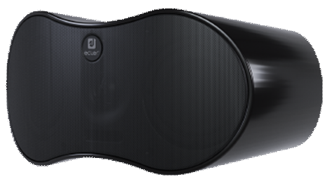  CNIMBO26BK NIMBO-26 2-way passive loudspeaker for surface mounting (2x 6" woofers and 1" tweeter). Capable of working at 938,27 €  both 4 Ωand 16Ωin low impedance, featuring the front switch locatedbehind the logo. 140 WRMS. Suitable for outdoor applications, with a wide dispersion pattern and IP-44 rating. Black color.  Dimensions 542,5 x 261 x 269 mm. / 21.35"x 10.27"x 10.59". Weight 8,5 kg. / 18.73 lb. Delivered by units. Price per unit. | 1 191,60 € | 380 000 Ft | 482 600 Ft

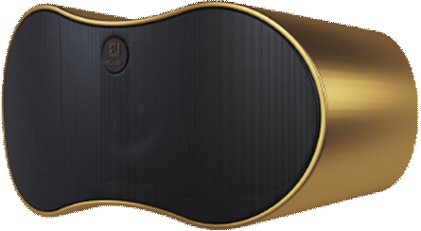  CNIMBO26GD NIMBO-26 2-way passive loudspeaker for surface mounting (2x 6" woofers and 1" tweeter). Capable of working at 938,27 €  both 4 Ωand 16Ωin low impedance, featuring the front switch locatedbehind the logo. 140 WRMS. Suitable for outdoor applications, with a wide dispersion pattern and IP-44 rating. Gold color.  Dimensions 542,5 x 261 x 269 mm. / 21.35"x 10.27"x 10.59". Weight 8,5 kg. / 18.73 lb. Delivered by units. Price per unit. | 1 191,60 € | 380 000 Ft | 482 600 Ft

NEW! | 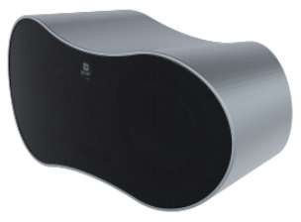  CNIMBO26TN | NIMBO-26 | 2-way passive loudspeaker for surface mounting (2x 6" woofers and 1" tweeter). Capable of working at both 4 Ωand 16Ωin low impedance, featuring the front switch locatedbehind the logo. 140 WRMS. Suitable for outdoor applications, with a wide dispersion pattern and IP-44 rating. Titanium color.  Dimensions 542,5 x 261 x 269 mm. / 21.35"x 10.27"x 10.59". Weight 8,5 kg. / 18.73 lb. Delivered by units. Price per unit. | 938,27 € | 1 191,60 € | 380 000 Ft | 482 600 Ft

NEW! | CNIMBO26CR  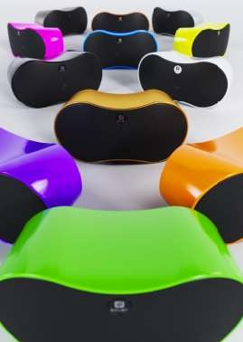 | NIMBO-26 | NIMBO-26 cabinet RAL customization (black grill and bracket). MOQ: 8 units. Delivery time: 45 days. Dimensions 542,5 x 261 x 269 mm. / 21.35"x 10.27"x 10.59". Weight 8,5 kg. / 18.73 lb. Delivered by units. Price per unit. | 1 077,53 € | 1 368,46 € | 436 400 Ft | 554 228 Ft
Ref.
Name
NIMBO Merchandising
Nettó lista ár Bruttó lista Nettó lista ár Bruttó lista ár
EUR ár EUR HUF HUF

NEW! | CMNIMBOSCREW   | NIMBOSCREW  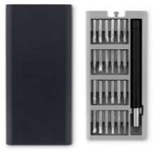 | Set of 24 small precision screwdrivers, with silk-screened NIMBO logo. Presented in an ABS magnetic box with snap-opening. Dimensions: 60 x 160 x 15 mm / 2.32" x 6.29" x 0.59". Weight:220gr / 0,48 lb.Price per unit. | 24,20 € | 30,73 € | 9 800 Ft | 12 446 Ft
Ref.
Name
ARQISi SERIES
Nettó lista ár Bruttó lista Nettó lista ár Bruttó lista ár
EUR ár EUR HUF HUF

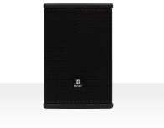  CARQIS105IB ARQIS 105iBK 2-way (5,25" woofer and 1" HF tweeter) wooden loudspeaker cabinet with a compact format and long 260,99 €  term reliability, featuring 70 WRMS @ 8 Ω. 280W Peak power. Its smart wall bracket (included), allows for pan&tilt adjustment, employing a single screw for fastening. Double INPUT/STACK connector, Euroblock type, with security attachment screws, and metal safety sling included. 150ºx130º dispersion pattern. Dimensions (WxHxD) 186 x 280 x 210 mm / 7,32 x 11,02 x 8,26 in  Weight 3.6 kg. Black color | 331,45 € | 105 700 Ft | 134 239 Ft

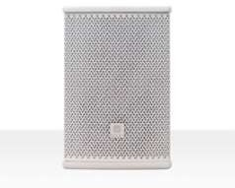  CARQIS105IW ARQIS 105iWH 2-way (5,25" woofer and 1" HF tweeter) wooden loudspeaker cabinet with a compact format and long 260,99 €  term reliability, featuring 70 WRMS @ 8 Ω. 280W Peak power. Its smart wall bracket (included), allows for pan&tilt adjustment, employing a single screw for fastening. Double INPUT/STACK connector, Euroblock type, with security attachment screws, and metal safety sling included. 150ºx130º dispersion pattern. Dimensions (WxHxD) 186 x 280 x 210 mm / 7,32 x 11,02 x 8,26 in .Weight 3.6 kg  White color | 331,45 € | 105 700 Ft | 134 239 Ft

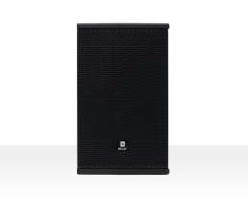  CARQIS106IB ARQIS 106iBK 2-way (6" woofer and 1" rotable HF Compressor Driver) wooden loudspeaker cabinet with a compact 356,30 €  format and long term reliability, featuring 120 WRMS@8Ω. 480W Peak power. Its smart wall bracket (included), allows for pan&tilt adjustment, employing a single screw for fastening. Double INPUT/STACK connector, Euroblock type, with security attachment screws, and metal safety sling included. 140ºx160º dispersion pattern. Dimensions (WxHxD) 216x350x240mm / 8.50"x13.78"x9.45". Weight 7,4 kg / 16.31 lb  Black color | 452,50 € | 144 300 Ft | 183 261 Ft

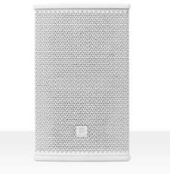  CARQIS106IW ARQIS 106iWH 2-way (6" woofer and 1" rotable HF Compressor Driver) wooden loudspeaker cabinet with a compact 356,30 €  format and long term reliability, featuring 120 WRMS@8Ω.480W Peak power. Its smart wall bracket (included), allows for pan&tilt adjustment, employing a single screw for fastening. Double INPUT/STACK connector, Euroblock type, with security attachment screws, and metal safety sling included. 140ºx160º dispersion pattern. Dimensions (WxHxD) 216x350x240mm / 8.50"x13.78"x9.45". Weight 7,4 kg / 16.31 lb. White color | 452,50 € | 144 300 Ft | 183 261 Ft

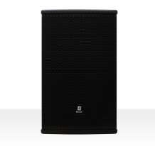  CARQIS108IB ARQIS 108iBK 2-way (8" woofer and 1" HF Compression Driver) wooden loudspeaker cabinet with a compact format, 421,48 €  stylish aesthetics, excellent sound quality and long term reliability, featuring 150 WRMS @ 8 Ω. 600W Peak power. Its smart wall bracket (included), allows for pan&tilt adjustment, employing a single screw for fastening. 130⁰x130⁰ dispersion pattern. Dimensions (WxHxD) 244 x 390 x 280 mm / 9.60" x 15.35" x 11.02". Weight 8,4 kg / 18.52 lb. Black color. | 535,28 € | 170 700 Ft | 216 789 Ft

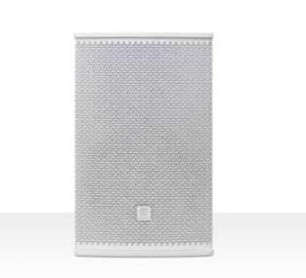  CARQIS108IW ARQIS 108iWH 2-way (8" woofer and 1" HF Compression Driver) wooden loudspeaker cabinet with a compact format, 421,48 €  stylish aesthetics, excellent sound quality and long term reliability, featuring 150 WRMS @ 8 Ω. 600W Peak power. Its smart wall bracket (included), allows for pan&tilt adjustment, employing a single screw for fastening. 130⁰x130⁰ dispersion pattern. Dimensions (WxHxD) 244 x 390 x 280 mm / 9.60" x 15.35" x 11.02". Weight 8,4 kg / 18.52 lb. White color | 535,28 € | 170 700 Ft | 216 789 Ft

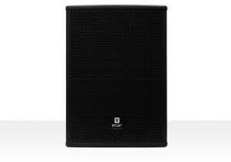  CARQIS110IB ARQIS 110iBK 2-way (10" woofer and 1" rotable HF Compression Driver) wooden loudspeaker cabinet with a compact 559,01 €  format, stylish aesthetics and long term reliability, featuring 300 WRMS @ 8 ohm. 1200W Peak power. 35 mm mount socket and 8 x M10 rigging points, allowing for horizontal or vertical mounting options (110°x 110° dispersion pattern). Dimensions (WxHxD) 359x495x310mm / 14.13"x19.49"x13.86".  Weight 14,8 kg / 32.63 lb  Black color. Bracket not included. Optional ARQ110UB, TRIPO and SR12 accessories. | 709,95 € | 226 400 Ft | 287 528 Ft

CARQIS110IW ARQIS 110iWH 2-way (10" woofer and 1" rotable HF Compression Driver) wooden loudspeaker cabinet with a compact 559,01 €  format, stylish aesthetics and long term reliability, featuring 300 WRMS @ 8 ohm. 1200W Peak power. 35 mm mount socket and 8 x M10 rigging points, allowing for horizontal or vertical mounting options (110°x 110° dispersion pattern). Dimensions (WxHxD) 359x495x310mm / 14.13"x19.49"x13.86".  Weight 14,8 kg / 32.63 lb  White color. Bracket not included. Optional ARQ110UB, TRIPO and SR12 accessories. | 709,95 € | 226 400 Ft | 287 528 Ft

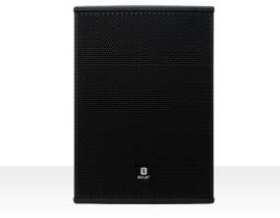  CARQIS112IB ARQIS 112iBK 2-way ( 12" woofer and 1,4" rotable HF Compression Driver) wooden loudspeaker cabinet with a 823,70 €  compact format, stylish aesthetics and long term reliability, featuring 500 WRMS @ 8 Ω. 2000W Peak power. 35 mm mount socket and 8 x M10 rigging points, allowing for horizontal or vertical mounting options (120°x 110° dispersion pattern). Dimensions (WxHxD)416x565x352mm / 16.37"x22.24"x13.86". Weight 20,0 kg / 44.09 lb. Black color. Bracket not included. Optional ARQ112UB, TRIPO and SR12 accessories. | 1 046,10 € | 333 600 Ft | 423 672 Ft

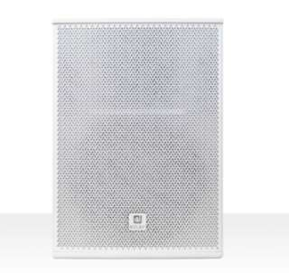  CARQIS112IW ARQIS 112iWH 2-way ( 12" woofer and 1,4" rotable HF Compression Driver) wooden loudspeaker cabinet with a 823,70 €  compact format, stylish aesthetics and long term reliability, featuring 500 WRMS @ 8 Ω. 2000W Peak power. 35 mm mount socket and 8 x M10 rigging points, allowing for horizontal or vertical mounting options (120°x 110° dispersion pattern). Dimensions (WxHxD)416x565x352mm / 16.37"x22.24"x13.86". Weight 20,0 kg / 44.09 lb. White color. Bracket not included. Optional ARQ112UB, TRIPO and SR12 accessories. | 1 046,10 € | 333 600 Ft | 423 672 Ft

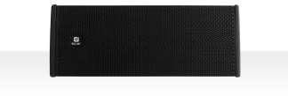  CARQIS205IB ARQIS 205iBK 2-way (2x 5,25" woofer and 1" HF rotable Compression Driver) wooden loudspeaker cabinet with a 415,56 €  compact format and long term reliability, featuring 140 WRMS @ 8 Ω. 560W Peak power. Double INPUT/STACK connector, Euroblock + Speakon© type, 8 x M8 cabinet flying points, metal safety sling included. Its "U" shape wall bracket (included) allows for tilt adjustment. 150º x 40º dispersion pattern. Dimensions (WxHxD) 480x186x210mm / 18.89"x7.32"x8.26". Weight 8.4 kg. / 18.52 lb  Black color. | 527,76 € | 168 300 Ft | 213 741 Ft

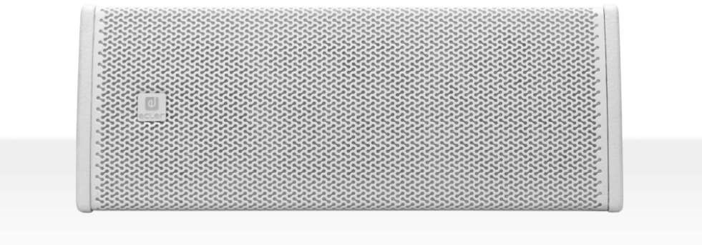  CARQIS205IW ARQIS 205iWH 2-way (2x 5,25" woofer and 1" HF rotable Compression Driver) wooden loudspeaker cabinet with a 415,56 €  compact format and long term reliability, featuring 140 WRMS @ 8 Ω. 560W Peak power. Double INPUT/STACK connector, Euroblock + Speakon© type, 8 x M8 cabinet flying points, metal safety sling included. Its "U" shape wall bracket (included) allows for tilt adjustment. 150º x 40º dispersion pattern. Dimensions (WxHxD) 480x186x210mm / 18.89"x7.32"x8.26". Weight 8.4 kg. / 18.52 lb. White color. | 527,76 € | 168 300 Ft | 213 741 Ft

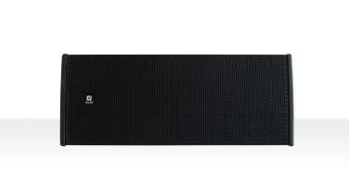  CARQIS208IB ARQIS 208iBK 2-way (2 x 8" woofer and 1" HF Compression Driver) wooden loudspeaker cabinet with a compact 639,26 €  format and long term reliability, featuring 300 WRMS @ 8 Ω. 1200W Peak power. Double INPUT/STACK connector, Euroblock + Speakon© type, 8 x M8 cabinet flying points, metal safety sling included.  Its "U" shape wall bracket (included) allows for tilt adjustment. 130ºx30º dispersion pattern. Dimensions(WxHxD) 610x244x280mm / 24.01"x9.60"x11.02". Weight 14.4 kg / 31.74 lb. Black color. | 811,86 € | 258 900 Ft | 328 803 Ft

CARQIS208IW ARQIS 208iWH 2-way (2 x 8" woofer and 1" HF Compression Driver) wooden loudspeaker cabinet with a compact 639,26 €  format and long term reliability, featuring 300 WRMS @ 8 Ω. 1200W Peak power. Double INPUT/STACK connector, Euroblock + Speakon© type, 8 x M8 cabinet flying points, metal safety sling included.  Its "U" shape wall bracket (included) allows for tilt adjustment. 130ºx30º dispersion pattern. Dimensions(WxHxD) 610x244x280mm / 24.01"x9.60"x11.02" . Weight 14.4 kg / 31.74 lb. White color. | 811,86 € | 258 900 Ft | 328 803 Ft
Ref.
Name
Nettó lista ár Bruttó lista Nettó lista ár Bruttó lista ár
EUR ár EUR HUF HUF

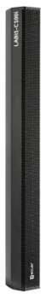  CLABI1C100I LABI1-C100i LABI1-C100i is a versatile and discreet column loudspeaker, designed for indoor and outdoor fixed 1 374,57 €  installations and portable applications.  It features twelve 3” drivers with 0.75” neodymium voice coil each one, 300W AES. Its versatile profile allows the column to be installed in several ways such on the LABI subwoofers, on wall, pole, truss, etc. thanks to LABI1 accessories. Stand alone or combined with other LABI1-C100i and LABI1-SP18p to create a complete powerful plug & play solution. Dimensions: 89 x 1000 x 117 mm / 3.5” x 39.4” x 4.6”. Weight: 7.8 kg / 17.2 lb. | 1 745,70 € | 556 700 Ft | 707 009 Ft
Ref.
Name
Nettó lista ár Bruttó lista Nettó lista ár Bruttó lista ár
EUR ár EUR HUF HUF

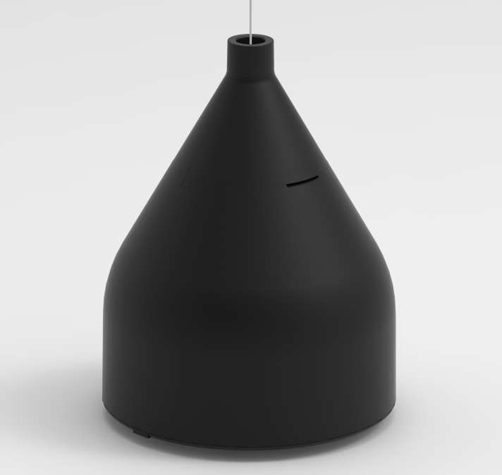  CDROP6BK DROP6 ECLER DROP6 is a 2-way 6.5”, 75W@8ohm pendant loudspeaker with a stylish design, including a 321,23 €  70/100V line transformer with 60/30/15 and 7,5W power selections, available at both high and low impedance levels. Dimensions (without accessories) Ø270mm x 355mm(H) / Ø10.6 in. x 14 in. (H). Weight 4.2 Kg / 9.26 lb. Stripped wire connection (5m). Black colour. | 407,97 € | 130 100 Ft | 165 227 Ft

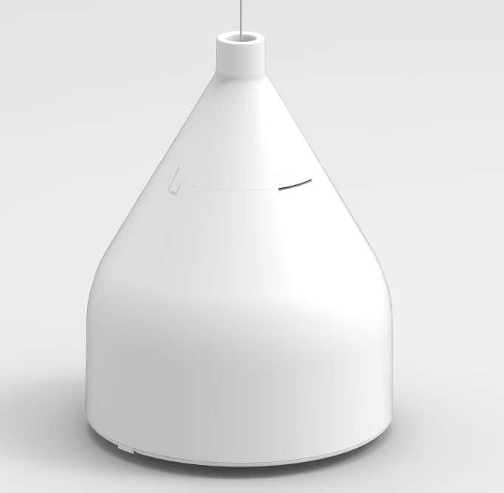  CDROP6WH DROP6 ECLER DROP6 is a 2-way 6.5”, 75W@8ohm pendant loudspeaker with a stylish design, including a 321,23 €  70/100V line transformer with 60/30/15 and 7,5W power selections, available at both high and low impedance levels. Dimensions (without accessories) Ø270mm x 355mm(H) / Ø10.6 in. x 14 in. (H). Weight 4.2 Kg / 9.26 lb. 2x stripped wire connection (5m). White colour. | 407,97 € | 130 100 Ft | 165 227 Ft
Ref.
Name
Nettó lista ár Bruttó lista Nettó lista ár Bruttó lista ár
EUR ár EUR HUF HUF

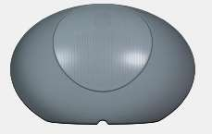  CZEN15GR ZEN-15 The new ZEN-15 in-ground loudspeaker with an elegant rounded rock shape seamlessly blends the 399,51 €  world of audio technology with the aesthetics of nature. Includes a 5,25" woofer and a 1" tweeter delivering 70W RMS @ 8ohm and 60W RMS @ 70/100V. This discreet outdoor audio solution effortlessly integrates into outdoor environments, providing a harmonious balance between functionality and visual appeal.Grey color. Dimensions 410 x 260 x 289mm / 16.14 x 10.23 x 11,37 in. Weight 4.4Kg / 9.7lb | 507,37 € | 161 800 Ft | 205 486 Ft

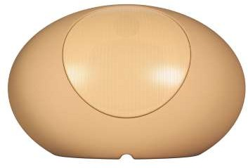  CZEN15SD ZEN-15 The new ZEN-15 in-ground loudspeaker with an elegant rounded rock shape seamlessly blends the 399,51 €  world of audio technology with the aesthetics of nature. Includes a 5,25" woofer and a 1" tweeter delivering 70W RMS @ 8ohm and 60W RMS @ 70/100V. Crafted to resemble a rugged, weathered stone, this discreet outdoor audio solution effortlessly integrates into outdoor environments, providing a harmonious balance between functionality and visual appeal.Sand color. Dimensions 410 x 260 x 289mm / 16.14 x 10.23 x 11,37 in. Weight 4.4Kg / 9.7lb | 507,37 € | 161 800 Ft | 205 486 Ft
Ref. Name RRP € RRP € RRP € RRP €

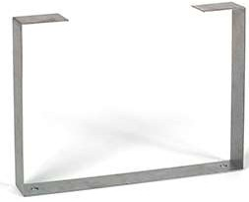  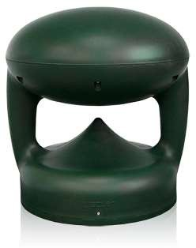  CIG108 IG108 Weatherproof loudspeaker (IP65) with an omni-directional horizontal dispersion pattern (360º). 8" 478,77 €  Kevlar woofer and 1" ACCW silk tweeter. 100 WRMS @ 8Ω, suitable for 70/100V ( 7.5/15/30/60 W @ 100V ). Frequency response 50Hz to 23kHz.Security ground bracket included. It is ideal for music and message applications in outdoor areas. Dimensions 360 x 392.5 mm. Weight 8.5 kg | 608,03 € | 193 900 Ft | 246 253 Ft
COMMERCIAL LOUDSPEAKERS
Ref.
Name
Nettó lista ár Bruttó lista Nettó lista ár Bruttó lista ár
EUR ár EUR HUF HUF

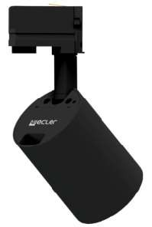  CTRAIL103BK TRAIL103BK 3" lamp style loudspeaker cabinet, with high Impedance (15W and 30W taps) and Low Impedance (15 234,81 €  WRMS @4Ω) connections. Includes 3 different installation system accesories for ceiling light rails, surface mount and truss mount. Dimensions (without arm) Ø 96mm x 110mm. Weight 1kg Black colour.  Delivered by units. Price per unit. | 298,21 € | 95 100 Ft | 120 777 Ft

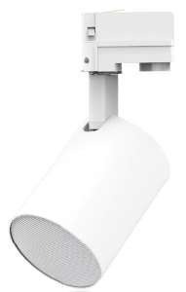  CTRAIL103WH TRAIL103WH 3" lamp style loudspeaker cabinet, with high Impedance (15W and 30W taps) and Low Impedance (15 234,81 €  WRMS @4Ω) connections. Includes 3 different installation system accesories for ceiling light rails, surface mount and truss mount. Dimensions (without arm) Ø 96mm x 110mm. Weight 1kg White colour.  Delivered by units. Price per unit. | 298,21 € | 95 100 Ft | 120 777 Ft
Ref.
Name
eAMBIT SERIES
Nettó lista ár Bruttó lista Nettó lista ár Bruttó lista ár
EUR ár EUR HUF HUF

EOL | CEAMB103BK  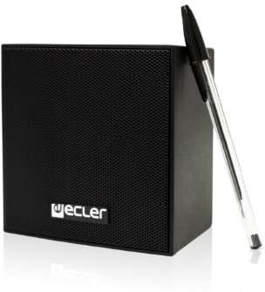 | eAMBIT103BK | Ultra compact 2-way (3.5” woofer and 0.5" tweeter) loudspeaker cabinet with neutral an discreet design, suitable for 70/100V (2.5/5/7.5/15 W) and low impedance (25 WRMS @8Ω) audio lines. IP54 certified. Includes on-wall hardware, safety sling, screws and wrench for fast installation.Dimensions (without accessories) 120 x 120 x 117 mm. Weight 1,275kg Black color.  Delivered by master carton of 2 units. Price per unit. | 70,37 € | 89,37 € | 28 500 Ft | 36 195 Ft

EOL | CEAMB103WH  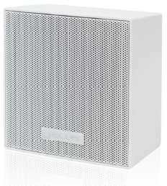 | eAMBIT103WH | Ultra compact 2-way (3.5” woofer and 0.5" tweeter) loudspeaker cabinet with neutral an discreet design, suitable for 70/100V (2.5/5/7.5/15 W) and low impedance (25 WRMS @8Ω) audio lines. IP54 certified. Includes on-wall hardware, safety sling, screws and wrench for fast installation.Dimensions (without accessories) 120 x 120 x 117 mm. Weight 1,275kg White color.  Delivered by master carton of 2 units. Price per unit. | 70,37 € | 89,37 € | 28 500 Ft | 36 195 Ft
Ref.
Name
AMBIT SERIES
Nettó lista ár Bruttó lista Nettó lista ár Bruttó lista ár
EUR ár EUR HUF HUF

NEW! | CAMBIT13BK  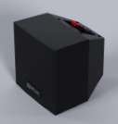 | AMBIT-13 | Ultra compact 2-way (3.5” woofer and 0.5" tweeter) loudspeaker cabinet with neutral an discreet design, suitable for 70/100V (2.5/5/7.5/15 W) and low impedance (25 WRMS @8Ω) audio lines. IP54 certified. Includes on-wall hardware, safety sling, screws and wrench for fast installation.Dimensions (without accessories) 120 x 120 x 117 mm. Weight 1,275kg Black color.  Delivered by master carton of 2 units. Price per unit. | 74,32 € | 94,39 € | 30 100 Ft | 38 227 Ft

NEW! | CAMBIT13WH  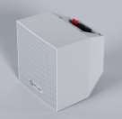 | AMBIT-13 | Ultra compact 2-way (3.5” woofer and 0.5" tweeter) loudspeaker cabinet with neutral an discreet design, suitable for 70/100V (2.5/5/7.5/15 W) and low impedance (25 WRMS @8Ω) audio lines. IP54 certified. Includes on-wall hardware, safety sling, screws and wrench for fast installation.Dimensions (without accessories) 120 x 120 x 117 mm. Weight 1,275kg White color.  Delivered by master carton of 2 units. Price per unit. | 74,32 € | 94,39 € | 30 100 Ft | 38 227 Ft

NEW! | CAMBIT16BK  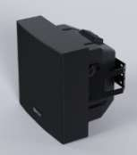 | AMBIT-16 | Ultra compact 2-way (6.5” woofer and 1" tweeter) loudspeaker cabinet with neutral an discreet design, suitable for 70/100V (5/7.5/15/30 W) and low impedance(50 WRMS @8Ω) audio lines. IP54 certified. Includes on-wall hardware, safety sling, screws and wrench for fast installation.Dimensions (without accessories) 210 x 210 x 160 mm. Weight 2,75kg Black color.  Delivered by master carton of 2 units. Price per unit. | 122,47 € | 155,54 € | 49 600 Ft | 62 992 Ft

NEW! | CAMBIT16WH  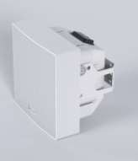 | AMBIT-16 | Ultra compact 2-way (6.5” woofer and 1" tweeter) loudspeaker cabinet with neutral an discreet design, suitable for 70/100V (5/7.5/15/30 W) and low impedance(50 WRMS @8Ω) audio lines. IP54 certified. Includes on-wall hardware, safety sling, screws and wrench for fast installation. Dimensions (without accessories) 210 x 210 x 160 mm. Weight 2,75kg White color.  Delivered by master carton of 2 units. Price per unit. | 122,47 € | 155,54 € | 49 600 Ft | 62 992 Ft

NEW! | CAMBIT18BK  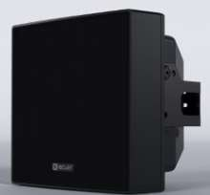 | AMBIT-18 | Ultra compact 2-way (8” woofer and 1,18" tweeter) loudspeaker cabinet with neutral an discreet design, suitable for 70/100V (60 W) and low impedance(75 WRMS @8Ω) audio lines. IP54 certified. Includes on-wall hardware, safety sling, screws and wrench for fast installation.Dimensions (without accessories) 258 x 258 x 225 mm. Weight 5.6k.g Black color.  Delivered by master carton of 2 units. Price per unit. | 251,85 € | 319,85 € | 102 000 Ft | 129 540 Ft

NEW! | CAMBIT18WH  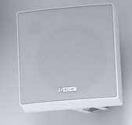 | AMBIT-18 | Ultra compact 2-way (8” woofer and 1,18" tweeter) loudspeaker cabinet with neutral an discreet design, suitable for 70/100V (60 W) and low impedance(100 WRMS @8Ω) audio lines. IP54 certified. Includes on-wall hardware, safety sling, screws and wrench for fast installation.Dimensions (without accessories) 258 x 258 x 225 mm. Weight 5.6k.g. White color.  Delivered by master carton of 2 units. Price per unit. | 251,85 € | 319,85 € | 102 000 Ft | 129 540 Ft
Ref.
Name
eMOTUS SERIES
Nettó lista ár Bruttó lista Nettó lista ár Bruttó lista ár
EUR ár EUR HUF HUF

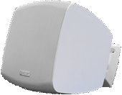  CEMOTUS3ODWH eMOTUS3ODWH 3" woofer (25 WRMS @ 8Ω) loudspeaker cabinet ready for outdoor installation(IP65). Suitable for 93,33 €  70/100V and low impedance(8Ω) audio lines. Includes wall bracket and security steel cable. Dimensions (without accessories) 132x132x117 mm. Weight 1.3 kg White colour.  Price per unit, sold in pairs. | 118,53 € | 37 800 Ft | 48 006 Ft

CEMOTUS3ODBK  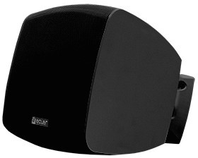 | eMOTUS3ODBK | 3" woofer (25 WRMS @ 8Ω) loudspeaker cabinet ready for outdoor installation(IP65). Suitable for 70/100V and low impedance(8Ω) audio lines. Includes wall bracket and security steel cable.  Dimensions (without accessories) 132x132x117 mm. Weight 1.3 kg Black colour. Price per unit, sold in pairs. | 93,33 € | 118,53 € | 37 800 Ft | 48 006 Ft
CEMOTUS5PBWC  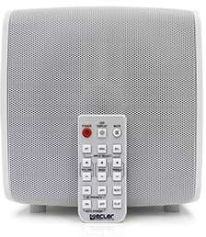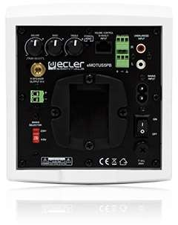 | eMOTUS5PBWH | Stereo loudspeaker kit (2 x 25 WRMS @ 8Ω) including an active and a passive cabinet. eMOTUS5PBBK performs BT connection, balanced and unbalanced audio inputs. Includes an IR remote control and 0- 10VDC remote port. Features: source selection, 2 band tone control, stereo/mono switch, auto stand- by and wall bracket and security steel cable. Dimensions 173x185x180mm. Weight 2.1 kg. White colour.  Delivered by kit (active + passive loudspeakers). Price per kit. | 356,30 € | 452,50 € | 144 300 Ft | 183 261 Ft
Ref.
Name
eUC SERIES
Nettó lista ár Bruttó lista Nettó lista ár Bruttó lista ár
EUR ár EUR HUF HUF
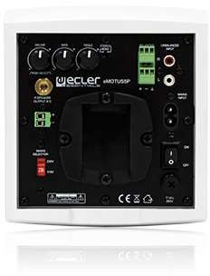  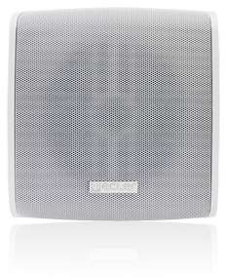  CEMOTUS5PWHC eMOTUS5PWH Stereo loudspeaker kit (2 x 25 WRMS @ 8Ω) including an active and a passive cabinet and performing 2 273,09 €  audio inputs: balanced and unbalanced. Suitable for low impedance audio lines, includes source selection, 2 band tone control, stereo/mono switch, auto stand-by and wall bracket and security steel cable. Dimensions (without accessories) 173x185x180mm. Weight 2.1 kg White colour.  Delivered by kit (active + passive loudspeakers). Price per kit. | 346,82 € | 110 600 Ft | 140 462 Ft

NEW! | CEMOTUS5PBKC  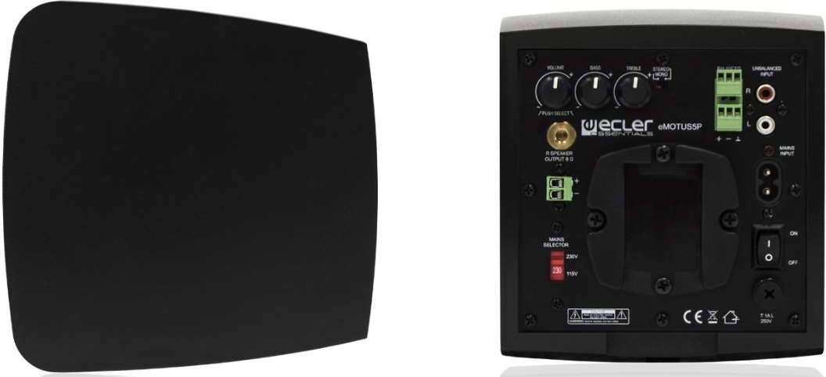 | eMOTUS5PBK | Stereo loudspeaker kit (2 x 25 WRMS @ 8Ω) including an active and a passive cabinet and performing 2 audio inputs: balanced and unbalanced. Suitable for low impedance audio lines, includes source selection, 2 band tone control, stereo/mono switch, auto stand-by and wall bracket and security steel cable. Dimensions (without accessories) 173x185x180mm. Weight 2.1 kg Black colour.  Delivered by kit (active + passive loudspeakers). Price per kit. | 273,09 € | 346,82 € | 110 600 Ft | 140 462 Ft

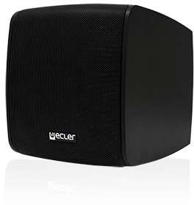  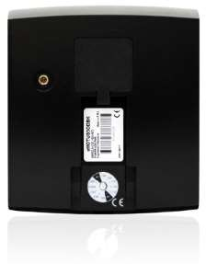  CEMOTUS5ODBK eMOTUS5ODBK 5" woofer and 1" tweeter (40 WRMS @ 8Ω) loudspeaker cabinet ready for outdoor installation(IP65). 150,62 €  Suitable for 100V (3,75/7,5/15/30W) and low impedance(8Ω) audio lines. Includes wall bracket and security steel cable. Dimensions (without accessories) 173x181x180mm. Weight 2.4 kg Black colour. Price per unit, sold in pairs. | 191,28 € | 61 000 Ft | 77 470 Ft

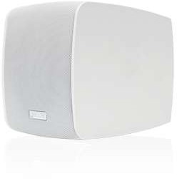  CEMOTUS5ODWH eMOTUS5ODWH 5" woofer and 1" tweeter (40 WRMS @ 8Ω) loudspeaker cabinet ready for outdoor installation(IP65). 150,62 €  Suitable for 100V (3,75/7,5/15/30W) and low impedance(8Ω) audio lines. Includes a wall bracket and security steel cable. Dimensions (without accessories) 173x181x180mm. Weight 2.4 kg White colour. Price per unit, sold in pairs. | 191,28 € | 61 000 Ft | 77 470 Ft

NEW! | 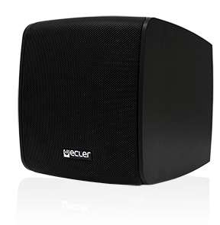  CEMOTUS5O16B | eMOTUS5O16 | 5" woofer and 1" tweeter (40 WRMS @ 16Ω) loudspeaker cabinet ready for outdoor installation(IP65). Suitable for low impedance(16Ω) audio lines. Includes a wall bracket and security steel cable.  Dimensions (without accessories) 173x181x180mm. Weight 2.4 kg. Black colour. Price per unit, sold in pairs. | 129,63 € | 164,63 € | 52 500 Ft | 66 675 Ft

NEW! | CEMOTUS5O16W | eMOTUS5O16 | 5" woofer and 1" tweeter (40 WRMS @ 16Ω) loudspeaker cabinet ready for outdoor installation(IP65). Suitable for low impedance(16Ω) audio lines. Includes a wall bracket and security steel cable.  Dimensions (without accessories) 173x181x180mm. Weight 2.4 kg White colour. Price per unit, sold in pairs. | 129,63 € | 164,63 € | 52 500 Ft | 66 675 Ft

CEMOTUS8ODBK eMOTUS8ODBK 8" woofer and 1" tweeter (100 WRMS @ 8Ω) loudspeaker cabinet ready for outdoor installation(IP65). 297,04 €  Suitable for 70/100V (3,75/7,5/15/30W/60W) and low impedance(8Ω) audio lines. Includes a wall bracket and security steel cable. Dimensions (without accessories) 268x242x264mm. Weight 4.25 kg Black colour.  Price per unit, sold in pairs. | 377,24 € | 120 300 Ft | 152 781 Ft

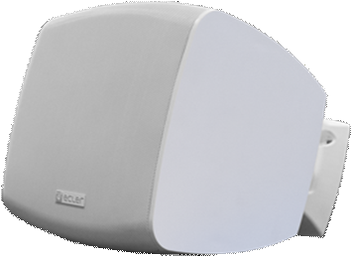  CEMOTUS8ODWH eMOTUS8ODWH 8" woofer and 1" tweeter (100 WRMS @ 8Ω) loudspeaker cabinet ready for outdoor installation(IP65). 297,04 €  Suitable for 70/100V (3,75/7,5/15/30W/60W) and low impedance(8Ω) audio lines. Includes a wall bracket and security steel cable. Dimensions (without accessories) 268x242x264mm. Weight 4.25 kg White colour.  Price per unit, sold in pairs. | 377,24 € | 120 300 Ft | 152 781 Ft

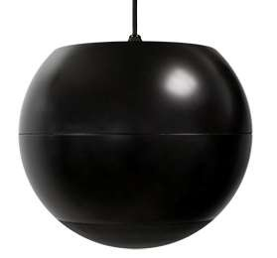  CEUC106BK eUC106BK Spherical pendant loudspeaker featuring a 6,5" woofer, 0.5" tweeter. 40 WRMS @ 8Ω and 70/100V 149,63 €  transformer (32/ 16/ 8/ 4 W @ 100V). Dimensions (without accessories) ø270 x 215 (H). Weight 3 kg Stripped wire connection (3m). Black colour. | 190,03 € | 60 600 Ft | 76 962 Ft

Ref.
Name
Nettó lista ár Bruttó lista Nettó lista ár Bruttó lista ár
EUR ár EUR HUF HUF
Ref.
Name
ARQISi SERIES
Nettó lista ár Bruttó lista Nettó lista ár Bruttó lista ár
EUR ár EUR HUF HUF
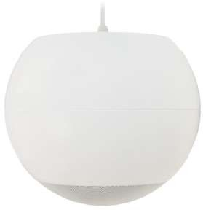  CEUC106 eUC106WH Spherical pendant loudspeaker featuring a 6,5" woofer, 0.5" tweeter. 40 WRMS @ 8Ω and 70/100V 149,63 €  transformer.(32/ 16/ 8/ 4 W @ 100V). Dimensions (without accessories) ø270 x 215 (H). Weight 3 kg Stripped wire connection (3m). White colour. | 190,03 € | 60 600 Ft | 76 962 Ft
Ref.
Name
eCMP SERIES
Nettó lista ár Bruttó lista Nettó lista ár Bruttó lista ár
EUR ár EUR HUF HUF

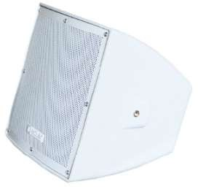  CECMP8 eCMP8 150W high efficiency musical projector ready for outdoor applications due to its waterproof and sun 448,64 €  screening building material (IP56). It performs an 8’’ LF driver and 1,4’’ HF coaxial driver, 150W @ 8Ω nominal power and 70/100V line transformer with 37, 5/75/150W/ 8Ω power options.  Dimensions: WxHxD: 300 x 302 x 334mm /11.8” x 11.9” x 13.2”  Weight: 11,0 kg / 24.3 lb | 569,78 € | 181 700 Ft | 230 759 Ft

CECMP12 eCMP12 300W high efficiency musical projector ready for outdoor applications due to its waterproof and sun 721,48 €  screening building material (IP56). It performs an 12’’ LF driver and 1,7’’ HF coaxial driver, 300W @ 8Ω nominal power and 70/100V line transformer with 50/100/200W/8Ω power options.  Dimensions: WxHxD: 407 x 410 x 378mm / 16.0” x 16.1” x 14.9”  Weight: 20,0 kg / 44.1 lb | 916,28 € | 292 200 Ft | 371 094 Ft
SUBWOOFERS

NEW! | CKICKSB18BK  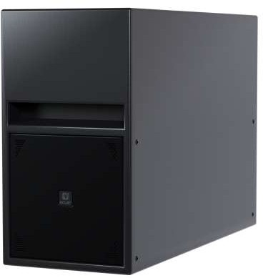 | KICK-SB18 | As the first Ecler outdoor subwoofer, the new KICK-SB18 features 1x8” woofers perfectly positioned to maximize the low frequency response while reducing the vibrations on the acoustic enclosure. It delivers 350 WRMS at 8Ω ready to be wall-mounted with the included bracket or positioned vertically and horizontally when needed. Dimensions TBC. Weight TBC  Black color. | 701,48 € | 890,88 € | 284 100 Ft | 360 807 Ft

CKICKSB28BK KICK-SB28 As the first Ecler outdoor subwoofer, the new KICK-SB28 features 2x8” woofers perfectly positioned to 1 315,31 €  maximize the low frequency response while reducing the vibrations on the acoustic enclosure. It delivers 700 WRMS at 4Ω ready to be wall-mounted with the included bracket or positioned vertically and horizontally when needed. Dimensions (WxHxD) 660 x 450 x 250 mm / 255,98 x 17,71 x 9,84 in. Weight 23Kg/50.7lb  Black color. | 1 670,44 € | 532 700 Ft | 676 529 Ft

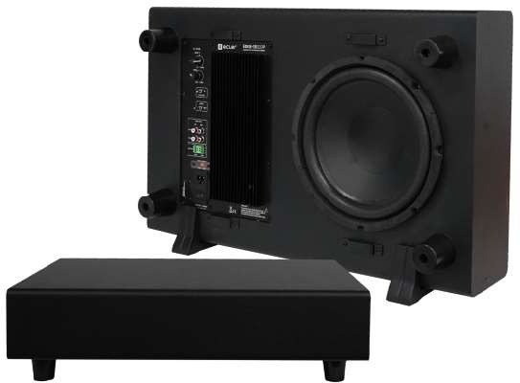  CEDGESB110P EDGE-SB110P Powerful bass sound in a compact size EDGE subwoofer is perfectly designed for small available spaces 450,62 €  like underneath restaurant seats or wall-mounted in a corner with the included bracket. This powered subwoofer of 181 mm high incorporates a 10” driver, 50Hz to 250Hz variable low pass filter, phase inverter and an amplified power output of 120W.Black color. Dimensions (WxHxD) 635 x 400 x 178 mm  / 23,62 x 15,74 x 7 in. Weight 11,25Kg & 24,8 lb | 572,28 € | 182 500 Ft | 231 775 Ft

NEW! | CEDGESB10P21 | EDGE-SB10P21 | EDGE-SB10P21 is a compact powered 2.1 device, including in a single enclosure a powered subwoofer and a stereo amplifier for full range external speakers or "satellites", as well as a number of additional components to control and process the audio signal.Powerful bass sound in a compact size EDGE subwoofer is perfectly designed for small available spaces like underneath restaurant seats or wall- mounted in a corner with the included bracket.Black color. Dimensions (WxHxD) 635 x 400 x 178 mm / 23,62 x 15,74 x 7 in. Weight 11,25Kg & 24,8 lb | 600,99 € | 763,25 € | 243 400 Ft | 309 118 Ft

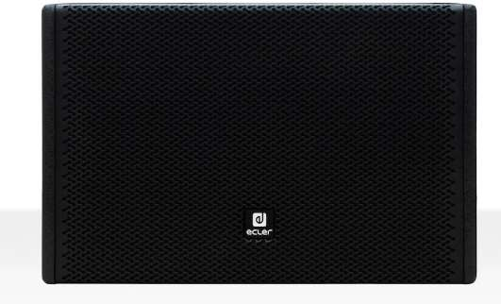  CARQISSB6TIB ARQISSB6TiBK Wooden wall-mount subwoofer reinforcement cabinet, featuring a 6,5" driver and a passive 6,5" 559,01 €  radiator. 480W peak power, 120 WRMS power @ 8 ohm and integrated 70/100V line transformer with 60 and 120W taps. Internal LPF with OFF, 120HZ and 150 HZ cut-off frequency selections. Installation U- bracket included. Dimensions (WxHxD) 250x390x130mm / 9.84"x15.35"x5.12". Weight 8,2 kg / 18.07 lb Black color. | 709,95 € | 226 400 Ft | 287 528 Ft

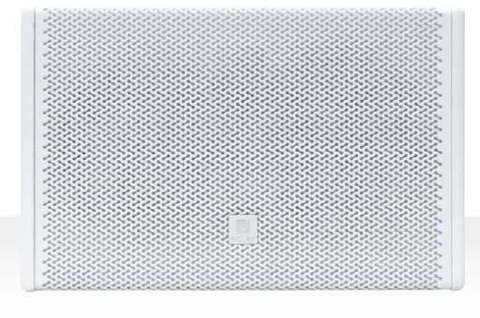  CARQISSB6TIW ARQISSB6TiWH Wooden wall-mount subwoofer reinforcement cabinet, featuring a 6,5" driver and a passive 6,5" 559,01 €  radiator. 480W peak power, 120 WRMS power @ 8 ohm and integrated 70/100V line transformer with 60 and 120W taps. Internal LPF with OFF, 120HZ and 150 HZ cut-off frequency selections. Installation U- bracket included. Dimensions (WxHxD) 250x390x130mm / 9.84"x15.35"x5.12". Weight 8,2 kg / 18.07 lb White color. | 709,95 € | 226 400 Ft | 287 528 Ft

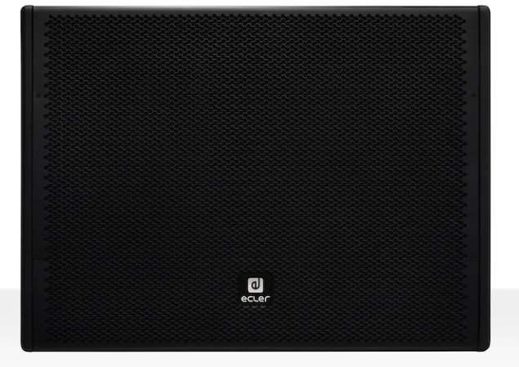  CARQISSB10IB ARQIS SB10iBK Wooden wall-mount subwoofer reinforcement cabinet with a slim and compact format and long term 569,88 €  reliability, featuring a 10" driver (150 WRMS @ 8 ohm, 600W peak power) and internal LPF (OFF/ 120Hz/150Hz). Euroblock connector, wall mount and 12 x M8 rigging points included. Dimensions (WxHxD) 600x442x228mm / 23.62"x17.40"8.97". Weight 16,6 kg / 36.37 lb.  Black color. | 723,74 € | 230 800 Ft | 293 116 Ft

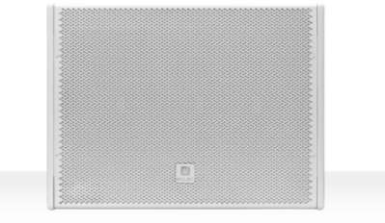  CARQISSB10IW ARQIS SB10iWH Wooden wall-mount subwoofer reinforcement cabinet with a slim and compact format and long term 569,88 €  reliability, featuring a 10" driver (150 WRMS @ 8 ohm, 600W peak power) and internal LPF (OFF/ 120Hz/150Hz). Euroblock connector, wall mount and 12 x M8 rigging points included. Dimensions (WxHxD) 600x442x228mm / 23.62"x17.40"8.97". Weight 16,6 kg / 36.37 lb.  White color. | 723,74 € | 230 800 Ft | 293 116 Ft

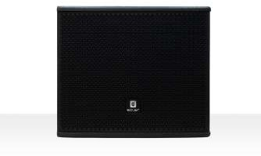  CARQISSB12IB ARQIS SB12iBK Wooden sub-woofer reinforcement cabinet with a compact format and long term reliability, featuring 761,48 €  300 WRMS @ 8 Ω and a 12" LF driver. 1200W Peak power. Double INPUT/STACK connector, Speakon© type.  8 x M8 rigging points included. Dimensions (WxHxD) 445 x 445 x 375 mm / 17.51 x 17.51 x 14.76 in. Weight 23 kg / 50,70 lb. Available only in black color. | 967,08 € | 308 400 Ft | 391 668 Ft

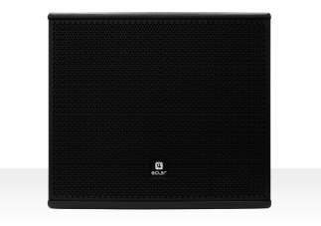  CARQISSB15IB ARQIS SB15iBK Wooden sub-woofer reinforcement cabinet with a compact format and long term reliability, featuring 964,20 €  600 WRMS @ 8 Ω and a 15" LF driver. 2400W Peak power. Double INPUT/STACK connector, Speakon© type.  35 mm top-hat pole mount socket and 8 x M8 rigging points included. Dimensions (WxHxD) 534 x 525 x 460 mm / 21.02 x 20.67 x 18.11 in. Weight 32 kg / 70,54 lb. Available only in black color. | 1 224,53 € | 390 500 Ft | 495 935 Ft
Ref. Name Nettó lista ár Bruttó lista Nettó lista ár Bruttó lista ár

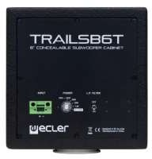  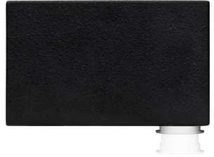  CTRAILSB6TBK TRAILSB6TBK Wooden subwoofer reinforcement cabinet with a very compact format, featuring a 6,5" driver, 60 467,65 €  WRMS @ 8Ω, 70/100V line transformer (7.5/15/30/60 W), and internal Low Pass Filter(150Hz / OFF). Specifically designed to fulfil permanent installation requirements: concealed in false ceilings or partition walls, on walls' surface, etc. Installation accessories included. Dimensions 200x200x320 mm. Weight 6,3kg  Available only in black finish. Delivered by units. Price per unit. | 593,92 € | 189 400 Ft | 240 538 Ft
Ref.
Name
LABI1 SERIES
Nettó lista ár Bruttó lista Nettó lista ár Bruttó lista ár
EUR ár EUR HUF HUF

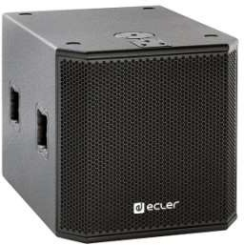  CLABI1SB18 LABI1-SB18 LABI1-SB18 is an 18” passive subwoofer, 500W AES 8Ω, designed for fixed installations and portable 1 608,40 €  applications (external amplification required). A stand alone compact subwoofer or combined with LABI1-C100i to create a complete powerful solution, easy to mount and plug and play. Dimensions: 513 x 513 x 704 mm / 20.2" x 20.2" x 27.7". Weight: 37kg / 81.8 lb. | 2 042,66 € | 651 400 Ft | 827 278 Ft

CLABI1SB18P LABI1-SB18p LABI1-SB18p is an 18” powered subwoofer, designed for fixed installations and portable applications. A 3 249,63 €  stand alone compact subwoofer or combined with LABI1-C100i to create a complete solution. It performs 2400W Class D built-in amplification power: 1 x 1200W for its low frequency woofer, and 2x600W amplifiers, able to power up to 4 x LABI1-C100i. It also features DC protection to avoid damage to the loudspeakers, and performs 18 factory presets - selectable through the LCD screen. Dimensions: 513 x 513 x 704 mm / 20.2" x 20.2" x 27.7". Weight: 37kg / 81.8 lb. | 4 127,03 € | 1 316 100 Ft | 1 671 447 Ft
Ref.
Name
LABI1 PACKS
Nettó lista ár Bruttó lista Nettó lista ár Bruttó lista ár
EUR ár EUR HUF HUF

CLABI1PACK1 LABI1PACK1 14 672,59 €  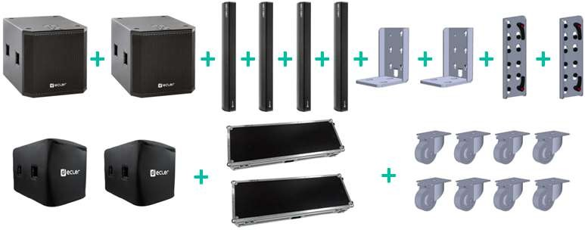  2 x LABI1-SB18p  4 x LABI1-C100i  2 x LABI1-SAC  2 x LABI1-CAC  2 x LABI1-SPC  2 x LABI1-CFC  2 x LABI1-SWK | 18 634,19 € | 5 942 400 Ft | 7 546 848 Ft

CLABI1PACK2 LABI1PACK2 7 335,80 €  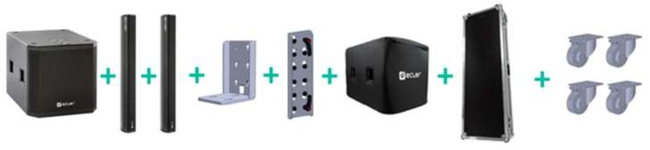  1 x LABI1-SB18p  2 x LABI1-C100i  1 x LABI1-SAC  1 x LABI1-CAC  1 x LABI1-SPC  1 x LABI1-CFC  1 x LABI1-SWK | 9 316,47 € | 2 971 000 Ft | 3 773 170 Ft

CLABI1PACK3 LABIPACK3 12 150,37 €  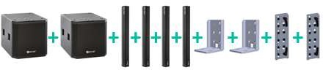  2 x LABI1-SB18p  4 x LABI1-C100i  2 x LABI1-SAC  2 x LABI1-CAC | 15 430,97 € | 4 920 900 Ft | 6 249 543 Ft

CLABI1PACK4 | LABIPACK4  2 x LABI1-SB18p  2 x LABI1-C100i  2 x LABI1-SAC | + | 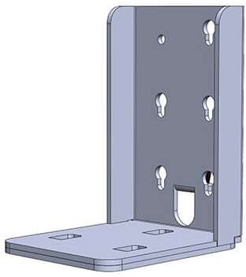  + + + + | 9 128,64 € | 11 593,38 € | 3 697 100 Ft | 4 695 317 Ft
INDUSTRIAL LOUDPEAKERS

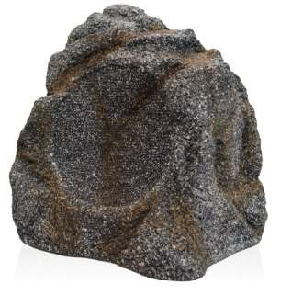  CERK108 eRK108 Outdoor and cost-effective ground loudspeaker. It features a 8" woofer, 0.5" tweeter. 70/100V 176,79 €  transformer (15W). IP65 rated. Ready to be installed in gardens, theme parks, leisure facilities, etc. Dimensions 325x290x270mm. Weight 5kg | 224,52 € | 71 600 Ft | 90 932 Ft

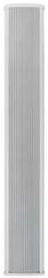  CECS803 eCS803 Column loudspeaker, featuring 8 x 3" woofer transducers, 100 WRMS @ 8Ω, low impedance direct 167,65 €  connection and 70/100V transformer (Selector de potencia: 30/ 20/ 10/ 5 W 100V/ 8 Ω). Aluminium enclosure with included wall bracket and IP44 outdoor class. Dimensions (without accessories) 105x760x90mm. Weight 4.5 kg | 212,92 € | 67 900 Ft | 86 233 Ft

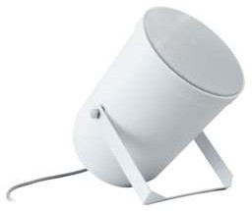  CEPRS10TI ePRS10Ti 10 WRMS sound projector carefully selected for the most extended 70/100V paging and background 81,48 €  music applications. Manufactured in reinforced ABS and IP55 rated, therefore suitable for outdoor superior performance in music high-quality applications.  Power selection: 2,5/5/10W @ 100V. Dimensions Ø 138 x 205mm. Weight 1.6kg (including accessories). | 103,48 € | 33 000 Ft | 41 910 Ft

CEPRS20TI ePRS20Ti 20 WRMS sound projector carefully selected for the most extended 70/100V paging and background 86,42 €  music applications. Manufactured in reinforced ABS and IP55 rated, therefore suitable for outdoor superior performance in music high-quality applications. Power selection: 5/ 10/ 20W @ 100V. Dimensions Ø 170 x 245mm. Weight 1.8 kg (including accessories). | 109,75 € | 35 000 Ft | 44 450 Ft

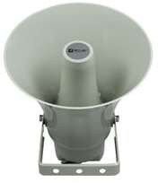  CEPHS30TI ePHS30Ti 30 WRMS horn loudspeaker carefully selected for the most extended 70/100V paging and background 109,38 €  music applications, offering durability and optimal speech and music reproduction. Manufactured in reinforced ABS and IP66 rated, therefore suitable for outdoor superior performance.  Power selection: 30W / 20W / 10W / 5W @ 100V. 30WRMS @ 8Ω. Dimensions Ø 246 x 292mm. Weight 2.4kg (including accessories). | 138,92 € | 44 300 Ft | 56 261 Ft

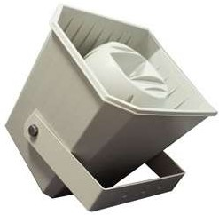  CEMSP50TI eMSP50Ti 50 WRMS 2-way musical horn carefully selected for the most extended 70/100V paging and 226,91 €  background music applications, offering durability and optimal speech and music reproduction. Manufactured in reinforced ABS and IP66 rated, therefore suitable for outdoor superior performance in music high-quality applications.  Power selection:2.6/4.5/9/12.5/25/50W @ 100V. 50WRMS @8Ω. Dimensions 362x252x310mm. Weight 3.9kg (including accessories). | 288,18 € | 91 900 Ft | 116 713 Ft

REMOTE CONTROLS & INTERFACES
EUR ár EUR HUF HUF
Nettó lista ár Bruttó lista Nettó lista ár Bruttó lista ár
MPAGE SERIES
Name
Ref.
Ref.
Name
Nettó lista ár Bruttó lista Nettó lista ár Bruttó lista ár
EUR ár EUR HUF HUF
Ref.
Name
Nettó lista ár Bruttó lista Nettó lista ár Bruttó lista ár
EUR ár EUR HUF HUF
REF.
Name
Nettó lista ár Bruttó lista Nettó lista ár Bruttó lista ár
EUR ár EUR HUF HUF

PAGING STATIONS

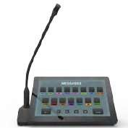  CPAGENETDN PAGENETDN Desktop paging console for voice notices with Dante™ audio over IP. Features a 10” touch screen, a 2 302,47 €  server client and a UCP server (User Control Panel). Since it’s a server/UCP client device, it’s possible to add other kind of control panels beside the ones destined for voice messages such as: volume control, sound source selection, presets recovery, communication via TCP/UDP with external devices, etc.  Power over Ethernet or local power supply. Gooseneck microphone included. | 2 924,14 € | 932 500 Ft | 1 184 275 Ft

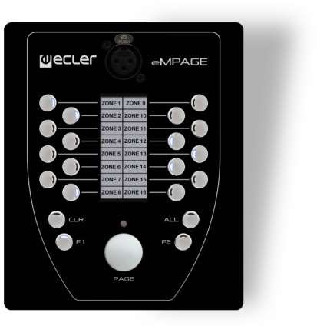  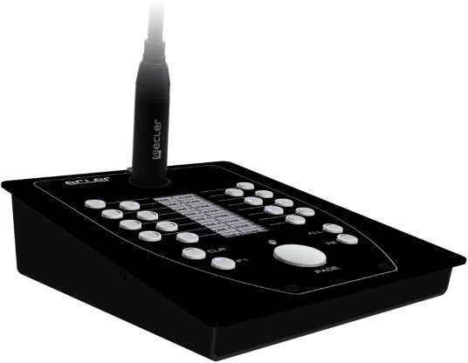  CEMPAGE eMPAGE Digital paging station (MPAGE16’s evolution), compatible with HUB, MIMO88, MIMO88SG and 620,25 €  MIMO1212SG digital matrixes. Includes: a gooseneck cardioid microphone (removable); 16 zone- selection keys; ALL, CLEAR and PAGE keys; 2 programmable keys, F1 & F2, for zone-group selection. Text labelling for destination areas by means of programmable electronic ink display. Dimensions (microphone excluded) 150mm x 180mm x 50mm. Weight 900g. | 787,71 € | 251 200 Ft | 319 024 Ft

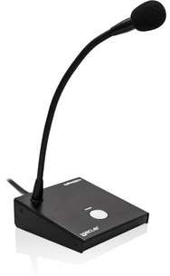  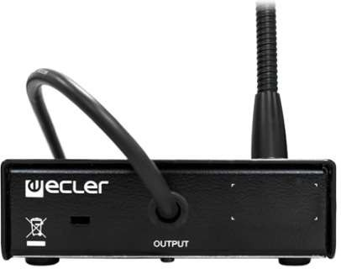  CMPAGE1R MPAGE1r 1-zone desktop paging station, compatible with any device including a phantom-powered microphone 212,84 €  input (SAM series, COMPACT series, DAM614, MIMO88, CA series, HMA series, etc.). Internal connections for a secure wiring. Dimensions (microphone excluded) 120mm x 126mm x 43mm. Weight 625 g. | 270,31 € | 86 200 Ft | 109 474 Ft

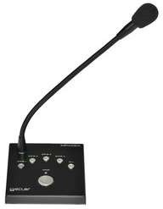  CMPAGE4 MPAGE4 4-zone desktop paging station compatible with DAM614, CA series, etc. It allows for real-time paging 344,20 €  with zones' destination selection. Selectable chime melody. Dimensions (microphone excluded) 120mm x 126mm x 43mm. Weight 650 g. | 437,13 € | 139 400 Ft | 177 038 Ft

DIGITAL CONTROLS & PANELS
Ref.
Name
PULSO Series
Nettó lista ár Bruttó lista Nettó lista ár Bruttó lista ár
EUR ár EUR HUF HUF

NEW! | CPULSO4  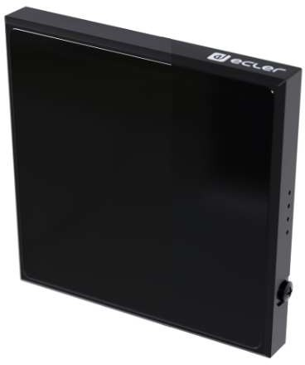 | PULSO-4 | PULSO-4 is a digital remote wall panel with an elegant minimalistic design. Featuring aluminum frame and capacitive 4" TFT 480x480 display, the new PULSO wall panels are the perfect choice to load the User Control Panels of VIDA Series, EclerNet and HUB Series. Single unit EU electrical wall box. PoE or external power supply. | 500,74 € | 635,94 € | 202 800 Ft | 257 556 Ft

NEW! | CPULSO6  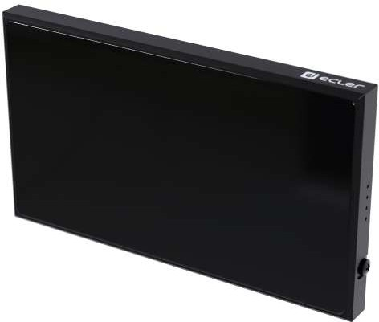 | PULSO-6 | PULSO-6 is a digital remote wall panel with an elegant minimalistic design. Featuring aluminum frame and capacitive 5,5" TFT 720x1280 display, the new PULSO wall panels are the perfect choice to load the User Control Panels of VIDA Series, EclerNet and HUB Series. Single unit EU electrical wall box. PoE or external power supply. | 651,11 € | 826,91 € | 263 700 Ft | 334 899 Ft

NEW! | 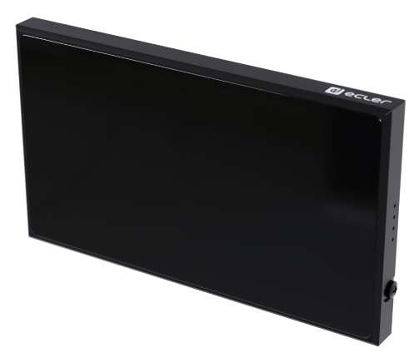  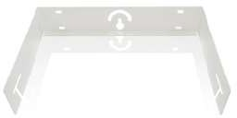  CPULSO10 | PULSO-10 | PULSO-10 is a digital remote wall panel with an elegant minimalistic design. Featuring aluminum frame and capacitive 10" TFT 1280x 800 display, the new PULSO wall panels are the perfect choice to load the User Control Panels of VIDA Series, EclerNet and HUB Series. Single unit EU electrical wall box. PoE or external power supply. | 1 002,47 € | 1 273,14 € | 406 000 Ft | 515 620 Ft
Ref.
Name
Nettó lista ár Bruttó lista Nettó lista ár Bruttó lista ár
EUR ár EUR HUF HUF

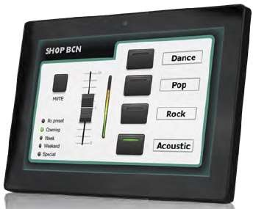  CWPNETTOUCH WPNETTOUCH Remote control TFT touchscreen compatible with all EclerNet products such as: MIMO4040DN, 1 094,57 €  MIMO88/SG, MIMO1212SG, and DUO-NET PLAYER. Incorporates a capacitive 10” touch screen, a server client and UCP server (User Control Panel). When including a WPNETTOUCH in an EclerNet installation is not necessary to use a computer to manage connected devices, neither to have the UCP panels created for the project. Power over Ethernet or local power supply. Surface-mount accessories included. Compatible with VESA75 mounting standard.  260x178x28mm, 700gr. | 1 390,10 € | 443 300 Ft | 562 991 Ft

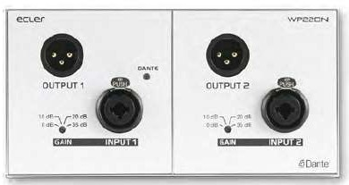  CWP22DN WP22DN Dante™ interface in a wall panel format. It features 2 audio MIC/LINE Combo connector inputs in its 767,65 €  frontal panel and 2 Dante™ conversion channels either directly or by the sum of channels (stereo to mono conversion). Also, it features 2 analogue outputs with duplicated connectors in XLR format for the front panel and Euroblock on the rear panel, both linked to 2 Dante™ channels coming from the local network. PoE supply or local power supply. | 974,92 € | 310 900 Ft | 394 843 Ft

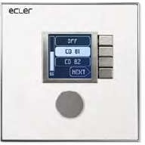  CWPNET4KVR WPNET4KV EclerNet compatible wall panel. It features a LCD screen, encoder and 4 selection keys. Works perfectly 404,44 €  to enable volume control, source and preset selection functions. Ethernet interface. PoE or local power supply. | 513,64 € | 163 800 Ft | 208 026 Ft

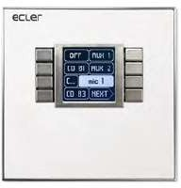  CWPNET8KR WPNET8K EclerNet compatible wall panel. It features a LCD screen and 8 selection keys. Works perfectly to enable 404,44 €  presets or source selection functions. Ethernet interface. PoE or local power supply. | 513,64 € | 163 800 Ft | 208 026 Ft

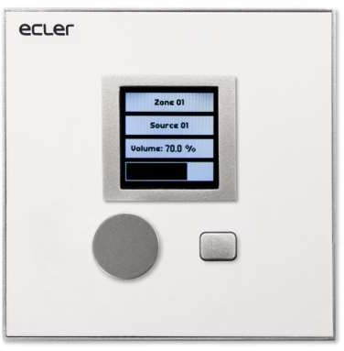  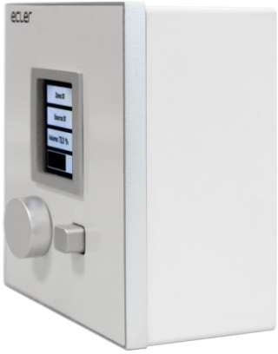  CEMCONTROL1R eMCONTROL1 Digital control panel for the HUB matrix with a wall format, It makes it possible to act as a zone 199,75 €  control, enabling the user to have 3 functions : volumen adjustment/MUTE, selection of musical sources and EQ adjustment with 3 band tone control. Coupled to a WPa type panel with an audio connector, provide remote control + balanced audio signal to the HUB, using only a single CAT5 type cable or higher. Universal surface-mount installation box included. Dimensions 86 x 38 x 86 mm. | 253,69 € | 80 900 Ft | 102 743 Ft

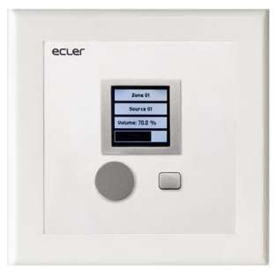  CEMCTROL1US eMCTROL1US Digital control panel for the HUB matrix with a wall format with USA frame. It makes it possible to act 199,75 €  as a zone control, enabling the user to have 3 functions : volumen adjustment/MUTE, selection of musical sources and EQ adjustment with 3 band tone control. Coupled to a WPa type panel with an audio connector, provide remote control + balanced audio signal to the HUB, using only a single CAT5 type cable or higher. Dimensions 116.5x114.8x27mm | 253,69 € | 80 900 Ft | 102 743 Ft

ANALOGUE CONTROLS & PANELS
Ref.
Name
WPa SERIES
Nettó lista ár Bruttó lista Nettó lista ár Bruttó lista ár
EUR ár EUR HUF HUF

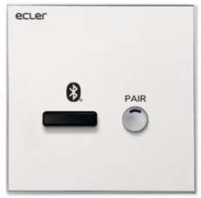  CWPABT WPaBT Class 1 bluetooth receiver (range 25m) A2DP profile, which keeps the standard wall-panel format of the 247,90 €  WPa series. Include a Euroblock balanced stereo output, double-mono configurable. Easy device name, PIN, stereo / mono output configuration using the Ecler Bluetooth® Manager application for Windows devices. GPO available, useful for automatic priority management. Surface installation box included. Dimensions 86 x 38 x 86 mm. | 314,83 € | 100 400 Ft | 127 508 Ft

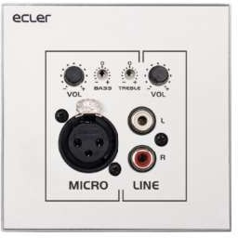  CWPAMIXT WPaMIX-T 2 channel micro-mixer which keeps the standard wall-panel format of the WPm series. It allows to a 142,47 €  mix a stereo unbalanced signal (2xRCA) with a microphone signal (XLR), getting a balanced mono output that can be sent to a preamplifier, amplifier, mixer, digital or analogue matrix, etc.  The MIC input includes a 2 band EQ (BASS, TREBLE) and talk-over function. Universal surface-mount installation box included. Dimensions 86 x 38 x 86 mm. | 180,94 € | 57 700 Ft | 73 279 Ft

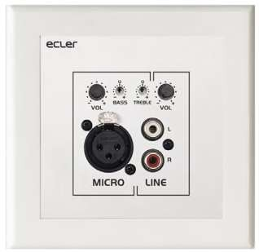  CWPAMIXTUS WPaMIX-TUS 2 channel micro-mixer which keeps the standard wall-panel format of the WPm series, but with USA 142,47 €  frame. It allows to a mix a stereo unbalanced signal (2xRCA) with a microphone signal (XLR), getting a balanced mono output that can be sent to a preamplifier, amplifier, mixer, digital or analogue matrix, etc.  The MIC input includes a 2 band EQ (BASS, TREBLE) and talk-over function. Dimensions 116.5x114.8x27mm | 180,94 € | 57 700 Ft | 73 279 Ft

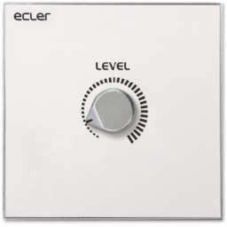  CWPAVOL WPaVOL Remote wall panel control for one volume management. Compatible with all Ecler 0-10V DC REMOTE 77,28 €  control port, like ALMA, MIMO88 / SG, NXA series, CA series, GPA series, etc. Universal surface-mount installation box included. Dimensions 86 x 38 x 86 mm. | 98,15 € | 31 300 Ft | 39 751 Ft

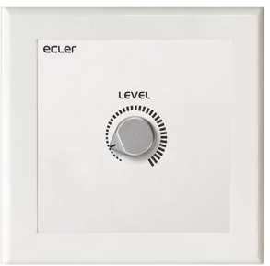  CWPAVOLUS WPaVOLUS Remote wall panel control with USA frame for one volume management. Compatible with all Ecler 0- 89,38 €  10V DC REMOTE control port, like MPA-R, ALMA, MIMO88 / SG, NXA series, CA series, GPA series, etc. Dimensions 116.5x114.8x27mm | 113,52 € | 36 200 Ft | 45 974 Ft

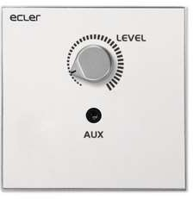  CWPAVOLJ WPaVOL-J Remote wall panel control for one volume management and a front panel stereo mini-jack connector. 90,37 €  Compatible with all ECLER 0-10V DC REMOTE control port, like MPA-R, ALMA, MIMO88 / SG, NXA series, CA series, GPA series, etc. | 114,77 € | 36 600 Ft | 46 482 Ft

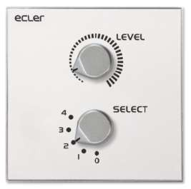  CWPAVOLSR WPaVOL-SR Remote wall panel control for one volume management + source or preset selection. Compatible with 110,37 €  all Ecler 0-10V DC REMOTE control port, like MPA-R, ALMA, MIMO88 / SG, NXA series, CA series, GPA series, etc.  Universal surface-mount installation box included. Dimensions 86 x 38 x 86 mm. | 140,17 € | 44 700 Ft | 56 769 Ft

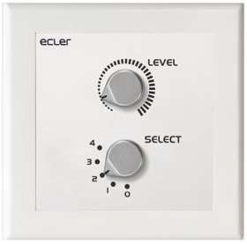  CWPAVOLSRUS WPaVOL-SRUS Remote wall panel control with USA frame for one volume management + source or preset selection. 110,37 €  Compatible with all Ecler 0-10V DC REMOTE control port, like MPA-R, ALMA, MIMO88 / SG, NXA series, CA series, GPA series, etc.  Dimensions 116.5x114.8x27mm | 140,17 € | 44 700 Ft | 56 769 Ft

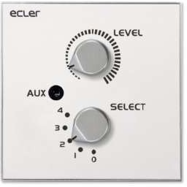  CWPAVOLSRJ WPaVOL-SR-J Same features as WPaVOL-SR + front panel stereo mini-jack connector. 115,56 €  Universal surface-mount installation box included. Dimensions 86 x 38 x 86 mm. | 146,76 € | 46 800 Ft | 59 436 Ft

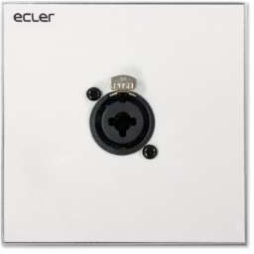  CWPACNXCBO WPaCNX-CBO Connection wall plate with Female 3 pin XLR connector + Jackk ST (combo connector). Screw-type 86,42 €  connector at the back (no solder needed).  Universal surface-mount installation box included. Dimensions 86 x 38 x 86 mm. | 109,75 € | 35 000 Ft | 44 450 Ft

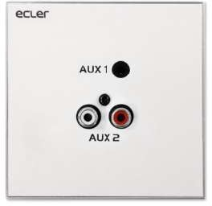  CWPACNXJRCA WPaCNX-JRCA Connection wall plate with 1 x stereo minijack and 2 x RCA connectors. 81,48 €  Universal surface-mount installation box included. Dimensions 86 x 38 x 86 mm. | 103,48 € | 33 000 Ft | 41 910 Ft

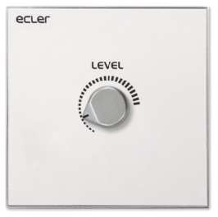  CWPAHAT6 WPaH-AT6 70 / 100V line attenuator with integrated 24 VDC priority relay. 6W maximum output power. 94,32 €  Universal surface-mount installation box included. Dimensions 86 x 38 x 86 mm. | 119,79 € | 38 200 Ft | 48 514 Ft

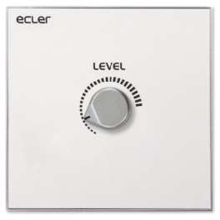  CWPAHAT40 WPaH-AT40 70 / 100V line attenuator with integrated 24 VDC priority relay. 40W maximum output power. 113,58 €  Universal surface-mount installation box included. Dimensions 86 x 38 x 86 mm. | 144,25 € | 46 000 Ft | 58 420 Ft

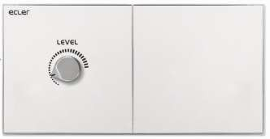  CWPAHAT100 WPaH-AT100 70 / 100V line attenuator with integrated 24 VDC priority relay. 100W maximum output power. 121,48 €  Universal surface-mount installation box included. Dimensions 172 x 38 x 86 mm. | 154,28 € | 49 200 Ft | 62 484 Ft

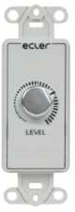  CUBWPAVOL UBWPaVOL UBWPaVOL is a remote wall panel control for one volume management, in US single gang bare format. 81,48 €  It is compatible with Ecler devices including 0-10VDC or 0-12VDC remote control ports (internal jumper selectable). Dimensions: 35x65x35mm / 1.4"x2.5"x1.4". Weight: 30gr / 0.07 lb. | 103,48 € | 33 000 Ft | 41 910 Ft

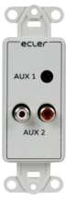  CUBWPACNXJRC UBWPaCNXJRC UBWPaCNX-JRC is a connection wall-panel, in US single gang bare format, with 1 x stereo minijack and 76,30 €  2 x RCA connectors. This connector can be screwed at the rear (does not require any soldering). Dimensions: 35x65x35mm / 1.4"x2.5"x1.4". Weight: 30gr / 0.07 lb. | 96,90 € | 30 900 Ft | 39 243 Ft

ACCESSORIES

PRODUCT ACCESSORIES
Ref.
Name
Nettó lista ár Bruttó lista Nettó lista ár Bruttó lista ár
EUR ár EUR HUF HUF

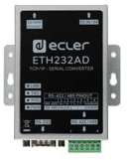  CETH232AD ETH232AD Ecler ETH232AD is a serial interface that allows bidirectional transparent transmission between RS- 219,75 €  232/422/485 and Ethernet. It includes a setting webpage for Ethernet and Serial customized settings. Dimensions: 100 × 86 × 26 mm (3.94” × 3.39” × 1.02”) Weight: 0.5kg / 1.10 lb. | 279,09 € | 89 000 Ft | 113 030 Ft

C1UHRMKIT 1UHRMKIT Kit that enables a half-width x 1U height rack device to be mounted into a standard width rack cabinet. 28,15 €  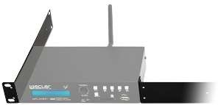 | 35,75 € | 11 400 Ft | 14 478 Ft

C2UHRMKIT 2UHRMKIT Kit that enables a half-width x 2U height rack device to be mounted into a standard width rack cabinet. 37,28 €  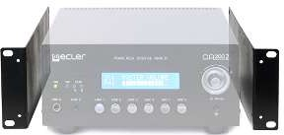 | 47,35 € | 15 100 Ft | 19 177 Ft

CVEORACK19 VEORACK19 Universal 19" rack mount accessory. Mounting screws and Velkro® included. 101,48 €  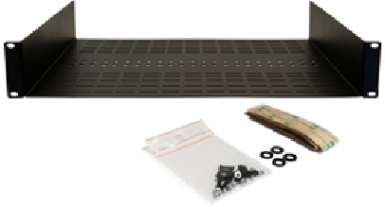 | 128,88 € | 41 100 Ft | 52 197 Ft

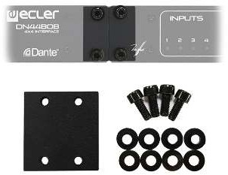  CPUM3 PUM3 Ecler PUM3 is a rack-mount accessory that allows to mount two half-width RU devices in 1 standard 18,27 €  width RU space. Mounting screws included. | 23,20 € | 7 400 Ft | 9 398 Ft

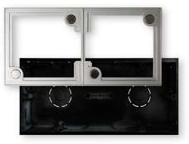  CWPA2FMBOX WPa2FMBOX Double Flush-Mount box, compatible with the WPa wall panel series. It includes a single frame for 52,35 €  fitting 2 adjacent panels in a twin housing. | 66,48 € | 21 200 Ft | 26 924 Ft

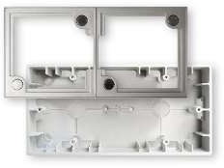  CWPA2SMBOX WPa2SMBOX Double Surface-mount box, compatible with the WPa wall panel series. It includes a single frame for 52,35 €  fitting 2 adjacent panels in a twin housing. | 66,48 € | 21 200 Ft | 26 924 Ft

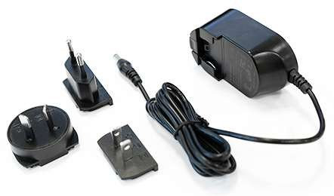  CWP24PSU WP24-PSU Ecler WP24-PSU is a 24VDC 0.5A external PSU. International AC plugs set. Coaxial connector (+ center), 49,38 €  compatible with eMPAGE, DN44BOB, WPNET Series, eMCONTROL1, WPaMIX-T and WPaBT. | 62,72 € | 20 000 Ft | 25 400 Ft

CLABI1SWK LABI1-SWK Subwoofer-Wheel-Kit. 4 wheel kit for LABI1-SB18/18p subwoofer 159,75 €   | 202,89 € | 64 700 Ft | 82 169 Ft

CLABI1CFC LABI1-CFC Column-Flight-Case. Flight case for 2 LABI1-C100i + wiring + mounting accessories 972,35 €  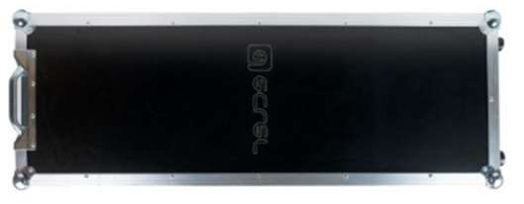 | 1 234,88 € | 393 800 Ft | 500 126 Ft

CLABI1SPC LABI1-SPC Subwoofer-Protection-Cover. Nylon protection cover for LABI1-SB18/18p subwoofer 196,79 €  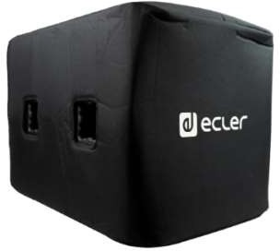 | 249,92 € | 79 700 Ft | 101 219 Ft

AUDIO CABLES & OTHERS
Ref.
Name
Nettó lista ár Bruttó lista Nettó lista ár Bruttó lista ár
EUR ár EUR HUF HUF

CMBSTAND MBSTAND Microphone floor boom stand. 57,28 €  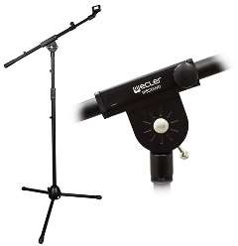 | 72,75 € | 23 200 Ft | 29 464 Ft

CMDSTAND MDSTAND Microphone desktop stand. 15,06 €  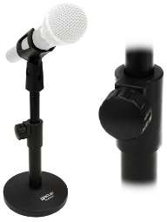 | 19,13 € | 6 100 Ft | 7 747 Ft

CNXAC8RM CNXAC8RM 8 x Schuko sockets rack mount AC strip + ON/OFF switch, 1 RU. 43,21 €  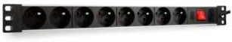 | 54,88 € | 17 500 Ft | 22 225 Ft

CNXEBEB1 CNXEBEB1 Euroblock 3 pin to Euroblock 3 pin premade cable, 1 metre length. 22,22 €  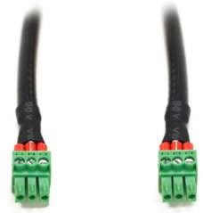 | 28,22 € | 9 000 Ft | 11 430 Ft

CNXEBEB2M5 CNXEBEB2M5 Euroblock 3 pin to Euroblock 3 pin premade cable, 2.5 metre length. 23,21 € | 29,48 € | 9 400 Ft | 11 938 Ft

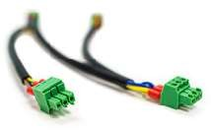  CNXEBLINK4 CNXEBLINK4 Euroblock 3 pin to Euroblock 3 pin, 4 connectors premade link cable (amplifiers, preamps and mixers 22,22 €  inputs link wire, to share the same audio signal). | 28,22 € | 9 000 Ft | 11 430 Ft

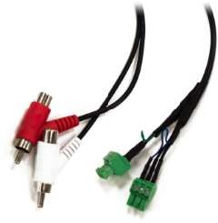  CNXEBRCA1 CNXEBRCA1 Double Euroblock 3 pin to double RCA male and female connection premade cable including RCA to 26,17 €  Euroblock unbalancing, 1 metre length. | 33,24 € | 10 600 Ft | 13 462 Ft

CNXRCAEBAD CNXRCAEBAD Euroblock 3 pin to RCA MONO female adapter including RCA to Euroblock unbalancing. 19,26 €  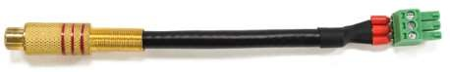 | 24,46 € | 7 800 Ft | 9 906 Ft

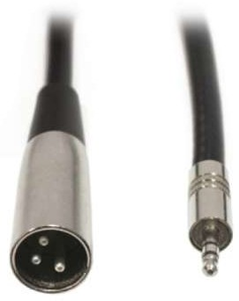  CNXMJXLR2 CNXMJXLR2 2m lenght minijack ST to mono XLR male. Includes an internal resistance for overload protection and a 26,17 €  propper sum of the signals. | 33,24 € | 10 600 Ft | 13 462 Ft

CNXXLRFEB CNXXLRFEB Euroblock 3 pin to XLR female connection premade cable, 0.5 metre length. 17,28 €  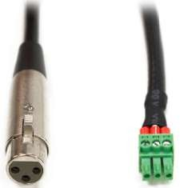 | 21,95 € | 7 000 Ft | 8 890 Ft

CNXXLRXLR1 CNXXLRXLR1 XLR male to XLR female cable, 1 metre length. 19,26 €  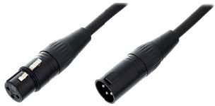 | 24,46 € | 7 800 Ft | 9 906 Ft

CNXXLRXLR5 CNXXLRXLR5 XLR male to XLR female cable, 5 metre length. 36,30 € | 46,10 € | 14 700 Ft | 18 669 Ft

CNXXLRXLR10 CNXXLRXLR10 XLR male to XLR female cable, 10 metre length. 56,30 € | 71,50 € | 22 800 Ft | 28 956 Ft

LOUDSPEAKERS HARDWARE
Ref.
Name
Nettó lista ár Bruttó lista Nettó lista ár Bruttó lista ár
EUR ár EUR HUF HUF

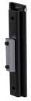  CFLATYBK FLATY FLATY is a wall bracket that allows the columns of the MIA series to be installed attached to the wall. It 30,12 €  is made of stainless steel and allows the height to be adjusted at any point along the length of the column, as well as allowing 2 columns to be installed side by side on top of each other. Black color. | 38,26 € | 12 200 Ft | 15 494 Ft

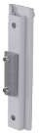  CFLATYWH FLATY FLATY is a wall bracket that allows the columns of the MIA series to be installed attached to the wall. It 30,12 €  is made of stainless steel and allows the height to be adjusted at any point along the length of the column, as well as allowing 2 columns to be installed side by side on top of each other. White color. | 38,26 € | 12 200 Ft | 15 494 Ft

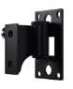  CHANDYBK HANDY HANDY is a wall bracket compatible with the MIA and NIMBO-14 series. It is incredibly versatile and 51,36 €  intelligent with swivel and tilt adjustment, made of stainless steel. Black color. | 65,22 € | 20 800 Ft | 26 416 Ft

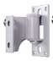  CHANDYWH HANDY HANDY is a wall bracket compatible with the MIA and NIMBO-14 series. It is incredibly versatile and 51,36 €  intelligent with swivel and tilt adjustment, made of stainless steel. White colour. | 65,22 € | 20 800 Ft | 26 416 Ft

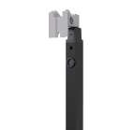  CGROUNDYBK GROUNDY GROUNDY is a bracket that allows you to install eMOTUS series speakers on the floor. Compatible with 37,28 €  eMOTUS3OD, eMOTUS5P, eMOTUS5PB and eMOTUS5OD. Available in black colour. | 47,35 € | 15 100 Ft | 19 177 Ft

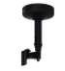  CCEILYBK CEILY CEILY is a bracket that allows eMOTUS series speakers to be mounted on the ceiling. Compatible with 41,23 €  eMOTUS3OD, eMOTUS5P, eMOTUS5PB and eMOTUS5OD. Black colour. | 52,37 € | 16 700 Ft | 21 209 Ft

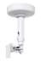  CCEILYWH CEILY CEILY is a bracket that allows eMOTUS series speakers to be mounted on the ceiling. Compatible with 41,23 €  eMOTUS3OD, eMOTUS5P, eMOTUS5PB and eMOTUS5OD. White colour. | 52,37 € | 16 700 Ft | 21 209 Ft

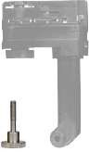  CRAILAPTORWH RAILAPTOR RAILAPTOR is an adapter for hanging compatible loudspeakers from a ceiling light rail. It is suitable for 25,19 €  eMOTUS5OD, AUDEO103 and AUDEO106 cabinets and light rails performing 4 wire 3 circuit track system such as Global Track Pro, Eutrac or other compatible systems. Dimensions: 85x150x30 mm / 3.3"x5.9"x1.2". Weight: 130gr / 0,29lb. White colour. | 31,99 € | 10 200 Ft | 12 954 Ft

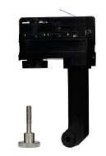  CRAILAPTORBK RAILAPTOR RAILAPTOR is an adapter for hanging compatible loudspeakers from a ceiling light rail. It is suitable for 25,19 €  eMOTUS5OD, AUDEO103 and AUDEO106 cabinets and light rails performing 4 wire 3 circuit track system such as Global Track Pro, Eutrac or other compatible systems. | 31,99 € | 10 200 Ft | 12 954 Ft

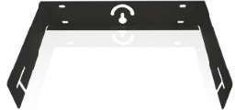  CARQ108UBBK ARQ108UBBK Optional U-BRACKET accessory kit available for the ARQIS108i model. 47,16 €  Black colour. | 59,89 € | 19 100 Ft | 24 257 Ft

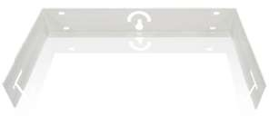  CARQ108UBWH ARQ108UBWH Optional U-BRACKET accessory kit available for the ARQIS108i model. 47,16 €  White colour. | 59,89 € | 19 100 Ft | 24 257 Ft

CARQ110UBBK ARQ110UBBK Optional U-BRACKET accessory kit available for the ARQIS110i model. 58,27 €  Black colour.  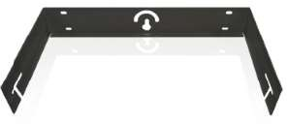 | 74,00 € | 23 600 Ft | 29 972 Ft

CARQ110UBWH ARQ110UBWH Optional U-BRACKET accessory kit available for the ARQIS110i model. 58,27 €  White colour.  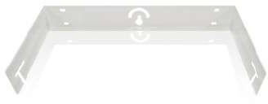 | 74,00 € | 23 600 Ft | 29 972 Ft

CARQ112UBBK ARQ112UBBK Optional U-BRACKET accessory kit available for the ARQIS112i model. 63,21 €  Black colour.  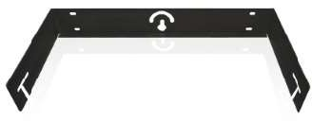 | 80,28 € | 25 600 Ft | 32 512 Ft

CARQ112UBWH ARQ112UBWH Optional U-BRACKET accessory kit available for the ARQIS112i model. 63,21 €  White colour. | 80,28 € | 25 600 Ft | 32 512 Ft

EOL | CARQSB10SATB  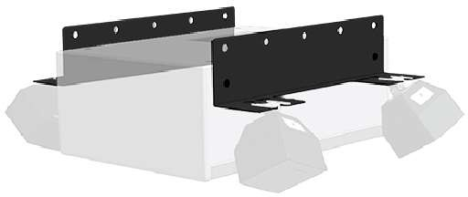 | ARQSB10SATB | Kit including 2 metal brackets, to convert an ARQISSB10i subwoofer unit into a hanging cluster, combining the ARQIS SB10 unit and 4 x eAMBIT103 satellite loudspeakers.  (loudspeakers not included with this reference) | 90,37 € | 114,77 € | 36 600 Ft | 46 482 Ft

EOL | CAVICCAN6L  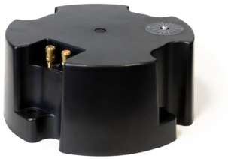 | AVICCAN6L | Low Profile Back Can for VIC6 in-ceiling loudspeakers. Delivered by master carton of 2 units. Price per unit. | 40,25 € | 51,11 € | 16 300 Ft | 20 701 Ft

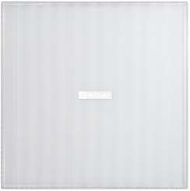  CAVICSG AVICSG Printable squared grill for VIC series (6 & 8 inches compatible). 48,40 €  Magnetic fixation. White colour.  Delivered by master carton of 2 units. Price per pair. | 61,46 € | 19 600 Ft | 24 892 Ft

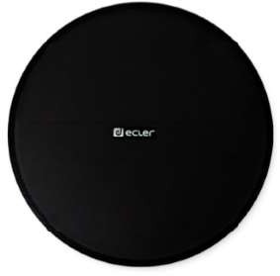  CAVICRG6BK AVICRG6 Printable round grill for VIC series (6 inches compatible). 38,27 €  Magnetic fixation. Black colour.  Delivered by master carton of 2 units. Price per pair. | 48,60 € | 15 500 Ft | 19 685 Ft

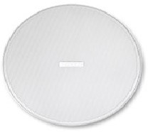  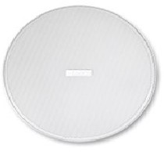  CAVICRG6WH AVICRG6 Printable round grill for VIC series (6 inches compatible). 36,30 €  Magnetic fixation. White colour.  Delivered by master carton of 2 units. Price per pair. | 46,10 € | 14 700 Ft | 18 669 Ft

CAVICRG8BK AVICRG8 Printable round grill for VIC series (8 inches compatible). 36,30 €  Magnetic fixation. Black colour.  Delivered by master carton of 2 units. Price per pair. | 46,10 € | 14 700 Ft | 18 669 Ft

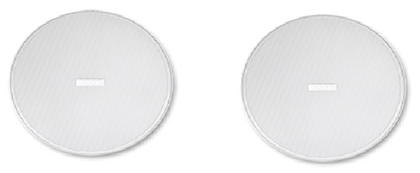  CAVICRG8WH AVICRG8 Printable round grill for VIC series (8 inches compatible). 40,25 €  Magnetic fixation. White colour.  Delivered by master carton of 2 units. Price per pair. | 51,11 € | 16 300 Ft | 20 701 Ft

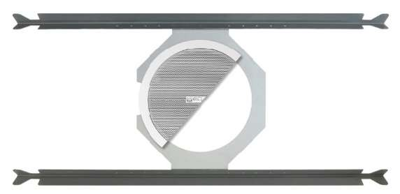  CICTB6 IC-TB6 Tile bridge compatible with IC6 in-ceiling loudspeakers. 40,25 €  Sold in kits of 2 units. Price per kit. | 51,11 € | 16 300 Ft | 20 701 Ft

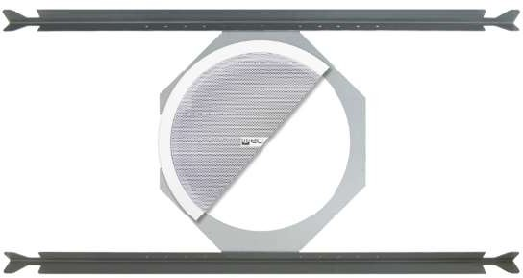  CICTB8 IC-TB8 Tile bridge compatible with IC8 and IC6CLASS series in-ceiling loudspeakers. 80,49 €  Sold in kits of 2 units. Price per kit. | 102,23 € | 32 600 Ft | 41 402 Ft

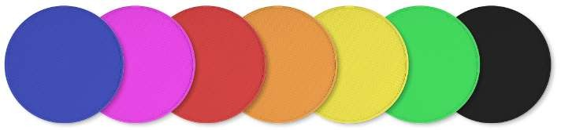  CCOLORPAINT COLORPAINT Launching of painting in ceiling loudspeakers grilles (PKIC6,PKIC8, AVICSG, AVICRG) in a RAL colour . 86,42 €  There is no charge for launching when painting a minimum of 100 units in the same RAL colour. | 109,75 € | 35 000 Ft | 44 450 Ft

CPAINT1S PAINT1S Painting by unit when there are less than 10 units. 240,00 € | 304,80 € | 97 200 Ft | 123 444 Ft

CPAINT10S PAINT10S Painting by unit when there are more than 10 units and with a maximum of 99 units. 39,26 € | 49,86 € | 15 900 Ft | 20 193 Ft

CPAINT100S PAINT100S Painting by unit when there are 100 or more units. 20,25 € | 25,71 € | 8 200 Ft | 10 414 Ft

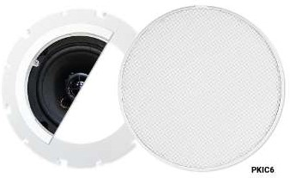  CPKIC6 PKIC6 Accessory for personalizing the IC6 ceiling loudspeaker. The kit includes a grille that can be painted 14,07 €  (with the appearance of the IC6CLASS) and an accessory (anchor ring) to mount this grille on the IC6. Easy to paint and mount. | 17,87 € | 5 700 Ft | 7 239 Ft

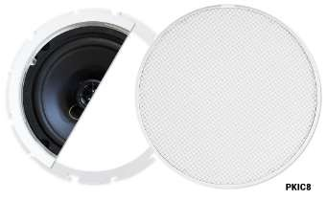  CPKIC8 PKIC8 Accessory to personalize the IC8 ceiling loudspeaker. The kit includes a grille that can be painted (with 42,22 €  the appearance of the IC6CLASS) and an accessory (anchor ring) to mount this grill on the IC8. Easy to paint and mount. | 53,62 € | 17 100 Ft | 21 717 Ft

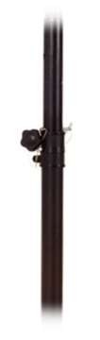  CPOLE01 POLE01 Adjustable 35 mm rod for pole for loudspeaker mount on top of a sub-woofer unit (ARQIS110i on top 42,22 €  of ARQISSB15). | 53,62 € | 17 100 Ft | 21 717 Ft

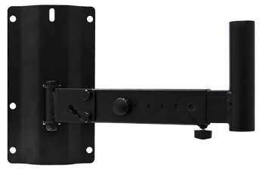  CSR12 SR12 Mount bracket for ARQIS110i and ARQIS112i loudspeakers. 38,27 €  Delivered by master carton of 2 units. Price per unit. | 48,60 € | 15 500 Ft | 19 685 Ft

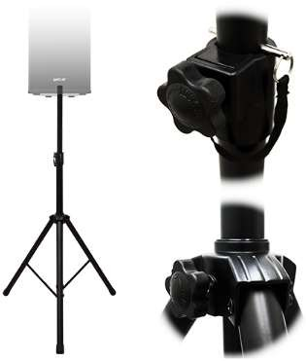  CTRIPO1 TRIPO1 Loudspeaker floor stand with 35 MM pole. 75,31 €  Delivered by master carton of 2 units. Price per unit. | 95,64 € | 30 500 Ft | 38 735 Ft

CLABI1SAC LABI1-SAC Subwoofer-adapter-column, to install the LABI1-C100i satellite loudspeaker on LABI1-SB18p 180,74 €  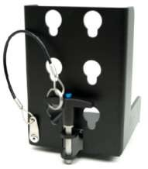 | 229,54 € | 73 200 Ft | 92 964 Ft

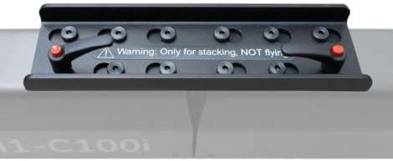  CLABI1CAC LABI1-CAC Column-adapter-column, to connect vertically two LABI1-C100i column loudspeakers. Includes 60cm 215,80 €  Speakon®-Speakon® cable.  Warning: Only for stacking, NOT for flying | 274,07 € | 87 400 Ft | 110 998 Ft

CLABI1TBC LABI1-TBC Truss-Bracket-Column. Support to install a LABI1-C100i loudspeaker to truss 130,62 €  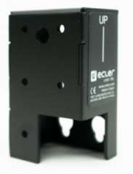 | 165,88 € | 52 900 Ft | 67 183 Ft

CLABI1PBC LABI1-PBC Pole-Bracket-Column. Pole adaptor to install LABI1-C100i loudspeakers in a 35mm standard pole 221,73 €  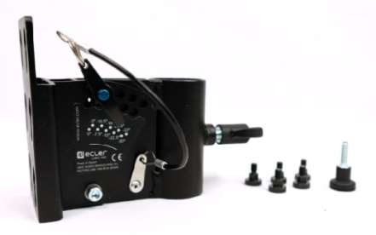 | 281,60 € | 89 800 Ft | 114 046 Ft

CLABI1WBC LABI1-WBC Wall-Bracket-Column. LABI1-C100i wall mount bracket 147,65 €  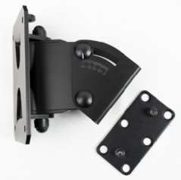 | 187,52 € | 59 800 Ft | 75 946 Ft

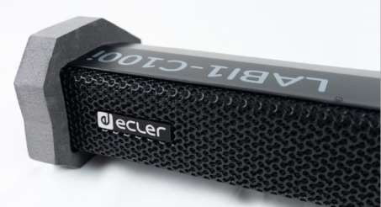  CLABI1HBC LABI1-HBC Horizontal-Bracket-Column. High-density foam pieces to let LABI1-C100i rest on the floor horizontally. 37,28 €  Allows 0º/ 30º/ 45º inclinations relative to the horizontal surface | 47,35 € | 15 100 Ft | 19 177 Ft

CLABI1ODCNX LABI1-ODCNX Outdoor kit to cover LABI1-C100i connections and make it ready for outdoor applications 75,31 €  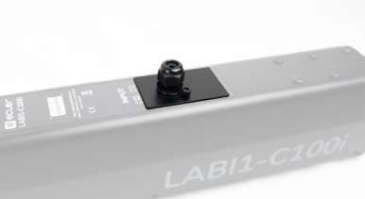 | 95,64 € | 30 500 Ft | 38 735 Ft

VIDEO

SWITCHERS
Ref
Name
Nettó lista ár Bruttó lista Nettó lista ár Bruttó lista ár
EUR ár EUR HUF HUF

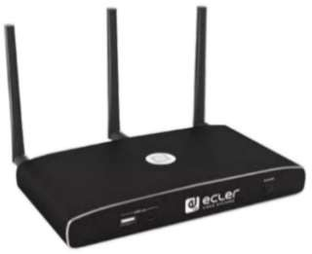  CVEOSWC44 VEO-SWC44 Wireless conferencing and presentation switcher with Full HD video resolution wireless inputs and a 4K 972,35 €  / UHD HDMI 2.0 video output. It supports wireless connection for USB devices like webcam and mic via dongle, Windows & macOS applications and is also Airplay / Miracast compliant. An integrated audio de-embedder provides stereo unbalanced analogue output on a 3,5mm jack connector. Includes a WebGUI for configuration and management as well as RS-232,TCP/IP remote control, all enabled by a pair of LAN RJ-45 connectors with independent networks available. Support for PoE. Dimensions 41x220x120 mm / 1.6"x8.66"x4.72". Weight 1 kg / 2.2 lb. | 1 234,88 € | 393 800 Ft | 500 126 Ft

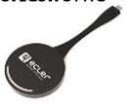  CVEOSWC44TU VEO-SWC44TU Plug-n-play USB Type-C for VEO-SWC44 wireless connection with a laptop or PC. 303,21 € | 385,08 € | 122 800 Ft | 155 956 Ft

CVEOSWC44TH VEO-SWC44TH Plug-n-play HDMI for VEO-SWC44 wireless connection with a laptop or PC. 303,21 €  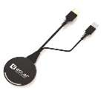 | 385,08 € | 122 800 Ft | 155 956 Ft

NEW! | 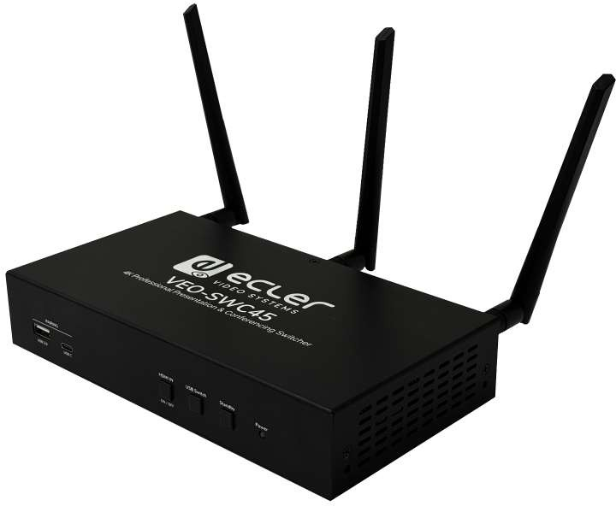  CVEOSWC45 | VEO-SWC45 | VEO-SWC45 is a professional 4K presentation and conferencing switcher designed for seamless connectivity via HDMI and wireless technologies. Supporting effortless collaboration, it features two HDMI video outputs with advanced screen management and a set of USB ports for integration with existing videoconference systems, including smart local camera switching capabilities. 1080p wireless presentation and conferencing are enabled through Chromecast, Miracast, Airplay, VEOShare app, and 4K wireless transmitter accessories VEO-SWC45TH and VEOSWC45TU for HDMI and USB-C connections. Dimensions 41x220x120 mm / 1.6"x8.66"x4.72". Weight 1 kg / 2.2 lb. | 1 303,46 € | 1 655,39 € | 527 900 Ft | 670 433 Ft

NEW! | 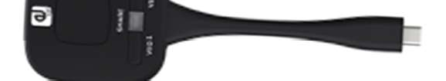    CVEOSWC45TU | VEO-SWC45TU | Plug-n-play USB Type-C for VEO-SWC45 wireless connection with a laptop or PC. | 316,05 € | 401,38 € | 128 000 Ft | 162 560 Ft

    NEW! CVEOSWC45TH VEO-SWC45TH Plug-n-play HDMI for VEO-SWC45 wireless connection with a laptop or PC. 316,05 € | 401,38 € | 128 000 Ft | 162 560 Ft

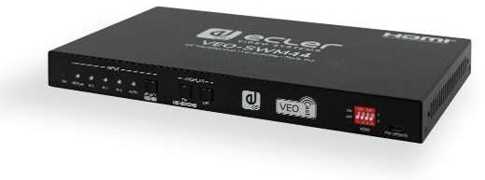  CVEOSWM44 VEO-SWM44 VEO-SWM44 is a compact 4K presentation switcher that includes 2 HDMI 2.0, a USB-C and 1 258,27 €  Miracast/Airplay wireless input selection via VEOCast to a single HDMI 2.0 output, supporting resolutions up to 4K/60Hz 4:4:4 HDR10 and Dolby Vision. An integrated audio de-embedder provides stereo analogue balanced outputs on Euroblock connectors. VEO-SWM44 includes 2 USB 3.0 type B and 2 USB 3.0 type A in order to support soft codec applications and external devices like webcam and KVM kits. Input selection is available via Auto-switching function, front panel buttons or RS-232.  Display control via front panel buttons through CEC or RS-232. Smart EDID management and HDCP 2.2 support.  Dimensions (WxHxD) 220mm x 44mm x 150mm / 8.66“ x 1.73“ x 5.90“ Weight 1,25 Kg / 2.75 lb | 1 598,00 € | 509 600 Ft | 647 192 Ft

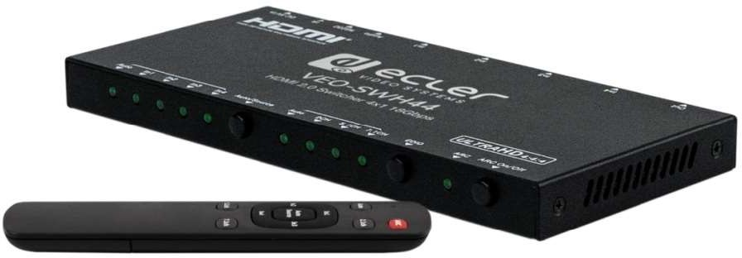  CVEOSWH44 VEO-SWH44 4x1 HDMI switcher for high dynamic range (HDR) formats. It is HDCP 2.2 compliant and supports 230,86 €  4K/UHD video @ 60 Hz with 4:4:4 chroma sampling, as well as HDMI signals with bandwidth up to 18 Gbps. It is the ideal solution for applications requiring 4K/UHD and HDR sources and displays. VEO- SWH44 includes audio de-embedding features and audio EDID management. The HDMI selection could be automatic (sense selection) and manual (frontal panel, remote control or serial commands). The controls include ARC mute and LED indications of the selected sources and settings.  Dimensions (WxHxD) 85 x 12 x 180 mm / 3.34” x 0.47” x 7.09” Weight 300g / 0.66 lb | 293,20 € | 93 500 Ft | 118 745 Ft

MATRIXES
Ref
Name
Nettó lista ár Bruttó lista Nettó lista ár Bruttó lista ár
EUR ár EUR HUF HUF

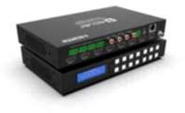  CVEOMXH44D VEO-MXH44D 4x4 HDMI 2.0 matrix with support for up to 4K/UHD video resolution, 60 Hz and 714,32 €  4:4:4 chroma sampling. It includes 8 analogue and digital audio de-embedding outputs as well as EDID management, a LCD display and an integrated WebGUI that allows to configure and control the unit. VEO-MXH44D can load and launch up to 8 presets which makes it a very interesting solution for professional applications that require video and audio HDMI signals routing between 4K/UHD sources and displays with a smart control management. Control via front panel and display, IR remote, RS-232 control, IP control and WebGUI. Dimensions 34x216x128mm / 1,34”x8,50”x5,04”. Weight 470g / 1,04 lb. | 907,19 € | 289 300 Ft | 367 411 Ft

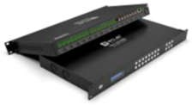  CVEOMXH88D VEO-MXH88D 8x8 HDMI 2.0 matrix with support for up to 4K/UHD video resolution, 60 Hz and 4:4:4 2 000,49 €  chroma sampling. It includes 8 analogue audio inputs and 16 analogue and digital audio de-embedding outputs as well as EDID management, a LCD display and an integrated WebGUI that allows to configure and control the unit. VEO-MXH88D can load and  launch up to 8 presets which makes it a very interesting solution for professional applications that require video and audio HDMI signals routing between 4K/UHD sources and displays with a smart control management. Control via front panel and display, IR remote, RS-232 control, IP control and WebGUI. Dimensions 44x482x220mm / 1,73”x18,97”x8,66”. Weight 2800g / 6,17 lb. | 2 540,63 € | 810 200 Ft | 1 028 954 Ft

NEW! | 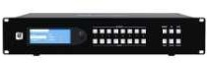  CVEOMXH48T | VEO-MXH48T | VEO-MXH48T is a 8x8 HDBaseT and HDMI® matrix with support for up to 4K/UHD video resolution, 60 Hz and 4:4:4 chroma sampling. It includes 8 analogue audio inputs and 16 analogue and digital audio de-embedding outputs as well as EDID management, a LCD display and an integrated WebGUI that allows to configure and control the unit in a very user friendly way. The HDBaseT outputs can deliver 4K/UHD video up to 40m and Full HD video up to 70m as well as PoC power supply to HDBaseT compliant receivers. It includes a video downscaler and an independent audio matrix. Dimensions  482.6 x 88 x 394 mm / 19 x 3.46 x 15.51 in. Weight 8.3 Kg / 18.30 lb. | 3 597,78 € | 4 569,18 € | 1 457 100 Ft | 1 850 517 Ft

SPLITTERS
Nettó lista ár Bruttó lista Nettó lista ár Bruttó lista ár EUR ár EUR HUF HUF

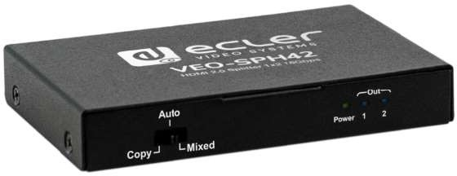  CVEOSPH42 VEO-SPH42 1×2 HDMI splitter for high dynamic range (HDR) formats. It is HDCP 2.2/1.4 compliant and supports 145,68 €  4K/UHD video @ 60 Hz with 4:4:4 chroma sampling, as well as HDMI signals with bandwidth up to 18 Gbps. It is the ideal solution for applications requiring 4K/UHD and HDR sources and displays. It includes EDID management features, front panel LED indicators for power and signal status.  Dimensions (WxHxD) 94mm x 15mm x 61mm / 3.7“ x 0.59“ x 2.4“ Weight 120g / 0.265 lb | 185,01 € | 59 000 Ft | 74 930 Ft

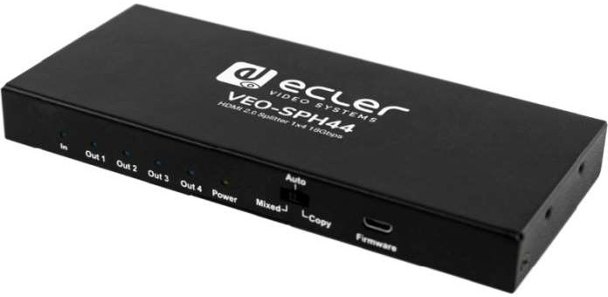  CVEOSPH44 VEO-SPH44 1×4 HDMI splitter for high dynamic range (HDR) formats. It is HDCP 2.2/1.4 compliant and supports 189,63 €  4K/UHD video @ 60 Hz with 4:4:4 chroma sampling, as well as HDMI signals with bandwidth up to 18 Gbps. It is the ideal solution for applications requiring 4K/UHD and HDR sources and displays. It includes EDID management features, front panel LED indicators for power and signal status.  Dimensions (WxHxD) 150mm x 17mm x 65mm / 5.9" x 0.67"x 2.56" Weight 245g / 0.54 lb | 240,83 € | 76 800 Ft | 97 536 Ft

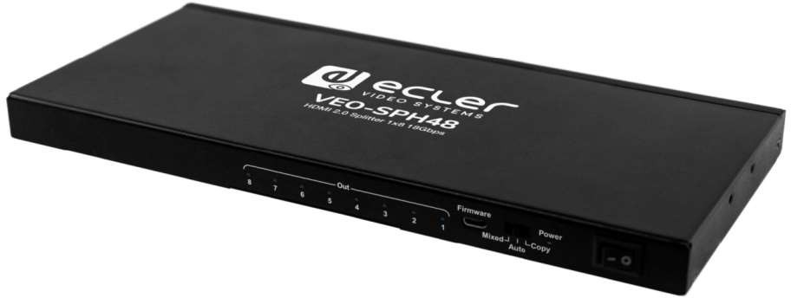  CVEOSPH48 VEO-SPH48 1×8 HDMI splitter for high dynamic range (HDR) formats. It is HDCP 2.2/1.4 compliant and supports 380,25 €  4K/UHD video @ 60 Hz with 4:4:4 chroma sampling, as well as HDMI signals with bandwidth up to 18 Gbps. It is the ideal solution for applications requiring 4K/UHD and HDR sources and displays. It includes EDID management features, front panel LED indicators for power and signal status.  Dimensions (WxHxD) 248mm x 17mm x 110mm / 9.76” x 0.67” x 4.33” Weight 610g / 1.34 lb | 482,91 € | 154 000 Ft | 195 580 Ft

NEW! | 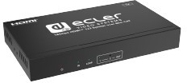  CVEOSPS42 | VEO-SPS42 | 1x2 18Gbps HDMI splitters that allows an HDMI source signal to be distributed and extended to remote displays, supporting up to 4K 60Hz 4:4:4 video signals. It includes an HDMI loop output and two main single Cat outputs, allowing for transmission distances of up to 35 meters for 4K/60Hz, 50 meters for 4K/30Hz, or 60 meters for 1080p over a single Cat 5e or higher cable. Supports one-way IR control signal pass-through, stereo unbalanced audio extraction on Euroblock connector, EDID management, and RS-232 serial control. Dimensions (WxHxD) 94mm x 15mm x 61mm / 3.7“ x 0.59“ x 2.4“ Weight 120g / 0.265 lb | 350,37 € | 444,97 € | 141 900 Ft | 180 213 Ft

NEW! | 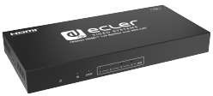  CVEOSPS44 | VEO-SPS44 | 1x4 18Gbps HDMI splitters that allows an HDMI source signal to be distributed and extended to remote displays, supporting up to 4K 60Hz 4:4:4 video signals. It includes an HDMI loop output and four main single Cat outputs, allowing for transmission distances of up to 35 meters for 4K/60Hz, 50 meters for 4K/30Hz, or 60 meters for 1080p over a single Cat 5e or higher cable. Supports one-way IR control signal pass-through, stereo unbalanced audio extraction on Euroblock connector, EDID management, and RS-232 serial control. Dimensions (WxHxD) 150mm x 17mm x 65mm / 5.9" x 0.67"x 2.56"  Weight 245g / 0.54 lb | 600,99 € | 763,25 € | 243 400 Ft | 309 118 Ft

NEW! | 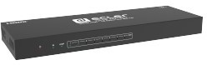  CVEOSPS48 | VEO-SPS48 | 1x8 18Gbps HDMI splitters that allows an HDMI source signal to be distributed and extended to remote displays, supporting up to 4K 60Hz 4:4:4 video signals. It includes an HDMI loop output and eight main single Cat outputs, allowing for transmission distances of up to 35 meters for 4K/60Hz, 50 meters for 4K/30Hz, or 60 meters for 1080p over a single Cat 5e or higher cable. Supports one-way IR control signal pass-through, stereo unbalanced audio extraction on Euroblock connector, EDID management, and RS-232 serial control,. Dimensions (WxHxD) 248mm x 17mm x 110mm / 9.76” x 0.67” x 4.33” Weight 610g / 1.34 lb | 1 002,47 € | 1 273,14 € | 406 000 Ft | 515 620 Ft

VIDEO DISTRIBUTION OVER IP
Nettó lista ár Bruttó lista Nettó lista ár Bruttó lista ár EUR ár EUR HUF HUF

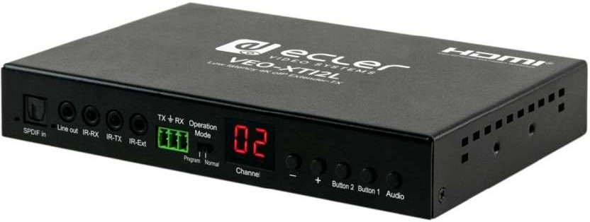  CVEOXTI2L VEO-XTI2L VEO-XTI2L and VEO-XRI2L are low latency 4K HDMI extenders over IP. Suitable both for creation of 668,40 €  AVoverIP matrixes in multipoint-tomultipoint configurations and for point-to-point extensions up to 120m via single Cat.5e/6 cable. They also provide optional fiber optic connection for extension of 4K signals up to 2Km. Additional features like analog and digital audio embedding and de-embedding, and videowall option make this product a very versatile solution for many applications. An intuitive user panel with LEDs display allows to select the stream channel just out of the box, without the need of connecting a PC. The extenders can be power supplied both via PoE or via the included external PSU. Web browser interface, PC tools and third party control protocol are available for advanced settings and advanced control.  Dimensions (WxHxD) 170 x 26 x 109 mm / 6.69” x 1.02” x 4.29” Weight 470g / 1.04 lb | 848,86 € | 270 700 Ft | 343 789 Ft

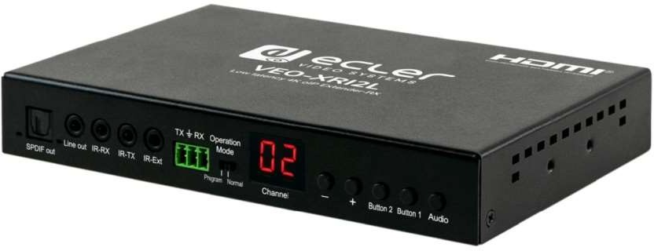  CVEOXRI2L VEO-XRI2L VEO-XTI2L and VEO-XRI2L are low latency 4K HDMI extenders over IP. Suitable both for creation of 740,49 €  AVoverIP matrixes in multipoint-tomultipoint configurations and for point-to-point extensions up to 120m via single Cat.5e/6 cable. They also provide optional fiber optic connection for extension of 4K signals up to 2Km. Additional features like analog and digital audio embedding and de-embedding, and videowall option make this product a very versatile solution for many applications. An intuitive user panel with LEDs display allows to select the stream channel just out of the box, without the need of connecting a PC. The extenders can be power supplied both via PoE or via the included external PSU. Web browser interface, PC tools and third party control protocol are available for advanced settings and advanced control.  Dimensions (WxHxD) 170 x 26 x 109 mm / 6.69” x 1.02” x 4.29” Weight 470g / 1.04 lb | 940,43 € | 299 900 Ft | 380 873 Ft

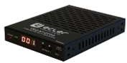  CVEOXTI1CG2 VEO-XTI1CG2 VEO-XTI1CG2 transmitter and VEO-XRI1CG2 receiver are a H.265 / H.264 over IP set of extenders that 385,43 €  allow for HDMI distribution over 1Gb Ethernet networks with up to 1080p@60Hz video support. Suitable for various applications which also require PoE, audio management, video wall compositing or RS-232 control, such as educational, commercial or corporate installations, where flexible and scalable AV systems are in need. Signal transmission distance up to 100m over Cat5e/6/7 cable. Support for audio embedding and extraction. Support for pass through and RS-232, TCP/IP, WebGUI management using VEO-XCTRLG2 controller module. Dimensions 21,5x95x120mm  / 0,85”x3,74”x4,72”. Weight 74g / 0,16 lb. | 489,50 € | 156 100 Ft | 198 247 Ft

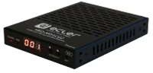  CVEOXRI1CG2 VEO-XRI1CG2 VEO-XTI1CG2 transmitter and VEO-XRI1CG2 receiver are a H.265 / H.264 over IP set of extenders that 385,43 €  allow for HDMI distribution over 1Gb Ethernet networks with up to 1080p@60Hz video support. Suitable for various applications which also require PoE, audio management, video wall compositing or RS-232 control, such as educational, commercial or corporate installations, where flexible and scalable AV systems are in need. Signal transmission distance up to 100m over Cat5e/6/7 cable. Support for audio embedding and extraction. Support for PoE function. Support for pass through and RS-232, TCP/IP, WebGUI management using VEO-XCTRLG2 controller module. Dimensions 21,5x95x120mm / 0,85”x3,74”x4,72”. Weight 74g / 0,16 lb. | 489,50 € | 156 100 Ft | 198 247 Ft

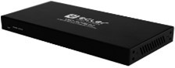  CVEOXCTRLG2 VEO-XCTRLG2 Control module for and expanded management experience with in-built WEB configuration interface. 360,25 €  Dimensions 204 x 21.5 x 98.5mm / 4.7 x 0.85 x 3.88 in. Weight  0.540 Kg / 1.19 lb | 457,51 € | 145 900 Ft | 185 293 Ft

NEW! | CWPTI1CG2  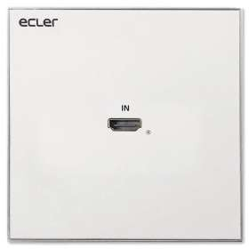 | WPTI1CG2 | WPTI1CG2 transmitter is a professional H.265 / H.264 device designed for HDMI distribution over 1Gb Ethernet networks, supporting resolutions up to WUXGA and 1080p. It delivers high-quality video compression over distances of up to 100 meters using a single Cat 5e or higher cable. Its wallplate design, featuring an HDMI input, RJ-45 port with PoE, and a reset button, provides an elegant solution for visible installations. Control and configuration are managed via the built-in Web GUI or pairing it with the VEO-XCTRLG2 controller, ensuring an easy setup and reliable performance.. Dimensions 86 x 38 x 86 mm. Weight TBC | 321,23 € | 407,97 € | 130 100 Ft | 165 227 Ft

EXTENDERS
Nettó lista ár Bruttó lista Nettó lista ár Bruttó lista ár EUR ár EUR HUF HUF

NEW! | 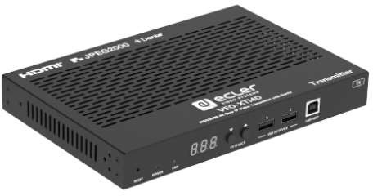    CVEOXTI4D | VEO-XTI4D | VEO-XTI4D transmitter is a professional JPEG2000 over IP extender that enable secure HDMI distribution with 18Gbps bandwidth, supporting 4K 60Hz 4:4:4 video over 1Gb Ethernet networks, reaching distances up to 100 meters on a single Cat 5e or higher cable and a transmission latency of 1- 2 frames. Equipped with dual RJ-45 ports, these units support independent or combined network configurations for Dante AV-A. Advanced video wall management up to a 9x9 configuration is also supported when paired with the VEO-XCTRL4D controller, along with additional control options.  Dimensions: 204 x 25.5 x 136 mm / 8.03 x 1.0 x 5.35 in. Weight: 0.631 Kg / 1.391 lb. | 901,98 € | 1 145,51 € | 365 300 Ft | 463 931 Ft

NEW! | 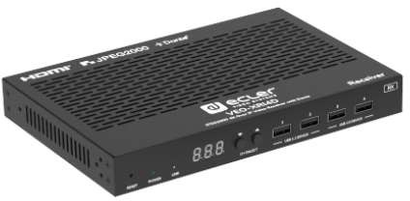  CVEOXRI4D | VEO-XRI4D | VEO-XTI4D receiver is a professional JPEG2000 over IP extender that enable secure HDMI distribution with 18Gbps bandwidth, supporting 4K 60Hz 4:4:4 video over 1Gb Ethernet networks, reaching distances up to 100 meters on a single Cat 5e or higher cable and a transmission latency of 1-2 frames. Equipped with dual RJ-45 ports, these units support independent or combined network configurations for Dante AV-A. Advanced video wall management up to a 9x9 configuration is also supported when paired with the VEO-XCTRL4D controller, along with additional control options.  Dimensions: 204 x 25.5 x 136 mm / 8.03 x 1.0 x 5.35 in. Weight: 0.631 Kg / 1.391 lb. | 901,98 € | 1 145,51 € | 365 300 Ft | 463 931 Ft

NEW! | 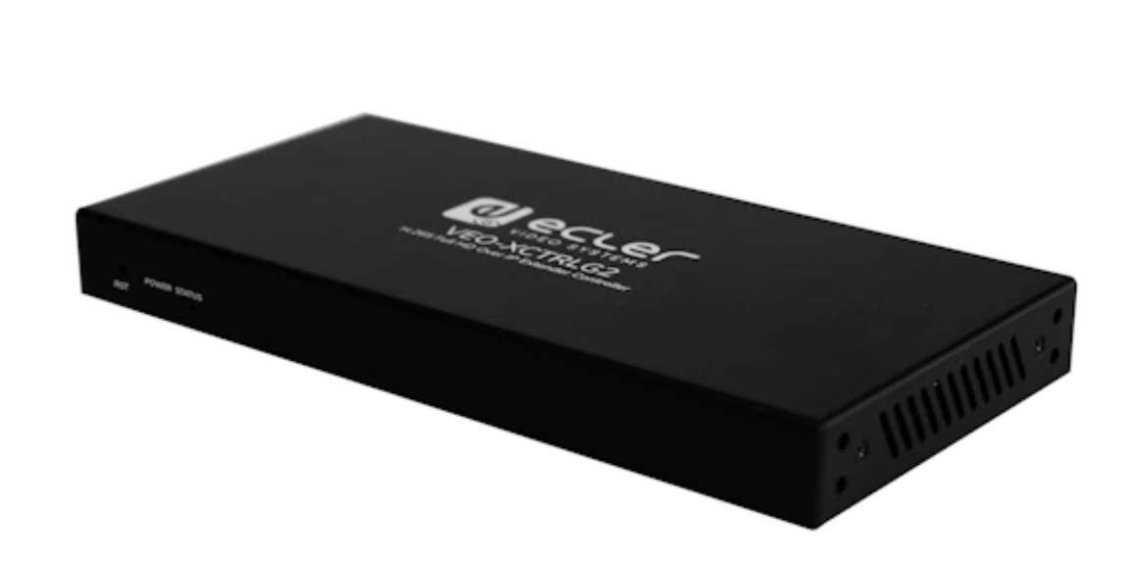  CVEOXRI4D | VEO-XRI4D | Control module for and expanded management experience with in-built WEB configuration interface. Dimensions 204 x 21.5 x 98.5mm / 4.7 x 0.85 x 3.88 in. Weight  0.540 Kg / 1.19 lb | 351,36 € | 446,22 € | 142 300 Ft | 180 721 Ft
HDBASET
Nettó lista ár Bruttó lista Nettó lista ár Bruttó lista ár
EUR ár EUR HUF HUF

NEW! | 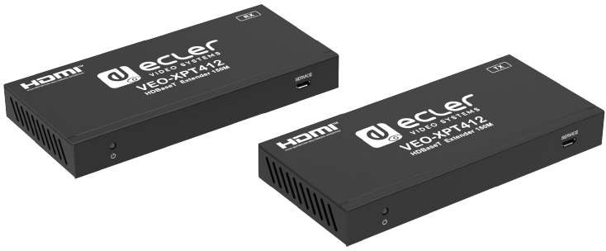    CVEOXPT412 | VEO-XPT412 | VEO-XPT412 is a professional HDBaseT extension kit that includes both a transmitter and a receiver. Its 18 Gbps HDMI connectors allow for the extension of 4K video signals at 60Hz 4:4:4 up to 120 meters, or Full HD signals up to 150 meters, over a single Cat 5e or higher cable. Dimensions TBC. Weight: TBC | 500,74 € | 635,94 € | 202 800 Ft | 257 556 Ft

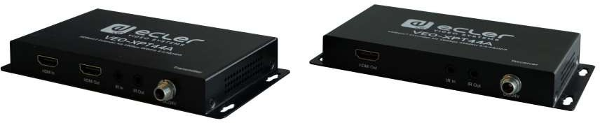  CVEOXPT44A VEO-XPT44A VEO-XPT44A allows to extend a 4K video signal up to 40m or a Full HD signal up to 70m over a single 474,57 €  Cat 5e/6 cable. It supports 4K video signals at 60Hz with 4:4:4 YUV chroma subsampling and HDR10. The transmitter includes a HDMI loop output for monitoring or daisy-chain connection. A stereo unbalanced output on Euroblock connector is available both, on the transmitter and the receiver, for easy integration. In addition, VEO-XPT44A includes bidirectional PoH feature so the transmitter can be powered by the receiver and vice versa. With a reduced form factor and the added features of RS-232 and bidirectional IR, this is the perfect solution for any applications where AV and control extensions are required. Dimensions 154,4mm × 78,3mm × 20mm / 6.08“x 3.08“x 0.79“. Weight: 688g / 1.52lbs (Pair) | 602,70 € | 192 200 Ft | 244 094 Ft

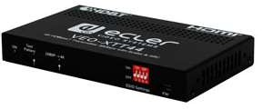  CVEOXTT44 VEO-XTT44 Ecler VEO-XTT44 is a professional HDBaseT Transmitter of High Dynamic Range (HDR) formats for 328,15 €  HDMI 2.0 extension. The extenders support video signal resolution up to 4K/UHD at 60Hz with 4:4:4 chroma sampling and HDMI data rate up to 18Gbps. Upscale fullHD input to 4K. Bidirectional PoH (Power Over HDBaseT) A 4-pin DIP switch allows managing EDID with multiple and customizable options. Include audio de-embedding and ARC support, bi-directional IR and RS-232 pass-through. A video pattern generator is included for testing purposes during the installation.  Dimensions (WxHxD) 140mm × 84mm × 20mm / 5.51“ x 3.31” x 0.79“ Weight 275g / 0,606 lb | 416,75 € | 132 900 Ft | 168 783 Ft

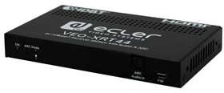  CVEOXRT44 VEO-XRT44 Ecler VEO-XRT44 is a professional HDBaseT Receiver of High Dynamic Range (HDR) formats for HDMI 328,15 €  2.0 extension. The extenders support video signal resolution up to 4K/UHD at 60Hz with 4:4:4 chroma sampling and HDMI data rate up to 18Gbps. The scaler implemented in the TX allows to upscale fullHD input to 4K. Bidirectional PoH (Power Over HDBaseT) . A 4-pin DIP switch allows managing EDID with multiple and customizable options. The extenders include audio de-embedding and ARC support, bi- directional IR and RS-232 pass-through  Dimensions (WxHxD) 140mm × 84mm × 20mm / 5.51“ x 3.31” x 0.79“  Weight 290g / 0,640 lb | 416,75 € | 132 900 Ft | 168 783 Ft

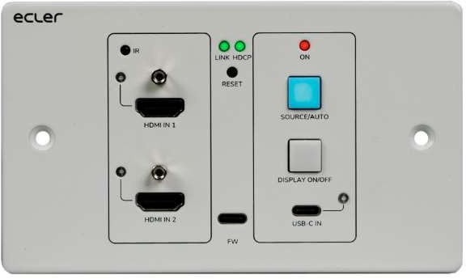  CVEOXWT44E VEO-XWT44E Ecler VEO-XWT44 is a HDbaseT transmitter in European 2-gang wallplate format. It allows to extend 776,54 €  one 4K video signal up to 40m over a single Cat 5e/6 cable or a FullHD signal up to 70m when connected to VEO-XRT44. It supports real 4K video signals at 60Hz with 4:4:4 YUV chroma subsampling and HDR 10 with a maximum bandwidth of 18Gbps. With bidirectional PoC feature, the transmitter can be powered by the receiver and vice versa. VEO-XWT44 includes 2 HDMI 2.0 Inputs and one USB-C Input selectable via front panel button, automatic switching feature or RS-232. It allows extending IR and a bidirectional RS-232 signal along with the video signal. Dimensions(WxHxD) 146mm × 86mm × 42mm / 5.75” x 3.39” x 1.65”. Weight 294g / 0.648 lbs | 986,21 € | 314 500 Ft | 399 415 Ft
HDMI
Nettó lista ár Bruttó lista Nettó lista ár Bruttó lista ár
EUR ár EUR HUF HUF

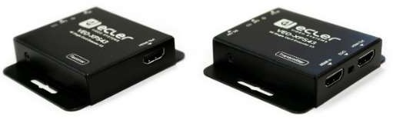  CVEOXPS43 VEO-XPS43 VEO-XPS43 is a professional HDMI extender kit that delivers 4K@30Hz up to 30m and a 1080p@60Hz 149,63 €  up to 60m HDMI video extension over a single Cat. 6 cable or higher, with zero-latency, and 480i/480p/720p/1080i/1080p/UHD/4K resolution support. It includes unidirectional PoC (the receiver powered by the transmitter) and EDID management features as well as IR pass through, from the display to the source, for seamless integration. The transmitter also includes a HDMI loop output useful when integrating local displays and/or cascading to multiple devices.  Dimensions 79.5mm x 69mm x 16.5mm (3.13”x2.71”x0.65”) Weight TX: 132g / 0.291lbs, RX: 130g /  0.286 lbs | 190,03 € | 60 600 Ft | 76 962 Ft

NEW! | 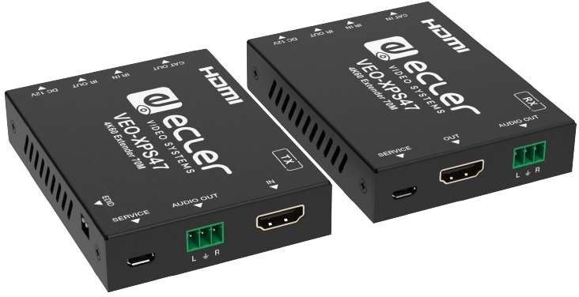  CVEOXPS47 | VEO-XPS47 | VEO-XPS47 is an HDMI 18Gbps extender kit that includes both a transmitter and a receiver. It enables 4K 50Hz 4:4:4 video signals to be extended up to 70 meters with zero latency over a single Cat 5e or higher cable.  Dimensions TBC Weight TBC. | 235,80 € | 299,47 € | 95 500 Ft | 121 285 Ft

AUDIO MANAGEMENT DEVICES
Nettó lista ár Bruttó lista Nettó lista ár Bruttó lista ár EUR ár EUR HUF HUF

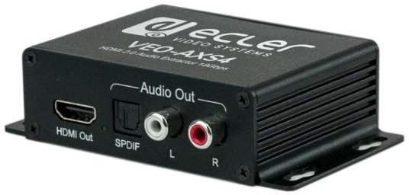  CVEOAXS4 VEO-AXS4 The VEO-AXS4 allows to extract audio signals from HDMI signals up to 4K. It provides a stereo analog 122,47 €  output on RCA connectors or a 5.1 digital output on Toslink connector, selectable through the onboard switch.  Dimensions (WxHxD) 105mm x 29mm x 65mm / 4.13” x 2.56” x 1.14” Weight 175g / 0.39 lb | 155,54 € | 49 600 Ft | 62 992 Ft

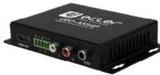  CVEOAXS4P VEO-AXS4P Ecler VEO-AXS4P is a professional HDMI audio extractor that allows to de-embed audio from a HDMI 153,58 €  signal, including audio from 4K sources. VEO-AXS4P provides uncompressed LPCM analogue stereo signal through RCA and Phoenix balanced output as well as Dolby Digital and DTS multichannel signals through the coaxial S/PDIF digital output. VEO-AXS4P is HDCP 2.2 and HDMI 2.0 compliant, supporting data rates up to 18 Gbps and video resolutions up to 4K/60Hz with 4:4:4 chroma sample and HDR contents.  Dimensions (WxHxD) 21.5 x 77 x 129 mm / 0.85” x 3.03” x 5.08”  Weight 244 g / 0.538 lb | 195,05 € | 62 200 Ft | 78 994 Ft

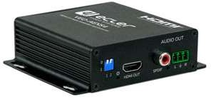  CVEOAEXS4 VEO-AEXS4 VEO-AEXS4 allows to extract audio signals from HDMI streams up to 4K or to embed a stereo analogue 132,59 €  signal into the HDMI, replacing the original sound. It provides a stereo unbalanced analogue input and output on Euroblock connectors, or a 5.1 digital output on S/PDIF coaxial connector. Function mode is selectable through the onboard dip-switch. Dimensions: 104.4 x 89 x 28.3mm (4.11 x 3.5x 1.11 inches). Weight: 155g / 0,342 lb | 168,39 € | 53 700 Ft | 68 199 Ft

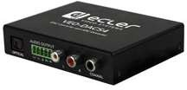  CVEODACS4 VEO-DACS4 VEO-DACS4 allows to convert a digital audio signals from HDMI ARC inputs, S/PDIF Toslink or Coaxial, 101,48 €  to a stereo analogue signal. In addition it can be used to convert digital S/PDIF audio from Toslink to Coaxial and vice versa. It provides a stereo balanced analogue output on Euroblock connectors, and RCA. Function mode is selectable through the onboard switch. Dimensions: 96.2 x 47.6 x 21mm ( 3.79 x 1.87 x 0.83 inches). Weight: 155 g (0.309 lbs) | 128,88 € | 41 100 Ft | 52 197 Ft
AV INTERFACES
Nettó lista ár Bruttó lista Nettó lista ár Bruttó lista ár EUR ár EUR HUF HUF

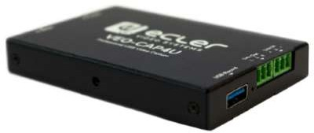  CVEOCAP4U VEO-CAP4U VEO-CAP4U is a plug-n-play HDMI to USB video capture device aimed for online media creators, 245,93 €  schools,educational and corporate market etc. that require a professional solution for capturing and streaming their audiovisual content. This product is designed to easily record video and audio from an HDMI source, and send it to a PC / MAC over USB 3.0 without the need of an external power supply or installation drivers. A balanced line input automatically mixes an external sound source into the main audio stream. Dimensions: 102mm × 68mm × 12mm (4.02” x 2.68” x 0.59”). Weight: 75g / 0.165 lbs | 312,33 € | 99 600 Ft | 126 492 Ft
ACCESSORIES
Nettó lista ár Bruttó lista Nettó lista ár Bruttó lista ár EUR ár EUR HUF HUF

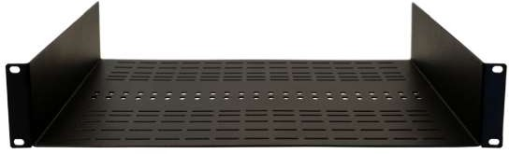  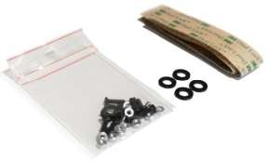  CVEORACK19 VEO-RACK19 Univ. 19” Rack mount shelf VEO series. Includes 12 x M3 screws with nuts and Dual Lock™ tape for 101,48 €  devices not provided of mounting ears. Central holes for cable ties. | 128,88 € | 41 100 Ft | 52 197 Ft

NEW! | 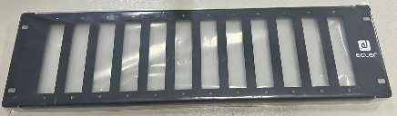  CVEORK1CG2 | VEO-RK1CG2 | VEO-RK1CG2 rack mount shelf is specifically designed for the VEO-1CG2 series, targeting the professional video market. Its 3U/19” frame supports both front and rear orientations for the mounted devices, enhancing its versatility across different setups. This shelf comes equipped with brackets and screws, enabling the installation of up to 12 VEO-XTI1CG2 or VEO-XRI1CG2 units. Dimensions: 483x132x15 mm / 19.02 x 5.20 x 0.59 in., Weight: 1.32 kg / 2.92 lb. | 175,80 € | 223,27 € | 71 200 Ft | 90 424 Ft

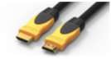  CVEOCH200 VEO-CH200 VEO-CH200 is a high speed HDMI 2.0 cable with Ethernet. 7,16 €  These high quality cables are the perfect solution for professional installations, ensuring reliable and seamless HDMI 2.0 connections up to 18Gbps.  All cables support HDMI, Ethernet, Audio and Control (ARC and CEC) signals. Length: 0.5m | 9,09 € | 2 900 Ft | 3 683 Ft

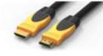  CVEOCH201 VEO-CH201 VEO-CH201 is a high speed HDMI 2.0 cable with Ethernet. 9,14 €  These high quality cables are the perfect solution for professional installations, ensuring reliable and seamless HDMI 2.0 connections up to 18Gbps.  All cables support HDMI, Ethernet, Audio and Control (ARC and CEC) signals. Length: 1m | 11,60 € | 3 700 Ft | 4 699 Ft

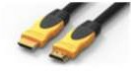  CVEOCH202 VEO-CH202 VEO-CH202 is a high speed HDMI 2.0 cable with Ethernet. 12,10 €  These high quality cables are the perfect solution for professional installations, ensuring reliable and seamless HDMI 2.0 connections up to 18Gbps.  All cables support HDMI, Ethernet, Audio and Control (ARC and CEC) signals. Length: 2m | 15,37 € | 4 900 Ft | 6 223 Ft

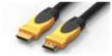  CVEOCH203 VEO-CH203 VEO-CH203 is a high speed HDMI 2.0 cable with Ethernet. 16,30 €  These high quality cables are the perfect solution for professional installations, ensuring reliable and seamless HDMI 2.0 connections up to 18Gbps.  All cables support HDMI, Ethernet, Audio and Control (ARC and CEC) signals. Length: 3m | 20,70 € | 6 600 Ft | 8 382 Ft

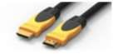  CVEOCH205 VEO-CH205 VEO-CH205 is a high speed HDMI 2.0 cable with Ethernet. 21,23 €  These high quality cables are the perfect solution for professional installations, ensuring reliable and seamless HDMI 2.0 connections up to 18Gbps.  All cables support HDMI, Ethernet, Audio and Control (ARC and CEC) signals. Length: 5m | 26,97 € | 8 600 Ft | 10 922 Ft

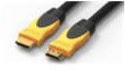  CVEOCH208 VEO-CH208 VEO-CH208 is a high speed HDMI 2.0 cable with Ethernet. 36,30 €  These high quality cables are the perfect solution for professional installations, ensuring reliable and seamless HDMI 2.0 connections up to 18Gbps.  All cables support HDMI, Ethernet, Audio and Control (ARC and CEC) signals. Length: 8m | 46,10 € | 14 700 Ft | 18 669 Ft

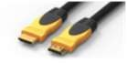  CVEOCH210 VEO-CH210 VEO-CH210 is a high speed HDMI 2.0 cable with Ethernet. 54,32 €  These high quality cables are the perfect solution for professional installations, ensuring reliable and seamless HDMI 2.0 connections up to 18Gbps.  All cables support HDMI, Ethernet, Audio and Control (ARC and CEC) signals. Length: 10m | 68,99 € | 22 000 Ft | 27 940 Ft

NEW! | CVEOXCH415  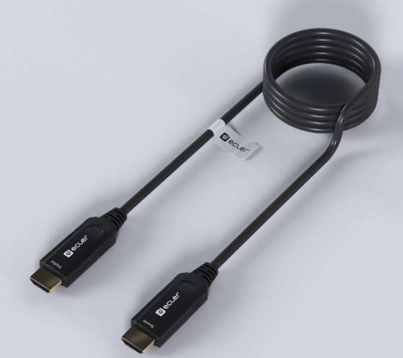 | VEO-XCH415 | VEO-XCH415 is a 15m 48 Gbps professional-grade Active Optical HDMI® Cable (AOC) designed to complement Ecler’s video product range. This high-performance cable ensures a reliable and seamless unidirectional HDMI® connection, supporting up to 8K 60Hz 4:4:4 resolution, 48-bit Deep Colour, and HDR content. The durable PVC jacket provides flexibility and robustness while maintaining a sleek black design, making it ideal for professional installations that require long-distance, high-quality HDMI® connections. | 90,37 € | 114,77 € | 36 600 Ft | 46 482 Ft

NEW! | CVEOXCH430 | VEO-XCH430 | VEO-XCH415 is a 30m 48 Gbps professional-grade Active Optical HDMI® Cable (AOC) designed to complement Ecler’s video product range. This high-performance cable ensures a reliable and seamless unidirectional HDMI® connection, supporting up to 8K 60Hz 4:4:4 resolution, 48-bit Deep Colour, and HDR content. The durable PVC jacket provides flexibility and robustness while maintaining a sleek black design, making it ideal for professional installations that require long-distance, high-quality HDMI® connections. | 120,49 € | 153,03 € | 48 800 Ft | 61 976 Ft

NEW! | CVEOXCH450 | VEO-XCH450 | VEO-XCH415 is a 50m 48 Gbps professional-grade Active Optical HDMI® Cable (AOC) designed to complement Ecler’s video product range. This high-performance cable ensures a reliable and seamless unidirectional HDMI® connection, supporting up to 8K 60Hz 4:4:4 resolution, 48-bit Deep Colour, and HDR content. The durable PVC jacket provides flexibility and robustness while maintaining a sleek black design, making it ideal for professional installations that require long-distance, high-quality HDMI®  connections. | 155,56 € | 197,56 € | 63 000 Ft | 80 010 Ft

NEW! | CVEOXCH470 | VEO-XCH470 | VEO-XCH415 is a 70m 48 Gbps professional-grade Active Optical HDMI® Cable (AOC) designed to complement Ecler’s video product range. This high-performance cable ensures a reliable and seamless unidirectional HDMI® connection, supporting up to 8K 60Hz 4:4:4 resolution, 48-bit Deep Colour, and HDR content. The durable PVC jacket provides flexibility and robustness while maintaining a sleek black design, making it ideal for professional installations that require long-distance, high-quality HDMI®  connections. | 190,62 € | 242,08 € | 77 200 Ft | 98 044 Ft

